Created
Nov, 2020
End user Manual
Human Resources & Payroll
Empower People
CONTACT US

Solvait
201 Amor Center, Queen Rania Al Abdullah St 415,
Amman, Jordan
In: www.solvait.com
And: info@solvait.com
T: +(962) 6 5330328

Record Changes to the memo

Update History

Date | Version | Writer | Description of Change
Dec, 2020 | 1.0 | Ayah Adnan

Review log

Date | Version | Writer | Description of Change

Contents
1. Record Changes to the memo 2
Update History 2
Review log 2
2. Contents 3
3. Human Resources 7
a. Department 7
i. Hierarchy of the department 9
b. Jobs 11
c. Positions 13
i. Position Hierarchy 16
4. Employee Information 18
i. Overview 18
ii. Hire new worker 20
iii. Worker’s profile 23
iv. Worker’s Address 26
v. Contact information 27
b. Employment 30
i. Employment Details 30
ii. Financial Dimensions 31
iii. worker’s identification 32
iv. worker’s Bank accounts 34
v. Worker's Employee Dependent 36
vi. worker’s Medical Insurance 38
vii. Worker's Legal Status 40
viii. Worker's Employee Custody 42
c. Contract 45
ii. Expiring Contract 55
iii. Expired Contract 56
iv. Employee Stop Salary & Stop Accrual 56
v. Periodic 62
5. Leave management 63
a. Overview 63
b. Leave setup 63
c. Leave registration 67
d. Leave return 71
6. Loans transaction 74
a. Loan setup 74
b. Loan transaction 76
7. Pay Transaction 80
a. Pay transaction setup 80
b. pay transaction 82
8. Overtime transaction 85
a. Overtime setup 85
b. overtime Transaction 86
9. End of service transaction 89
a. Overview 89
b. Setup 89
i. End of Service Calculation 89
ii. End of Service Reasons 91
c. End of service transactions 91
d. End of Service Clearance 96
10. Pay Cycle 98
a. Overview 98
b. Pay cycle setup 98
i. Calculation methods 98
ii. Allowances and Deductions 100
iii. Pay groups 102
iv. Payment sub cycle 103
v. Cutoff days 103
vi. Posting profile 104
c. Pay Cycle processing 105
i. Generate Payment 105
ii. Pay Cycle 108
iii. Cycle payment 109
iv. Accruals 110
v. Post to ledger 111
vi. Pay Accruals 114
vii. Payroll Journal 115
viii. Payroll Journal - Loan 116
d. Pay cycle inquires 117
i. Pay slip 117
ii. Detailed payroll Report 118
iii. Salary Bank 119
11. Attendance Management 121
a. Attendance Parameters 121
i. Defaults 121
b. Attendance and Absence 121
i. Employee Calendar 121
ii. Absence profile 126
iii. Lateness profile 127
iv. Early leave profile 128
v. Break profile 129
vi. No login/out profile 130
c. Worker 131
i. Attendance setup 131
d. Generate Attendance 133
e. Import attendance from machine 134
f. Import attendance (By excel) 135
g. Timesheet 137
h. Calculate 137
i. Attendance main screen 138
j. View Attendance 139
i. Employee attendance details 140
1. Absence 141
2. Delays 142
3. Early leave 143
4. Break 144
5. No log in/out 145
6. Overtime 146
7. Leave 147
8. Excuses 148
9. Business trip 148
10. Courses 149
ii. All employee’s attendance details 150
iii. All employee’s attendance calculations 151
k. Clear attendance lines 152
12. Appraisal 154
a. Assign Goals 154
b. Assign competencies 155
c. Master Appraisal page 157
i. Create an Appraisal 157
d. HR appraisal list 162
e. All appraisal requests 163
f. Appraisal assigned to me 163
g. My appraisal 166
h. Appraisals Pending stages 168
i. Reports 169
i. Appraisal Report 169
j. Employee Self-Services 170
i. Appraisal Assigned to Me 170
ii. My appraisal 173
iii. Appraisal results 175
13. Payroll Workflow 176
14. System Administration 183
a. Users 183

Human Resources

Department
Department is the operating unit that represents the class or functional area of the organization. The department is responsible for a specific area of regulation, such as sales or accounting.

The system can update/add branches or sections to department and can show the organization structure easily.

Path: Human Resources -> Departments -> Departments

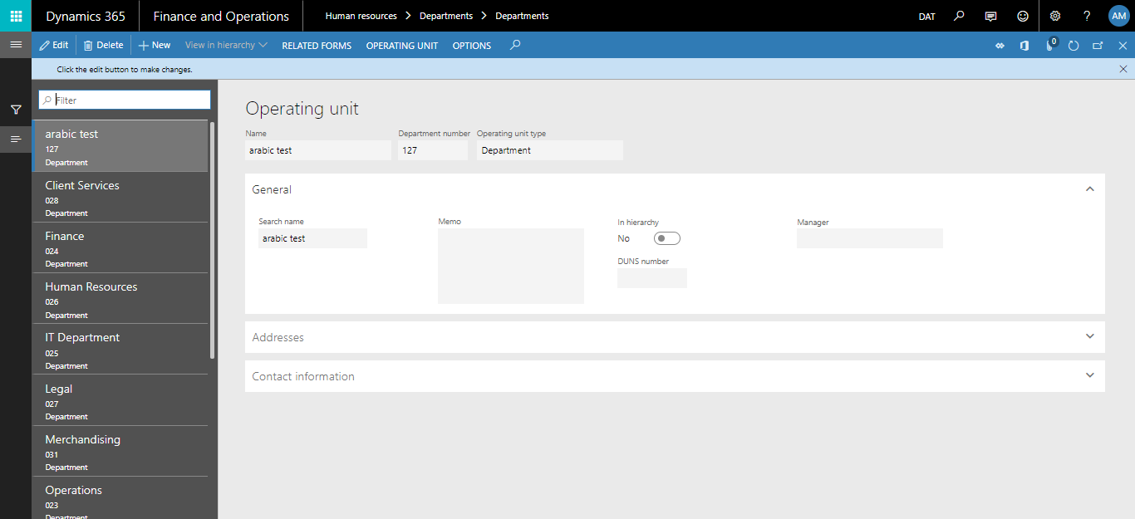

- Screen Details:
Name | Structure operating name
Operating unit Number | Define department ID
Search Name | Department search name
Operating type | Defined as department
General | Define some note with operating manger
Address-contact information | Define operating unit and contact information

- Create new department:
Steps | Expected result
1. Click on Human resources  2. Click on "Department"  3. Click on "Department" link  4. Click on “New" button.  5. Fill in the required field (Name)  6. Click on "Save" button | The user should be able to enter the required information and then the new department will be created after clicking on Save button

Note: To see the number of employees in each section click on "Number of workers" under related forms

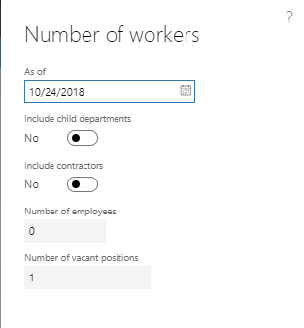

- Screen Details:
Total | Show number off employee on current department and number of vacant positions
Positions | User can define all available position for department

- Verify the number of workers and vacant position in Department:
Steps | Expected result
1. Click on Human resources  2. Click on "Department"  3. Click on "Department" link  4. Select any department  5. Click on "Related Form" button  6. Click on "Number of workers" link | Number of workers and vacant position should display for each department

Note: To view all posts currently available in the section click on "positions"

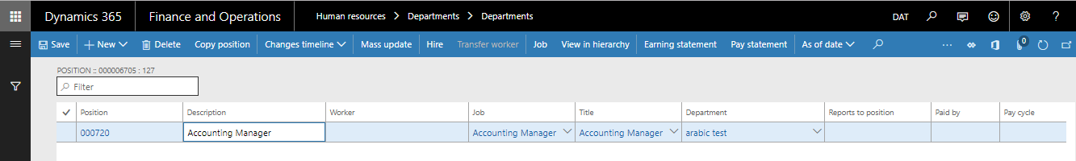

Hierarchy of the department
Displays the hierarchy of the department.

- Configure the structure of the organization with a set of easy steps by identifying institutions and doing drag and drop.
- Identify the main legal entity and drop the next legal entities and then define the administration
- Hierarchy and cost of business centers and units

Path: Human Resources -> Department – > Department Hierarchy

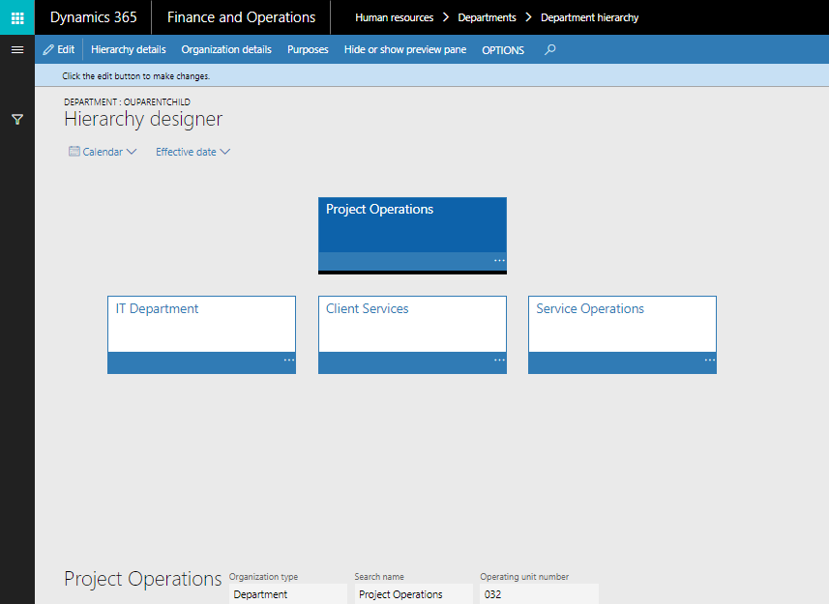

- View Department Hierarchy
Steps | Expected result
1. Click on Human resources  2. Click on "Department"  3. Click on "Department Hierarchy" link | The hierarchy of each department will be displayed. However, the hierarchy can be edited and customized

Deploying hierarchy changes with tracking dates and complete revision dates. You can also activate a date hierarchy in the future. The date of the hierarchy application can be set

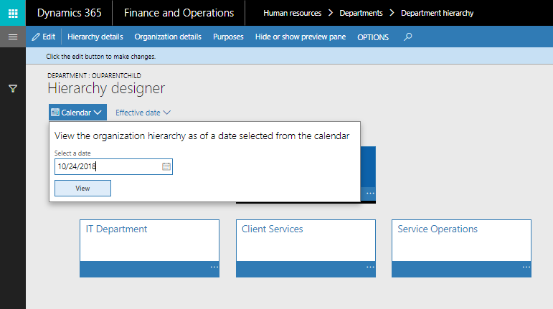

  - Jobs
A job is a collection of tasks and responsibilities. A position is a specific instance of a job. Areas of responsibility, job tasks, job functions, skills, education information, and certificates that are defined for a job are also automatically related to positions that are associated with a job.
Path: Human resources -> Jobs -> Jobs

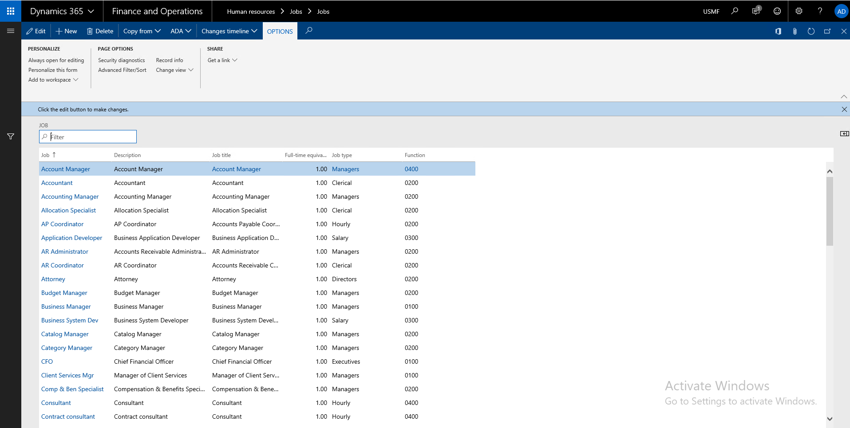

Define Job details
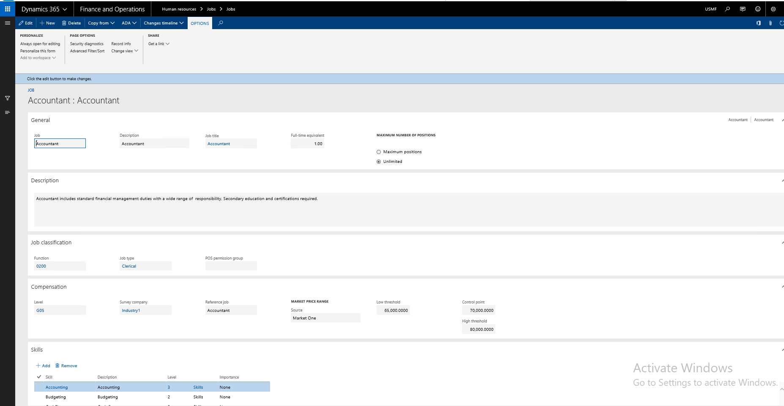
- Screen Details:
Job Classification | Select the job type and function
Skills | Select all required skills for selected job
Certificates | Indicate the achievements of a worker or achievements that are required for employment.
Tests | Maintain a list of tests that workers can take
Education | You can set up categories of education, such as college diploma, some college, or high school diploma
Screenings | Use the Screening types form to enter types of worker screenings
Job Task | Job tasks describe the basic tasks that a worker in a position for that job must complete. The same job task can be added to multiple jobs.
Areas of responsibility | Use areas of responsibility to indicate the work roles, processes, and products that a worker in a position for that job would be responsible for

- Create new job:
Steps | Expected result
1. Click on Human resources  2. Click on "Job"  3. Click on " Job " link.  4. Click on "New" button.  5. Fill all the required information like skills, courses, etc.  6. Click on "Create Job " button  7. Check the "Description" & "Job" fields.  8. Click on "Save" button. | The user should be able to enter the required information and then the new position will be created after clicking on Save button

Positions
Positions are an important element of the hierarchy of the enterprise starting from the lowest level. The position is an individual and specific example of a job. For example, the position of sales manager is just one of the positions associated with this task "Sales Manager". Could be Link position for the partition can be open or customized to an employee.

Path: Human resources -> positions -> positions

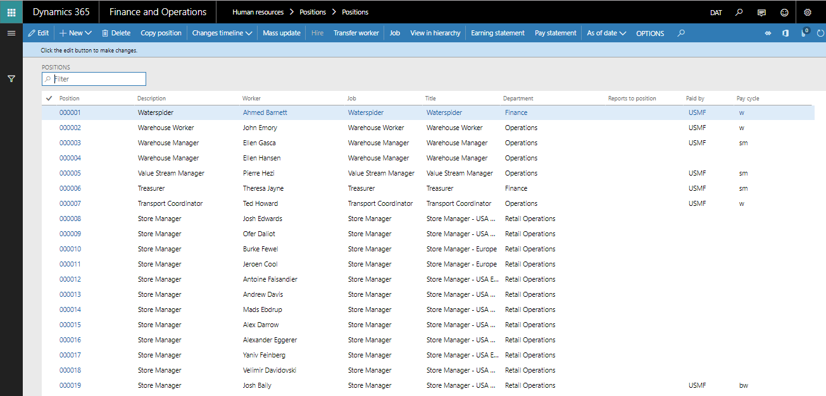

- Screen Details:
General | Define position ID and description, select job id, and reported to position, select position title
Position duration | Every position has a length of time that the position is effective. This length of time is referred to as duration. For example, summer positions might have duration of May 1, 2012 until August 31, 2012. Some positions might not have a date of expiration
Worker assignment | When you assign a worker to a position, you fill that position. You can assign workers to multiple positions, but only one worker can be assigned to a position at the same time.
Financial Dimensions | select the default financial dimension defined on GL

- Create new position:
Steps | Expected result
1. Click on Human resources  2. Click on "Positions"  3. Click on "Positions" link.  4. Click on "New Position" button.  5. Select any Job from the list (Preferred the added job in the above scenario).  6. Click on "Create Position" button  7. Check the "Description" & "Job" fields.  8. Select any value from the "Department" list.  9. Select any value from "Position type"  10. Click on "Save" button. | The user should be able to enter the required information and then the new position will be created after clicking on Save button

- To edit the details for the position, click on any position then "edit"

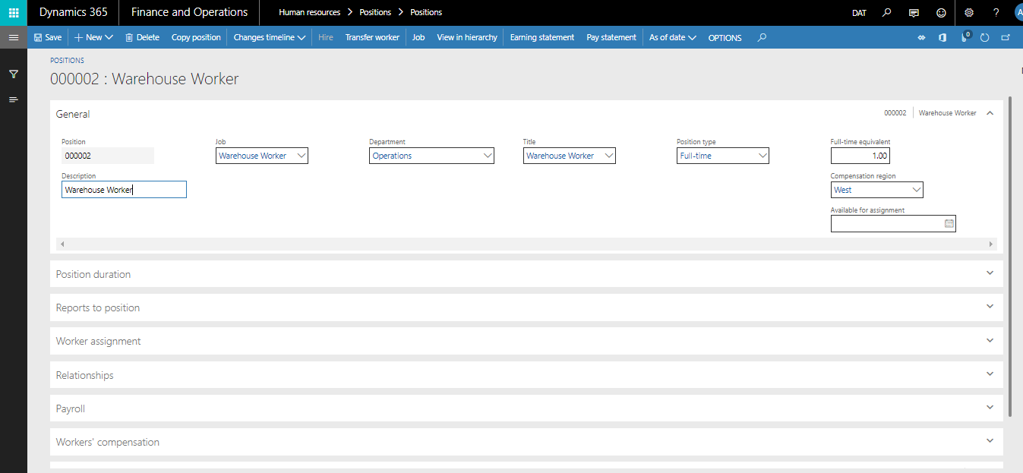

Position Hierarchy
The user can view the hierarchy of the position by the operator's name or the position identifier by the position hierarchy in the hierarchy and to who follows.

Path: Human resources -> positions -> Position Hierarchy

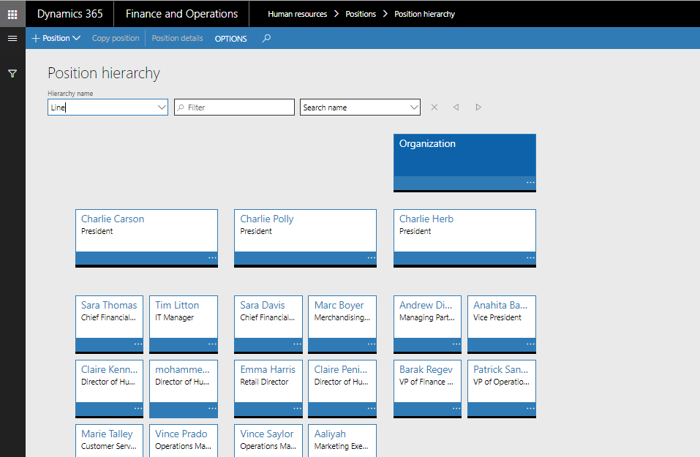

Employee Information

Overview
During this part we will include all details of the information about a factor, such as personal details or competencies or privileges and the following chart will explain how we can define all information about the worker:

The number of employees in the first box will be the number of a company on the employee's company, as follows:

1 | The employees of Granada Sport
2 | Employees of Granada Industries
3 | Owners of the company
4 | Domestic labor

Hire new worker
The staff recruitment system is the first of the systems used to fill information, starting with the ID of the worker, his name, and the position he is assigned to with the employment date.

Path: Payroll -> Workers -> Workers -> Hire new worker

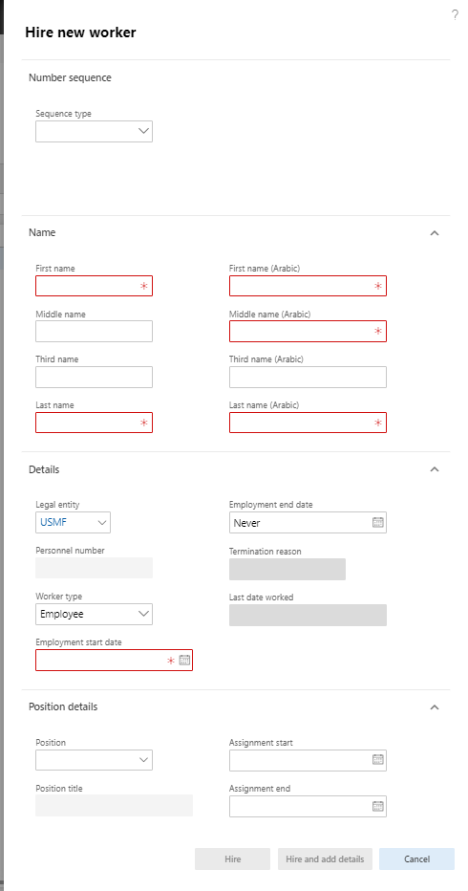

To hire a new worker, follow the following steps:
Steps | Expected result
1. Click on "Solvait Payroll"  2. Click on "Workers" link.  3. Click on "Hire new worker" button.  4. Fill in the required data:  - Sequence Type  - First name  - Middle name.  - Third name  - Last name  - First name (Arabic)  - Middle name (Arabic)  - Third name (Arabic)  - Last name (Arabic)  - Personnel number  - Employment start date  5. Click the "Hire new worker" button.  6. Click on "Save" button | The user should be able to enter the required information and then the new worker will be created after clicking on Hire new worker button

- Screen Details:

Field name | Description
Sequence type | Select sequence type which is defined earlier by the user
Name:
First Name | Define worker first name
Middle Name | Define worker middle name
Third Name | Define worker third name
Last name | Define worker Last name
First Name (Arabic) | Define worker first name (Arabic)
Middle Name (Arabic) | Define worker middle name (Arabic)
Third Name (Arabic) | Define worker third name (Arabic)
Last name (Arabic) | Define worker Last name (Arabic)
Details:
Legal entity | Select worker default legal entity
Personnel Number | Define worker id or get it automatic
Worker Type | Define worker type as (employee – Contractor)
Employment start date | Define employee start working day
Employment end date | Define employee end work date or leave it never
Position Details:
Assign a position | Select check box if you want to assign worker to a position
Position | Select vacant position defined before for this legal entity
Position Title | Select position title
Assignment Start | Define worker start date for his position
Assignment End | Define worker end date for his position or leave it never

Worker’s profile
Worker summary define all worker basic information, such as name details, nationality, qualification, joining date, language, and religion.

Path: Payroll -> Workers -> Workers -> Profile -> worker summary

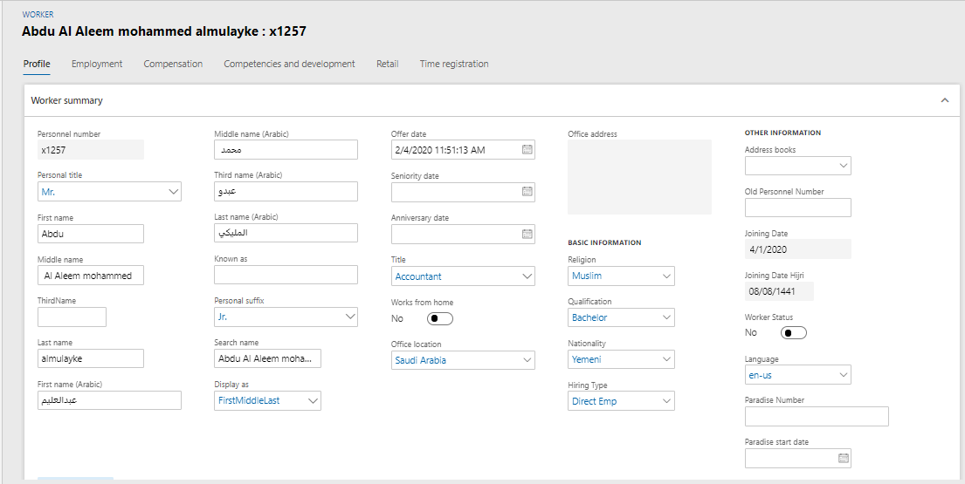

- To check the worker's profile, follow the following steps:
Steps | Expected result
1. Click on "Solvait Payroll"  2. Click on "Workers" link.  3. Search for the created worker or any existing worker  4. Click on the record link or click on "Edit" button  5. Under the "Profile" tab, select and fill all the required data  6. Click on "Save" button | The user should be able to enter and select the required information and the data will be saved successfully after clicking on Save button

- Screen Details:
Personal Number | Already defined from hire new worker form
Personal Title | Select worker personal title, such as Mr., Mrs., and Dr.
First Name | Define worker first name
Middle Name | Define worker middle name
Third Name | Define worker third name
Last name | Define worker Last name
First Name (Arabic) | Define worker first name (Arabic)
Middle Name (Arabic) | Define worker middle name (Arabic)
Third Name (Arabic) | Define worker third name (Arabic)
Last name (Arabic) | Define worker Last name (Arabic)
Known as | Define if the worker has an alternative name
Personal suffix | Select worker personal suffix, such as Jr., or Sr.
Search name | Already defined from hire new worker form
Display as | Choose how to display the name, such as: First Middle Last, or Last Middle First.
Offer date | Choose the offer date
Seniority date | Choose the seniority date
Anniversary date | Choose the anniversary date
Title | Select worker job title from list
Works from home | Choose yes if worker works from home
Office location | Choose office location from list
Office address | Write office address
Religion | Select worker religion from list, such as Islam
Qualification I | Select worker qualification id
Nationality | Select worker nationality, such as Egyptian, Saudi
Hiring type | Select worker type, such as contractor, or official employee.
Address book | Select address book from list
Old personnel number | Write the old personnel number

Worker’s Address
Define all worker addresses, such as home internal or external

Path: Payroll -> Workers -> Workers -> Profile-> Addresses

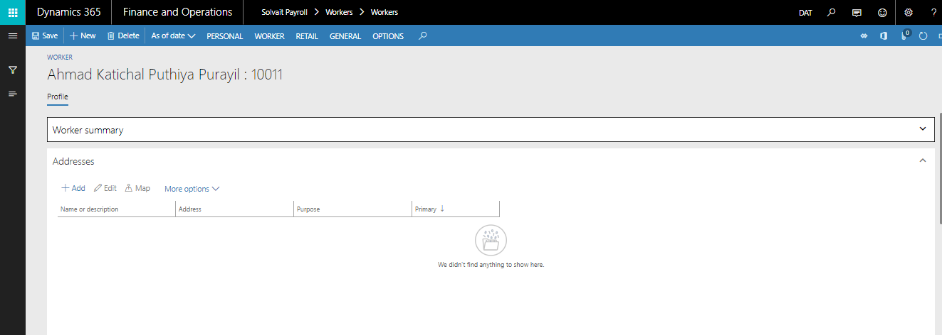

- Screen Details:
Add | Add new address for worker
Edit | Edit worker addresses data
Map | Define location Map
More option | Define more option for worker addresses
Name | Name or description for address header
Address | Location and street and PO box
Purpose | Purpose of address Home or business
Primary | If user need to set location is primary will select yes or no if it’s temp
Private | Mean private address

- Add new address:
Steps | Expected result
1. Click on "Solvait Payroll"  2. Click on "Workers" link.  3. Search for the created worker or any existing worker  4. Click on the record link or click on "Edit" button  5. Under the "Profile" tab, go to "Addresses" tab  6. Click on "New" button  7. Fill in the required information  8. Click on "Ok" button | The user should be able to add new address for the worker

Contact information
Select all the contact information for the worker, especially the e-mail address and mobile number

Path: Solvait Payroll -> Workers -> Workers -> Profile -> Contact info

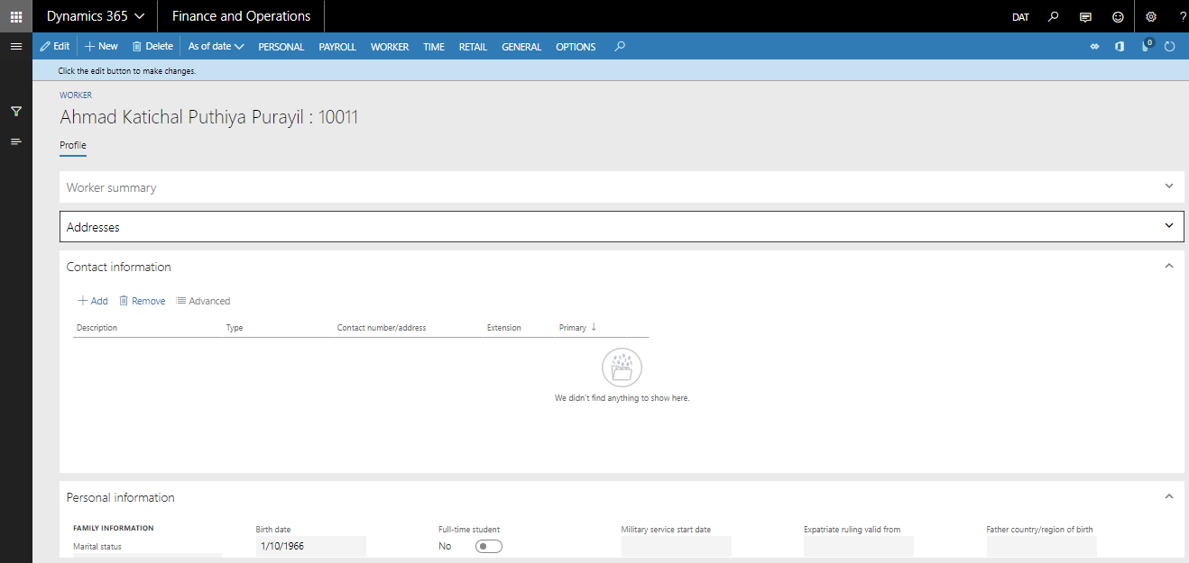

- Screen Details:
Add | Add new address for worker
More option | Define more option for worker addresses
Description | Contact description
Type | Phone or Email or URL or telex or fax
Contact Number | Number
Extension | Phone extension
Primary | If user need to set location is primary will select yes or no if it’s temp
Private | Mean private contact information

- Add new contact information:
Steps | Expected result
1. Click on "Solvait Payroll"  2. Click on "Workers" link.  3. Search for the created worker or any existing worker  4. Click on the record link or click on "Edit" button  5. Under the "Profile" tab, go to "Contact Information" tab  6. Click on "New" button  7. Fill in the required information  8. Click on "Ok" button | The user should be able to add new contact for the worker

Employment
In employment section, user can define employment details and financial dimensions details.

Employment Details
Define all employment details, such as hiring date and probation and termination

Path: Payroll -> Workers -> Workers -> Profile -> Employment

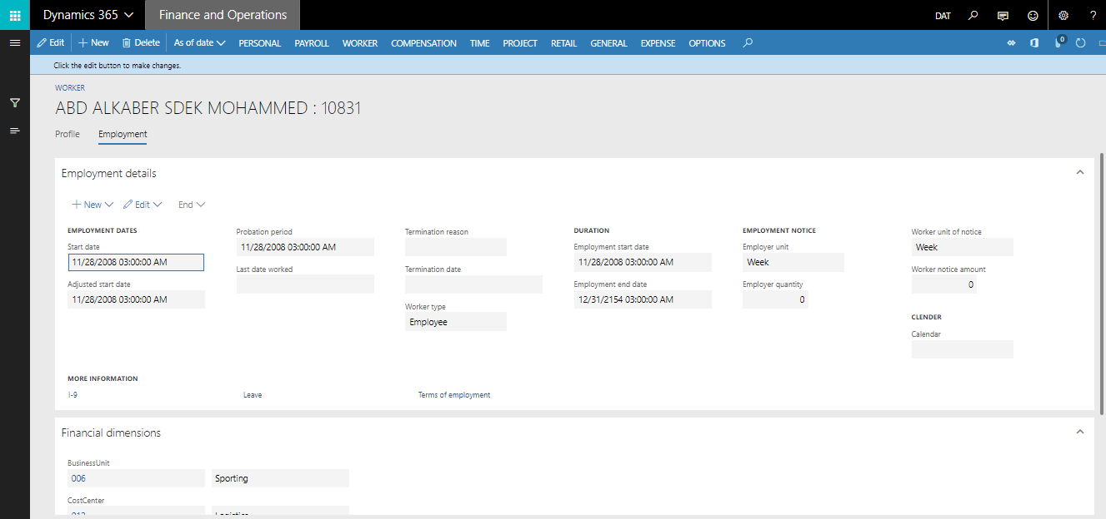

- Screen Details:
Duration | Worker type and start date and end date
Worker employment dates | Start date and adjust start date and probation period and termination date and reason
Calendar | Employee calendar

- Worker's Employment:
Steps | Expected result
1. Click on "Solvait Payroll"  2. Click on "Workers" link.  3. Search for the created worker or any existing worker  4. Click on the record link or click on "Edit" button  5. Under the "Employment" tab, fill all the required data  6. Click on "Financial Dimension" tab  7. Select the required data  8. Click on "Save" button | The user should be able to select the required information under the "Employment" and "Financial Dimension" tabs and the data will be saved successfully after clicking on Save button

Financial Dimensions
Financial dimensions are defined from the general ledger (GL).
Financial dimensions may include branch, cost center, department, and region.
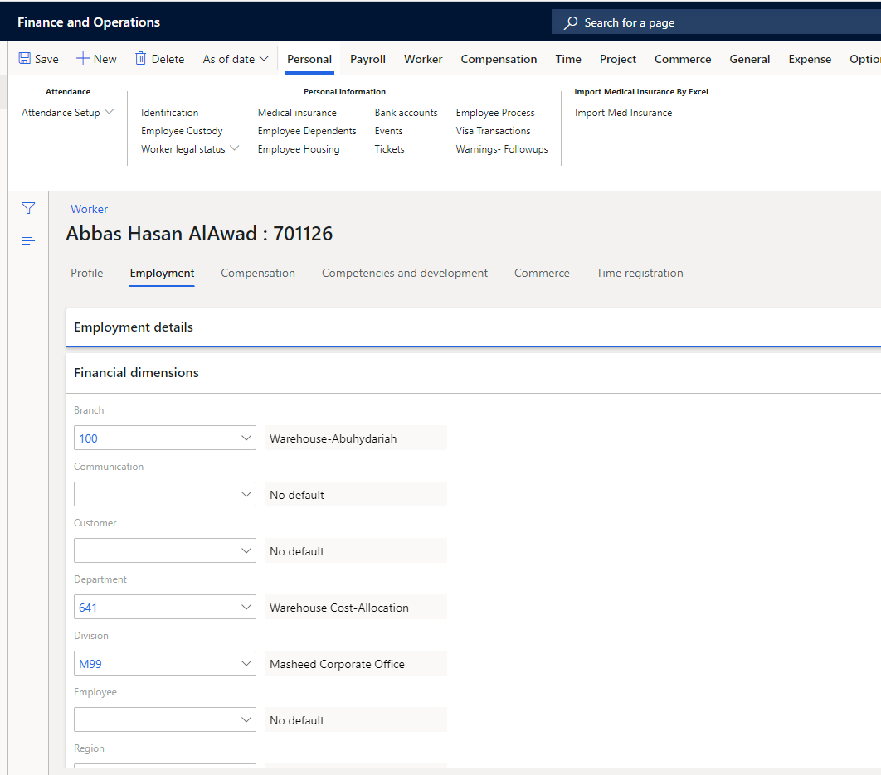

worker’s identification
Define worker Identification, such as National id or IQAMA Id with issue date and expiry

Path: Payroll -> Workers -> Workers -> Profile -> Personal -> Identification

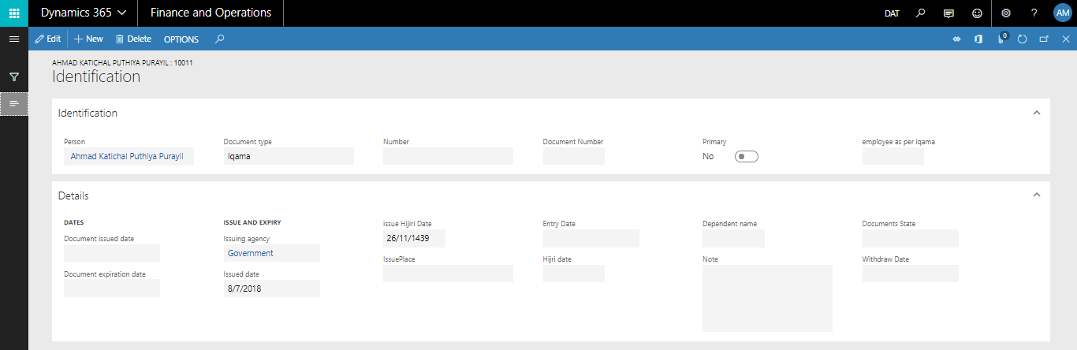

- Screen Details:
Document Type | Select document type, such as National id or IQAMA or etc.
Person | Worker name, will be filled automatically
Document Number | Define document number
Employee name as per the document | Specify employee name as in the document
Primary | Means main document for related transaction, such as bank salary
Issue date | Define issue date for document
Entry date in Hijri | Choose entry date in Hijri
Expiry date | Define expiry date for document
Document state | Specify state -if any-
Issuing Agency | Select document type, such as National id or IQAMA or etc.
Document Type | Select document type, such as National id or IQAMA or etc.
Number | Define document number

- Add new Identification:
Steps | Expected result
1. Click on "Solvait Payroll"  2. Click on "Workers" link.  3. Search for the created worker or any existing worker  4.Click on "Personal" tab  5. Under the "Personal" tab, click on "Identification" button  6. Click on New button and Click on New button and Fill in the required data  7. Click on "Save" button | The user should be able to select/enter the required information for identification and the data will be saved successfully after clicking on Save button

worker’s Bank accounts
Define worker bank details for transferring salary

Path: Payroll -> Workers -> Workers -> Profile -> Personal -> Bank Account

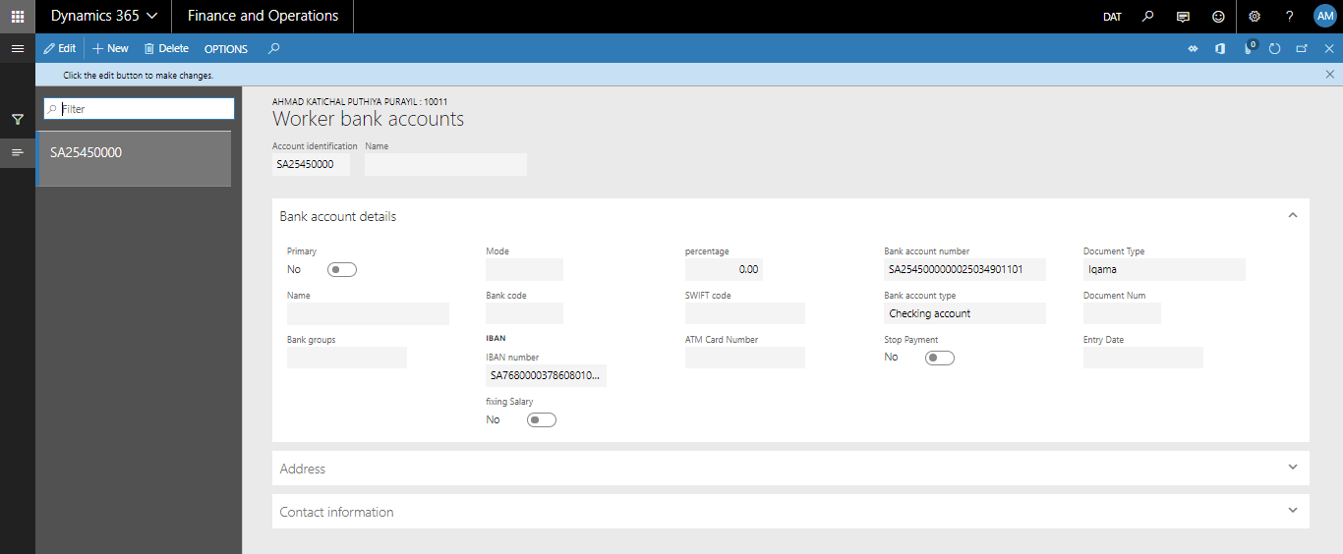

- Screen Details:
Bank identification | Bank account name, so that to differentiate between multiple accounts -if any-
Name | Description of bank identification
Bank Groups | Select bank group from list, can be used as bank name
Mode | Specify mode -if any-
Bank code | Abbreviation of bank name
Bank Account No | Define worker Account No
IBAN No | Define worker IBAN No
Swift code | Enter swift code
ATM Card number | Enter ATM Card number
Bank Account Type | Select type, such as (Checking account or saving Account).
Stop payment | Yes/ no if worker payment is topped from this bank
Document number | Write document number if there is an extra document
Percentage | Yes/ no if a specific percentage and specify the percentage if yes
Bank’s card status | Received or not
Address | Define worker bank address
Contact Information | Define bank contact information details, such as telephone, mobile phone, and email.
Entry date | Specify entry date -if any-

- Add new Bank Account:
Steps | Expected result
1. Click on "Solvait Payroll"  2. Click on "Workers" link.  3. Search for the created worker or any existing worker  4.Click on "Personal" tab  5. Under the "Personal" tab, click on "Bank Account" button  6. Click on New button and Fill in the required data  7. Click on "Save" button | The user should be able to select/enter the required information for Bank Account and the data will be saved successfully after clicking on Save button

Worker's Employee Dependent
Define employee dependent members

Path: Payroll-> Workers-> Workers-> Personal -> Employee dependent

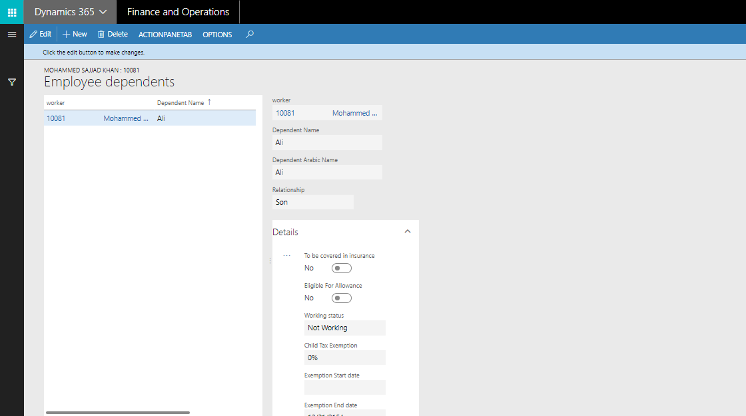

- Screen Details:
Dependent name | Define dependent name
Dependent ID | Dependent document ID number
Relationship | Select relationship, such as partner or child
To be covered in insurance | Check this if dependent include in Insurance
Eligible for allowance | if dependent Eligible for allowance add to Employee Salary
Gender | Type of Sex
Birth date | Birth date of dependents
Job | Dependent job
Number of tickets | Number of tickets for dependents
Eligible to tickets | Yes / no
Dependent location | In country or outside country
Working status | Working or not working
Eligible for allowance | Yes / no
Tax related data:  Name details | Name details including
Place of birth | Dependent place of birth
Finance number | Specify finance number
ID number | Specify ID number
Child Tax Exemption | Percentage of child tac exemption
Exemption Start date | Start date of tax exemption
Exemption End date | End date of tax exemption

- Add new Employee Dependent:
Steps | Expected result
1. Click on "Solvait Payroll"  2. Click on "Workers" link.  3. Search for the created worker or any existing worker  4.Click on "Personal" tab  5. Under the "Personal" tab, click on "Employee Dependents" button  6. Click on "New" button  7. Click on New button and Fill in the required data  8. Click on "Save" button | The user should be able to select/enter the required information for Employee dependent and the data will be saved successfully after clicking on Save button

worker’s Medical Insurance
Define employee and dependent medical insurance details

Path: Payroll-> Workers-> Workers-> Personal -> Medical insurance

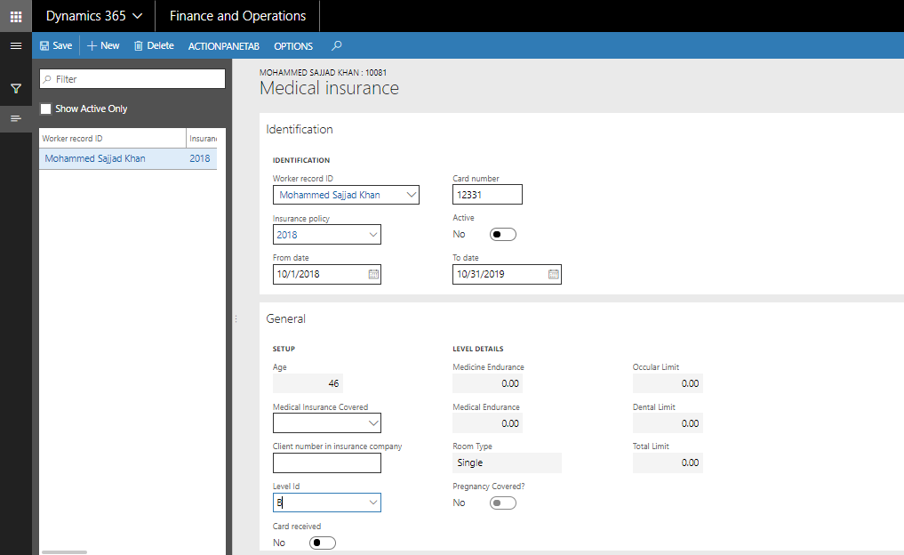

- Screen Details:
Policy date | From date up to date
Membership Number | Insurance membership number
Active | Yes / no
From and to dates | Dates of insurance
Card No | Define card no
Card received | Card received status
Level ID | Select worker policy level
Dependent | Define dependent medical insurance details, such as no and cards numbers and covered status
Standard and Upgraded medical insurance:
Charged to | Company or Employee
Company | If charged to company, specify company (legal entity) code
Upgrade section | If medical insurance changed, specify the change in upgrade section. Charged to, company, and cost.
Cost | Cost of medical insurance
Age | Age of worker automatically filled
Medical Insurance Covered | Covered or not covered
Client number in insurance company | Company number in insurance company
Level Id | Medical insurance level/ class
Card received | Yes / no
Receiving Date | Specify the date of receiving

- Add new Medical Insurance:
Steps | Expected result
1. Click on "Solvait Payroll"  2. Click on "Workers" link.  3. Search for the created worker or any existing worker  4.Click on "Personal" tab  5. Under the "Personal" tab, click on "Medical Insurance" button  6. Click on New button and Fill in the required data  - Insurance Policy  - Card Number  - From/To date  - Level ID  7. Click on "Save" button | The user should be able to select/enter the required information for Medical Insurance and the data will be saved successfully after clicking on Save button

Worker's Legal Status
Define all legal information, such as sponsor details and Iqama profession and visa details

Path: Payroll-> Workers-> Workers-> Personal -> Legal status

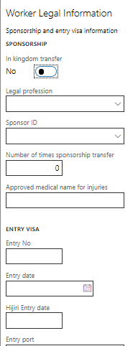

- Screen Details:
In Kingdom transfer | Check Yes or No, if KAFALA transfer or Not
Legal profession | Legal profession in Iqama
Sponsor ID | Fill in the Sponsor ID
Number of times sponsorship transfer | Specify the number of needed
Approved medical name for injuries | Specify the name if needed
Visa number | Fill in Entry Visa Number
Entry Port | Fill in Entry Port Number
Issue place | Specify issue place if needed
Issue Date/place /end date | define visa issue date and place and end date
Social Insurance Number | Define GOSI Number
Social Insurance Profession | Profession written in social insurance
Social Insurance Start and End Date | Specify dates if needed
Social insurance office | Specify office name if needed

- Add new Legal Status:
Steps | Expected result
1. Click on "Solvait Payroll"  2. Click on "Workers" link.  3. Search for the created worker or any existing worker  4.Click on "Personal" tab  5. Under the "Personal" tab, click on "Worker Legal Status" button  6. Fill in the required data  8. Click on "ok" button | The user should be able to select/enter the required information for worker legal status and the data will be saved successfully after clicking on Save button

Worker's Employee Custody
To identify all the equipment borrowed by the worker

Path: Payroll-> Workers-> Workers-> Personal -> Employee Custody

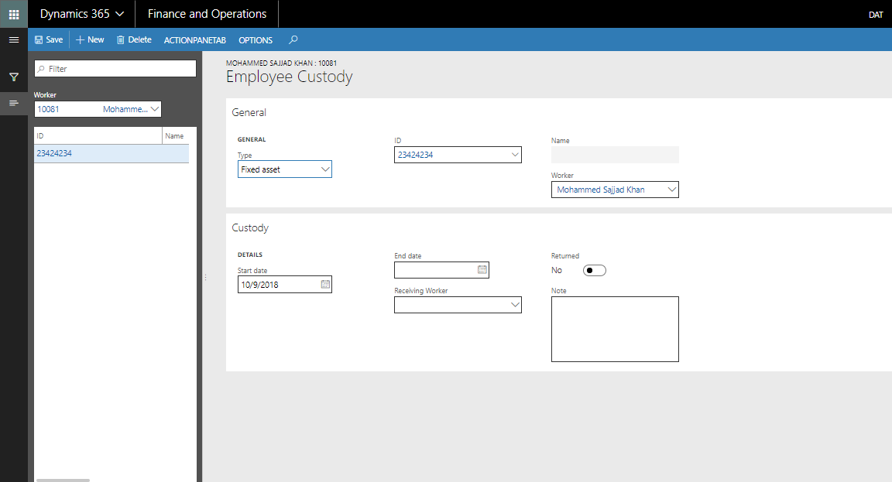

- Screen Details:
Worker | Worker name
Type | The type of the custody
ID | The id of the borrowed item
Department | Specify department of custody -if any-
Start/end date | Date of borrowed the item
Receiving worker | Fill in the receiving worker
Returned | Check if the stuff is returned or not
Note | Write extra notes if needed

- Add new Employee Custody:
Steps | Expected result
1. Click on "Solvait Payroll"  2. Click on "Workers" link.  3. Search for the created worker or any existing worker  4.Click on "Personal" tab  5. Under the "Personal" tab, click on "Employee Custody" button  6. Click on New button and Fill in the required data  - Type  - ID  - Worker  - Start/End date  7. Click on "Action pane tab" button  8. Click on "Confirm" link  9. Click on "Save" button | The user should be able to select/enter the required information for Employee Custody and the data will be saved successfully after clicking on Save button

Contract

General
Define contract general details, such as employee grade and contract dates

Path: Solvait Payroll-> Worker -> Payroll -> Contract -> General

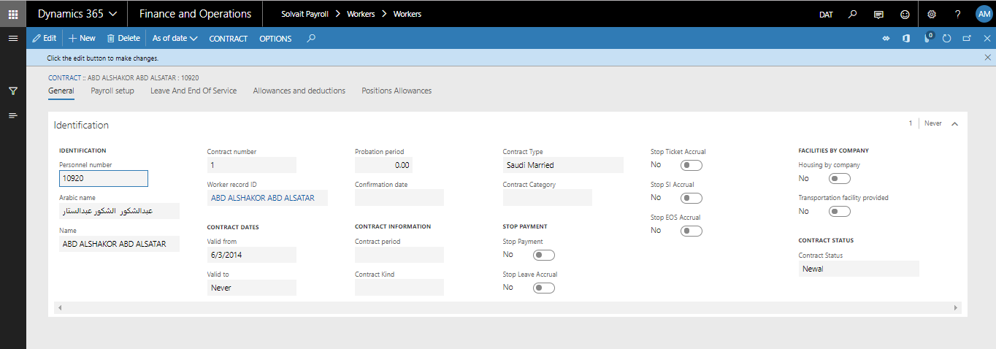

- Screen Details:
Identification | Personal no and name and contract no
Valid from and to | Contract start and end date
Probation period | Number of days in probation period
Confirmation date
Contract Kind | Full time, part time, contracted, etc.
Contract Category | Single, married or family
Contract Status | Contract renewal, end with renew, or end without renew
Employee Type | National, expat, or special expat
Employment Type | Employee, outsourcing, or sister company.
Employee grades | Select employee grade and salary scale level
Contract period | Define contact date and probation period
Stop payment
Stop Leave Accrual | Stop calculating leave accrual from pay cycle
Stop Ticket Accrual | Stop calculating ticket accrual from pay cycle
Stop SI Accrual | Stop calculating social insurance accrual from pay cycle
Stop EOS Accrual | Stop calculating End of Service accrual from pay cycle
Housing by company | Company provides a house for employee
Transportation facility provided | Company provides a house for employee for transportation
Notes | Write extra notes if needed

- Worker's Contract - General tab:
Steps | Expected result
1. Click on "Solvait Payroll"  2. Click on "Workers" link.  3. Search for the created worker or any existing worker  4.Click on "Solvait Payroll" tab  5. Under the "Solvait Payroll" tab, click on "contract" button  6. Click on "Edit" button  7. Click on New button  8. Under "General" tab, Fill in the required data  9. Click on "Save" button | The user should be able to select/enter the required information for Contract "General tab" and the data will be saved successfully after clicking on Save button

Payroll Setup
Define all worker contract setup, such as pay group and employee group and method of payment and basic salary

Path: Solvait Payroll-> Worker -> Payroll -> Contract -> Payroll setup

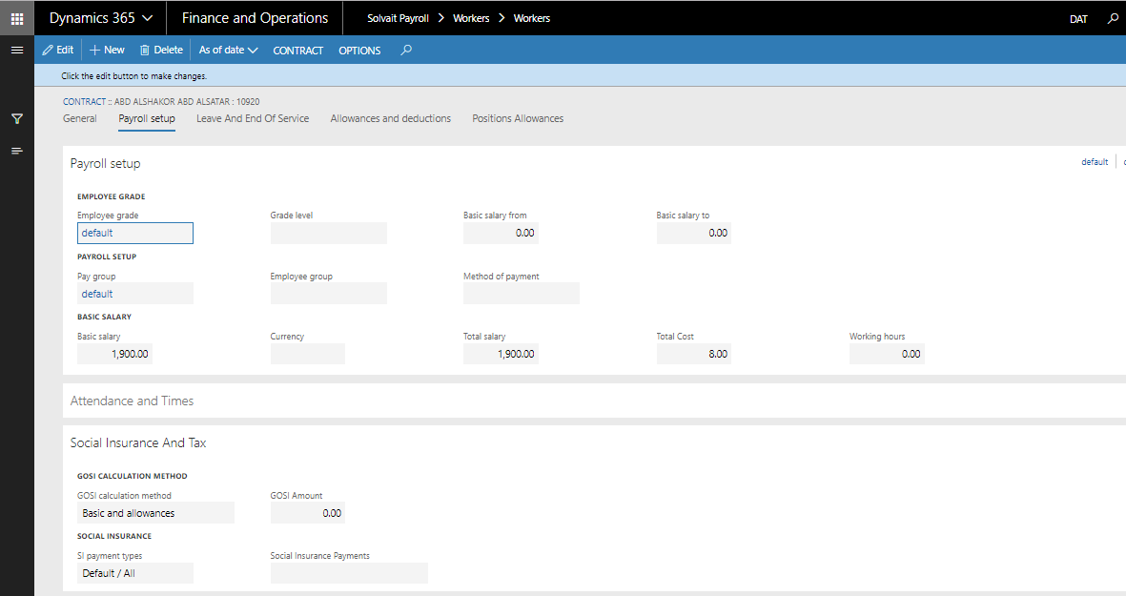

- Screen Details:
Payroll setup | Define pay group and employee group and method of payment and calendar
Tax emption | Define work tax (not used in Saudi)
Social insurance | Define GOSI calculation setup
Basic salary | Define basic salary and working hours and salary calculation and overtime type
Basic salary effective date | If basic salary was adjusted using benefit adjustment, then the effective date will be the date of new salary after adjustment
Grade level | Optional feature for employee grade that describes the level of employee grade. E.g., an employee grade will be promoted each four grade levels. In this case, there will be two grade levels, and 8 employee grades. And might be the opposite based on the company policy.
Employee group | Employee groups might be defined based on specific features, can be used in posting pay cycles to journals. Posting profile will be categorized based on employee groups.
Working hours
Method of payment | Method of payment of salaries such as cash, bank, check, etc. It is just as information and does not affect in pay cycle. If a group of employees will be paid in cash, there will be a separated pay group for them.
Insurance Category | Medical insurance category (level) such as VIP, Golden, bronze, etc. Medical insurance level is also mentioned in medical insurance tab in worker profile. (Worker -> personal -> medical insurance)
Currency | Currency of paying salary.
Social Insurance and Tax:
GOSI calculation method | Basic and Allowances if GOSI will be calculated based on the percentage of GOSI from basic and allowance.  (GOSI calculation percentage is configured in the following path: Solvait payroll -> setup -> GOSI)  or fixed amount if GOSI will be paid regardless of the basic and salary
GOSI Amount | If calculation method chosen is fixed amount, specify GOSI fixed amount
is Employee Exemption | Yes, if employee is exempted from tax  No, if employee
Exemption start and end date | Start and end date of employee exemption from tax

- Worker's Contract - Payroll Setup tab:
Steps | Expected result
1. Click on "Solvait Payroll"  2. Click on "Workers" link.  3. Search for the created worker or any existing worker  4.Click on "Payroll" tab  5. Under the "Solvait Payroll" tab, click on "contract" button  6. Click on "Edit" button  7. Under "Solvait Payroll Setup" tab, Fill in the required data  8. Click on "Save" button | The user should be able to select/enter the required information for Contract "Solvait Payroll Setup" tab and the data will be saved successfully after clicking on Save button

Leave and EoS of services
Through this form, annual leave and end of service data can be entered.

Types of leave are:
o Annual leave of 21 days becomes 30 days after 5 years
o Employees can apply for leave after two years, and Saudi one year
o Annual ticket every two years
o After five years full salary and the first five years basic salary only

You need to modify the program; it is not supported in the system and is not recommended for its work. A "change request" will be required for the customer to complete this process.

Path: Solvait Payroll-> Worker -> Payroll -> Contract -> Leave and EOS of services

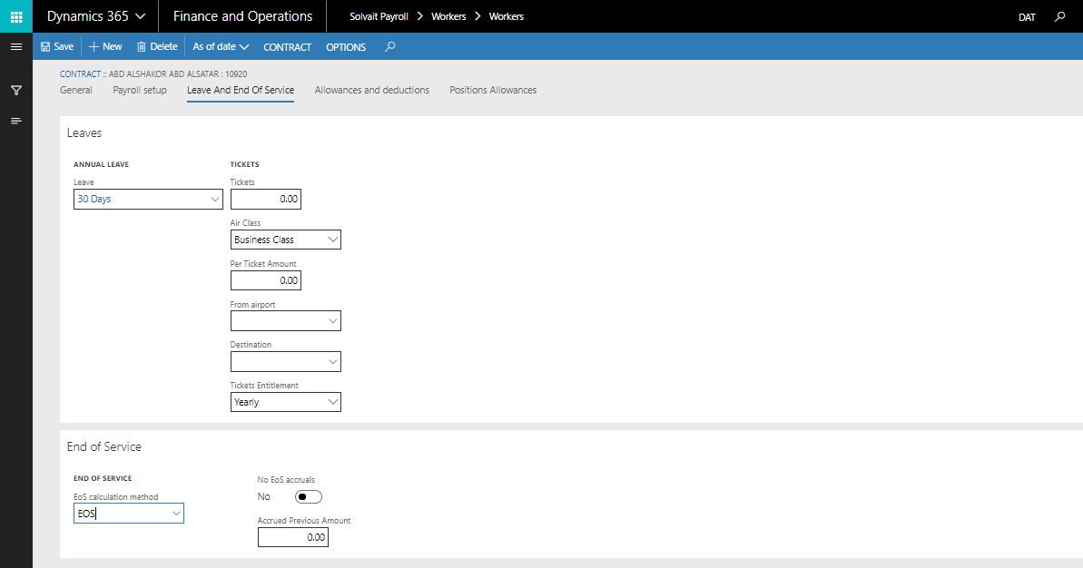

- Screen Details:
Leave | Select the leave type for the worker
Annual leave effective date | If annual leave was adjusted using benefit adjustment, then the effective date will be the date of new annual leave after adjustment. E.g., Annual leave adjusted from 21 days to 30 days in 2/1/2020. The effective date of annual leave will be 2/1/2020.
Tickets | Enter the number of allowed tickets for worker
Tickets effective date | If number of tickets in “tickets” field was adjusted using benefit adjustment, then the effective date will be the date of new tickets value after adjustment. E.g., tickets adjusted from 2 to 5 in 2/1/2020. The effective date of tickets will be 2/1/2020.
Air Class | Ticket class/ level
From airport | Optional field to specify the departure place
Destination | Optional field to specify the destination place
Tickets Entitlement | Yearly if the specified number of tickets in “tickets” field is allowed each year.  2 years if the specified number of tickets in “tickets” field is allowed each two years.
End of Service:
EOS calculation method | Select the EOS calculation method for the worker
No EoS accruals | Stop calculating end of service accruals from pay cycle
Accrued Previous Amount | Yes, if accrued previous amount

- Worker's Contract – Leave and EOS of services tab:
Steps | Expected result
1. Click on "Solvait Payroll"  2. Click on "Workers" link.  3. Search for the created worker or any existing worker  4.Click on "Solvait Payroll" tab  5. Under the "Solvait Payroll" tab, click on "contract" button  6. Click on "Edit" button  7. Under " Leave and EOS of services " tab, Fill in the required data  8. Click on "Save" button | The user should be able to select/enter the required information for Contract " Leave and EOS of services" tab and the data will be saved successfully after clicking on Save button

Allowances and Deductions
Define worker allowances and fixed deduction and cost

Path: Solvait Payroll-> Worker -> Payroll -> Contract -> Allowances

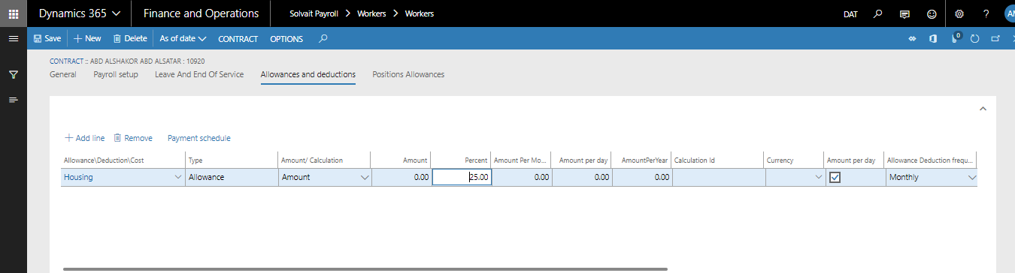

- Screen Details:
Allowance/deduction/cost | Define allowance id, such as housing or transportation and fixed deduction and cost, such as
Type | Allowance – deduction – cost
Amount- Calculation | If amount, the element will be a specific amount.  If calculation, the element amount will be calculated based on the chosen calculation method
Amount | Write the amount if amount
Percent | Specify the percent of basic salary  (Either specify the amount or percent)
Amount/percentage | Amount or percentage
Amount per month | After entering amount per day, amount per month is calculated automatically
Amount per day | Amount per day is entered manually
Amount per year | After entering amount per day, amount per year is calculated automatically
Calculation ID | Specify the calculation ID if the field “Amount- Calculation” chosen was Calculation
Currency | Currency of paying allowances and deduction and cost in pay cycle
Amount per day | Check box mean will deduct in case worker absent
Allowance Deduction frequency | Specify frequency if needed
Deserved every | Specify duration of deserved element
Effective date from and to | If annual leave was adjusted using benefit adjustment, then the effective date will be the date of new annual leave after adjustment. E.g., allowance adjusted from 3000 to 6000 in 2/1/2020. The effective date of allowance will be 2/1/2020. The effective date can be specified without benefit adjustment as well.
Allowance deduction frequency | To determine payment schedule, such as yearly or monthly or half year
Include on GOSI | Yes, if element will be included in calculating GOSI amount
Include in tax | Yes, if element will be included in calculating tax amount
Is stopped | Auto,  Yes,  No,

- Worker's Contract - Allowances tab:
Steps | Expected result
1. Click on "Solvait Payroll"  2. Click on "Workers" link.  3. Search for the created worker or any existing worker  4.Click on "Solvait Payroll" tab  5. Under the "Solvait Payroll" tab, click on "contract" button  6. Click on "Edit" button  7. Under "Allowances" tab, Fill in the required data  8. Click on "Save" button | The user should be able to select/enter the required information for Contract "Allowances" tab and the data will be saved successfully after clicking on Save button

Expiring Contract

Path: Solvait Payroll-> Worker -> Payroll -> Contract -> Expiring contracts

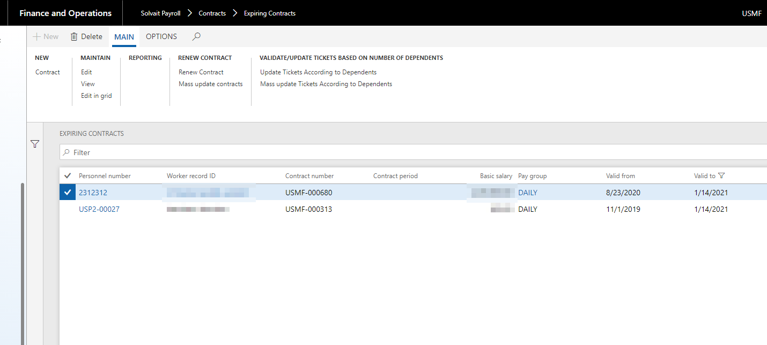

Expiring contracts displays the all the contracts that will be expired in two months. Based on contract “valid to” date.
The screen details are the same in contract screen.

Expired Contract
Expiring contracts displays the all the contracts that have been expired in two months. Based on contract “valid to” date.
The screen details are the same in contract screen.

Employee Stop Salary & Stop Accrual
This screen displays both the contracts that have stop salary and accruals and the ones who do not have.

Overview
There were, initially, functional grades on the following coal:
    - CEO
    - Administrators
    - Heads of departments
    - Area managers
    - managers
    - Employees
    - Technicians
    - workers

Staff allowances are:
    - Housing allowance - all employees six months or annually

Non-fixed that unrelated to salary
    - Monthly bonus / bonus (will be canceled)
    - Transportation
    - Connection allowance

Allowances and Deductions
Allowance and deduction section have been explained in details in contract section.

Grade Level
Grade levels can be used as if for each grade level there might be several employee grades, such as grade levels 1, 2 for employee grade: A, and grade levels 3 and 4 for employee grade B. Grade levels might be used the opposite as if for each employee grade, there might be different levels set to it. This is usually needed based on the company policy in setting grades.

Employee grades

Before we begin to explain the details of the contract, we will provide information about the "career ladder" and how the "career ladder" helps the user to identify some benefits to specific groups of employees according to the rules of the company.

The "Job Level" is used to control the account settings and employee benefits list. Where the user can define more than one degree within the career ladder, including the bike features such as the type of annual leave due and the number of tickets.

When a staff member is associated with a certain degree, all grade features such as the type of annual leave and the number of tickets in his employment contract will be the same as the employee's grade. These benefits may be optional or mandatory, as the user cannot change the value at the employee contract level if the benefit is mandatory.

List of benefits and settings specified in the contract:
- Calendar
- Personality delay
- Salary scale
- yearly vacation
- Number of annual tickets
- Medical Insurance
- Matrix assignments

Path: Solvait Payroll -> Contract -> Setup -> Employee Grade -> Employee Grade

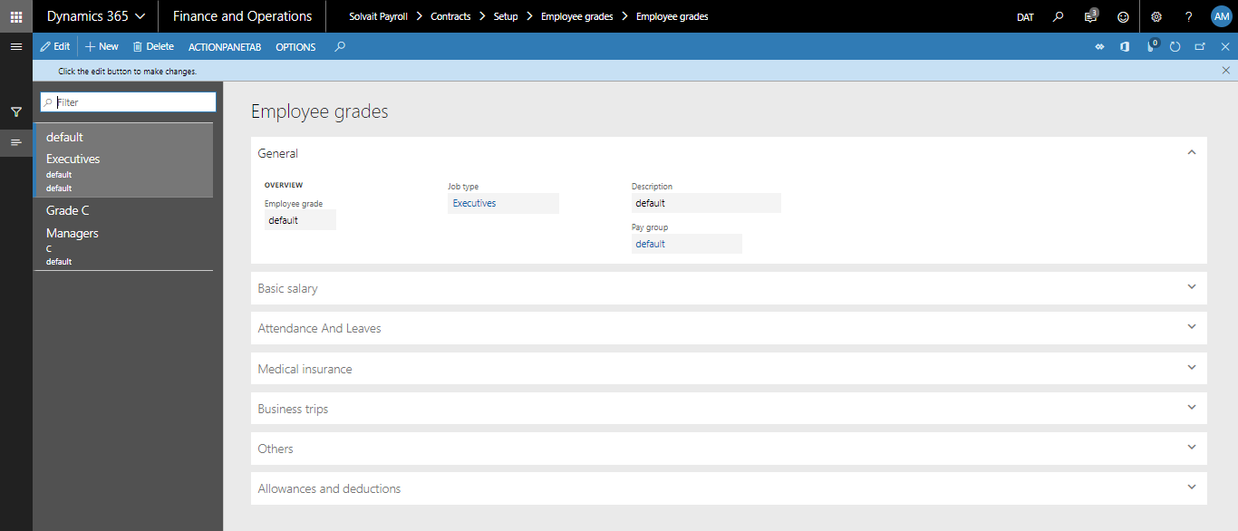

- Screen Details:
Employee Grade | Employee Grade Id
Job type | Specify job type -optional-, i.e., employee grade affects the selected job type.  Add new job type screen details:
Description | Grade description
Pay Group | Specify pay group for employee grade.  Pay group is important for running pay cycle, as there might be different pay groups for running different pay cycle.
Indicator Only | Whether this salary scale is only an indicator, so it can be changed at the contract level or not. If not, then user won’t be able to change the value to less than the “Basic Salary From” or greater than “Basic salary to” in “salary scale” field.
Salary scale | Add salary scale screen details:  From step: First step number  Number of Steps: number of steps specified.  Grade Step increment: the amount of increment
Calendar | Specify calendar for employee grade. Must be defined in attendance module only if attendance module is used by client. Calendar includes working time templates for attendance hours.
Annual Leave | The default value of the annual leave, predefined in leaves setups.
Maximum number of visas | Maximum number of visas for worker
Maximum number of Tickets for single | The default value of the number of tickets for single
Maximum number of Tickets for married | The default value of the number of tickets for married
Lateness Profile | The default lateness profile
Working hours | Specify number of working hours
Optional/Mandatory | Determines whether this type of payments is mandatory (must exist) for all workers of this types of grades
Contract Type | Information to show this grade
Allow Providing Tickets for Local Nationality | Yes, if local nationality can take tickets  No, if local nationality is not allowed to take tickets
Calculate overtime | Calculate overtime
Maximum number of tickets | Set the maximum number of ticket if needed
Optional-mandatory | Choose if optional or mandatory
Salary calculated without absence | Check if salary is calculated without absence
Grade, Grade Level, Basic Salary From, Basic Salary To | Fields that are taken from the Salary Scale form
Annual Leave | The default value of the annual leave
Insurance coverage | • Employee with all family members  • Employee with some of family members  • Employee only
Members covered in medical | Maximum number of family members to be covered with the employee
Level Id | Insurance Class/ level
Business Trip Matrix | The matrix of business trips per diems to be applied for this grade
Others:
EoS calculation method | EoS calculation method for grade
Transportation facility provided | Yes, if a car provided by company
Housing by company | Yes, if a house provided by company
Check Max in Pay Cycle
Objectives Percentage | Objectives percentage in appraisal total amount
Competencies Percentage | Competencies percentage in appraisal total amount
Allowances – Deductions - Cost | This tab is to apply allowances for grade
Allowance type | Type of payment
Amount | Amount of that payment
Percent | Percent of element amount from the Basic Salary
Amount per day | Whether the amount is to be deducted in case employee is not working (in leave or in absence state)
Include in GOSI | Whether this type of allowances to be part of the GOSI calculations or not
Minimum amount and Maximum amount | Minimum and maximum allowed amount predefined in allowance profile, and reflected automatically in the grade

- Worker's grades:
Steps | Expected result
1. Click on "Solvait Payroll"  2. Click on "Contract" link.  3. Click on "Setup" link  4. Click on "Employee Grade" then "Employee grade" link  5.Click on "New" button  6. Fill in the required data  7. Click on "Save" button | The user should be able to add employee grade

Periodic
Auto Renew Contracts Period This batch process is used to renew
all the employees’ contracts that are going to expire
in the interval period configured under the Contracts Parameter screen.
Screen details:
Field | Description
Recurrence | Setup of batch job recurrence
Alerts | Set alerts as needed
Batch group | Batch groups are needed

Leave management
  - Overview
Employees of the company will enjoy different vacations according to the regulations of the Ministry of Labor, which requires the employee to enjoy an annual vacancy.

We have considered the system to include all elements of the required leave of annual vacations and one-day vacations such as Hajj vacations, as well as various other holidays such as marriage, death, maternity, maternity leave, unpaid leave

  - Leave setup
This form is used to determine available types of annual leaves, sick leaves, unpaid leaves... etc.

Path: Solvait Payroll -> leaves -> Setup -> Leaves setup

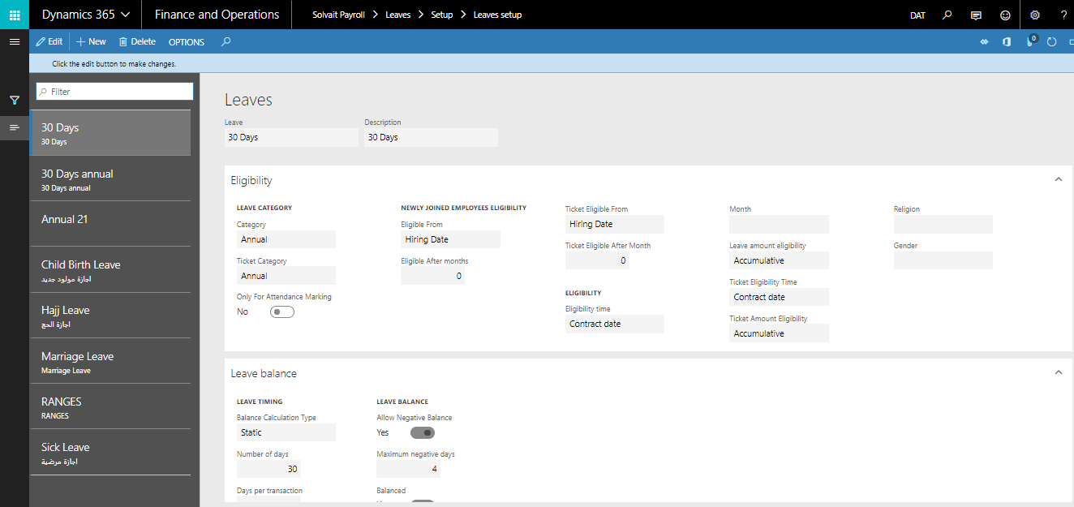

- Screen Details:
Field | Description
Leave | Id of leave type
Description | Leave description
Eligibility:
Category | Annual: annual leave  Other: Any leave than sick or annual leave, such as marriage, death leave, and exam leaves.  One time: taken only one time by employee, and not allowed to apply for it again. Such as Hajj leave.  Sick leave: sick leave type.
Ticket Category | Annual: annual leave  Other: Any leave than sick or annual leave, such as marriage, death leave, and exam leaves.  One time: taken only one time by employee, and not allowed to apply for it again. Such as Hajj leave.  Sick leave: sick leave type.
Leave amount eligibility | The value of the days that a worker can have as leave  - Accumulative: leave balance calculated on daily basis incrementally. I.e., it will be increase starting from 0 until the end of year, it will reach the number of leave days.  - Period start: balance is calculated based on leave days. Opposite of accumulative, it starts by the number of days, then decreases based on the leave days taken by worker until it reaches 0.  - Period End  - Table entry
Nationality | Only the specified nationality can take this leave
Ticket Eligible From | Allowed to take tickets from probation date or from hiring date
Ticket Eligibility Time | Specify time for ticket eligibility if needed
Ticket Eligible After Month | Specify the number of tickets that the worker is eligible to take after
Ticket Amount Eligibility | The value of the days that a worker can have as ticket  - Accumulative: ticket balance calculated on daily basis incrementally. I.e., it will be increase starting from 0 until the end of year, it will reach the number of leave days.  - Period start: balance is calculated based on tickets. Opposite of accumulative, it starts by the number of days, then decreases based on the tickets taken by worker until it reaches 0.  - Period End  - Table entry
Apply Egypt Calculation | If the calculation is based on Egypt policy (for Egyptian clients only)
Only for Attendance Marking
Newly Joined Employees Eligibility:

Leave eligible from | From when to start taking leaves
Eligibility time | Determines if the leave balance depends on the Contract start date or Annually (by specific month)
Month | In case the Eligibility Time is Annual
Religion | Only the specified religion can take this leave
Gender | Only the specified gender can take this leave
Terms & Conditions
To Be Shown On SSS | To show this leave on SSS leave types
Leave balance:
Balance Calculation Type | Static: a static number of leave days will be, with no conditions  Range: number of leave days will be based on the range setup.
Number of days | Number of days for that leave
Days per transaction | Maximum number of days that a worker can have per one leave transaction
Every No of days | Specify the duration for eligibility of leave days. E.g.,
Remove holidays from transaction days | Choose wither to remove holidays or include it in in leave transaction
Remove Weekends from transaction day | Choose wither to remove weekends or include it in in leave transaction
Days will be deducted from service period in EoS | Choose wither to deduct it from service period in EoS
Allow Negative Balance | If negative balance is not allowed, a message will be displayed when the balance reaches 0
Maximum negative days | If negative days are allowed specify the maximum number of days
Balanced | Is balance calculated or not
Ticket Balanced | Are ticket balances or not
Maximum balanced years | Specify maximum balanced years
Convert to absence when no balance | When no more balance available, convert leaves to absence days
Get balance from this leave when no balance | Choose yes or no
Annual | Mark this in case this leave type is annual, so it can be selected at the contract
Only one-time vacation | Determines whether this type of leaves will be taken as only one time in career life, such as Haj leave
Eligible after hiring or probation | In case this type of leave is only eligible after passing a specified number of months starting from Hiring Date or Probation Period Date
Days per transaction | Maximum number of days that a worker can have per one leave transaction
Every year | Determines per how many years those number of days in that leave is due
Leave amount calculation | Determines how the calculation of leave amount will be per days

  - Leave registration
This form is used to register leave transactions for the employee.

Path: Solvait Payroll -> Leaves -> Leaves Transaction

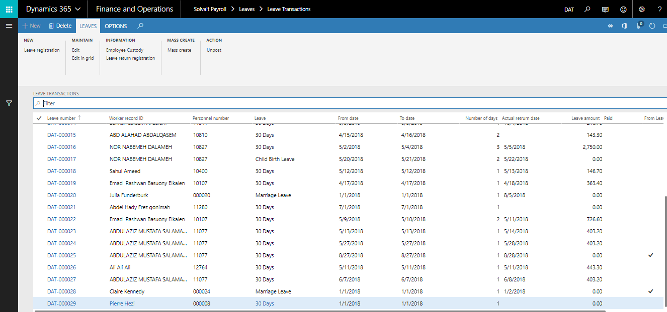

- Screen Details:
General | Will enter worker ID and select leave type, such as annual or sick or unpaid and select ticket type (booking – cash) and visa if it’s required
From Leave Request | Will be checked automatically if it comes from a leave request
Leave | Specify leave
Description | Write description if needed
Leave amount | Amount will be calculated automatically
Dates | Specify start and date of leave
Number of days | How many days of leave
Leave balance | Balance will be calculated automatically
Auto Return from Leaves | Will be checked if auto return of this leave type is enabled
Visa Issued | Yes or no
Ticket payment method | Specify ticket payment method, e.g., cash or booking
Number of tickets | From worker’s contract
Per Ticket Amount | From worker’s contract
Tickets balance | Balance will be calculated automatically
Balance remaining | Balance remaining will be calculated automatically
Destination | Specify if needed
Reason code | Specify if needed
Pay leave with salary | If checked means leave will be displayed and paid in pay cycle
Encashment | Specify if needed
Submit as ready | Ready to be submitted to pay cycle
Paid | Means paid wither in or outside pay cycle
Journal batch number | Will be specified if it has an external journal
Working days amount | Number of working days before leave
Ticket amount | Ticket amount specified
Other additions | Worker’s other additions
Gross total | Worker’s gross total
Loan value | Worker’s loan value
Total deductions | Worker’s total deductions
Net amount | Additions minus deductions
Other additions | Extra addition -if any-
Additions Notes | Notes for other addition
Other deductions | Extra deduction -if any-
Deductions Notes | Noted for other deduction
Calculation:  Working days calculation | Working days before leave and leave working days
Leave days calculation | Calculations for leave days
Visa | Exit entry visa details: issue date, number of visas, Visa number, Hijri issue date, Expiration date, Expiry Date Hijri, Visa required.
Loaned Items and custodies | Receiving loaned items
Financial dimensions | Finical dimension for worker cost

- Create new transaction:
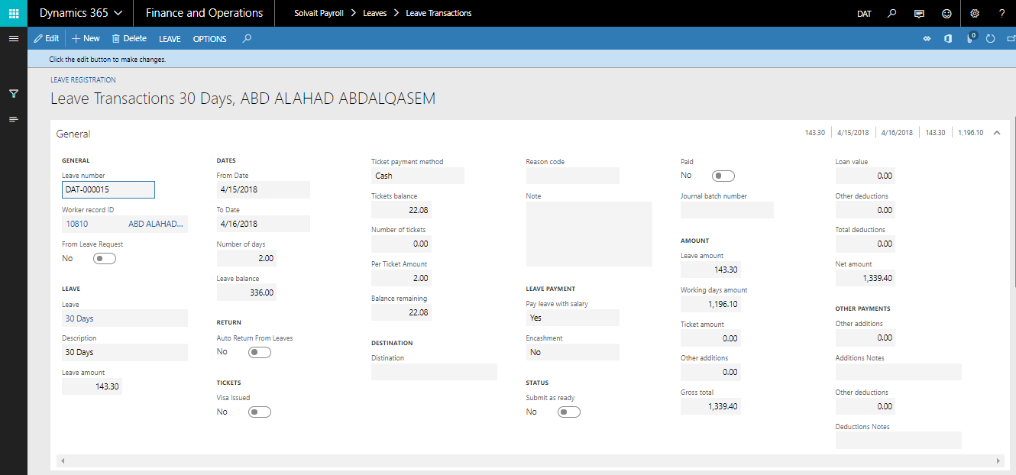

- New Leave Transaction:
Steps | Expected result
1. Click on "Solvait Payroll"  2. Click on "Leaves"  3. Click on "Leaves Transactions" link.  4.Click on "New Leave Registration" button  5. Search for the created worker or any existing worker  6. Click on New button and Fill in the required data for the leave  - Leave type  - From date  - To date  7. Click on "Calculate" button under calculate tab  8. Check the "Auto Return from Leaves" option  9. Click on "Submit as Ready" button or "Close" button | The user should be able to enter the required data for the Leave and the leave transaction should be created.  The data should be reflected correctly based on the worker's data (Ex. Leave Balance and calculations)

  - Leave return
Use this form to rejoin worker from his leave and calculate his absent days in case he come lately

Path: Solvait Payroll -> Leaves -> Leaves return registration

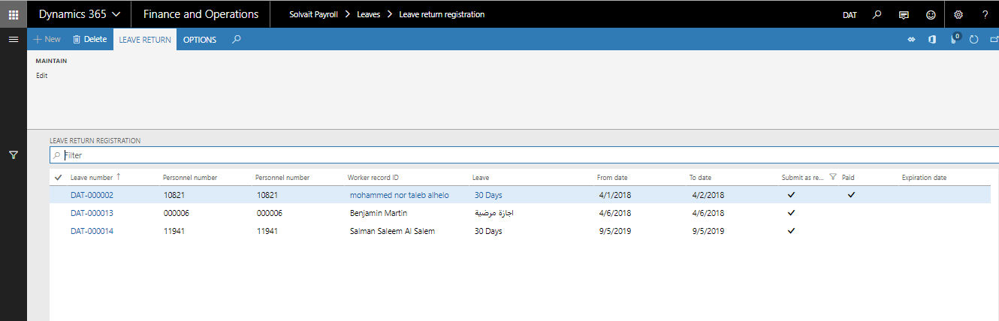

- Select the actual return date for the worker:

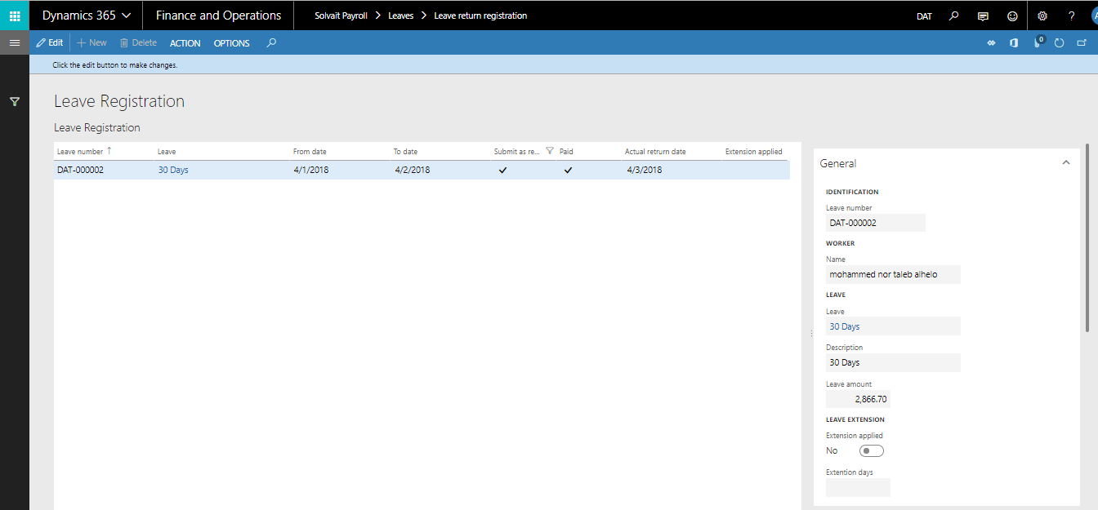

- Screen Details:
General | Worker information, leave id, reaming balance, return date, and rest of leave general information
Leave extension | In case worker come lately user have 3 option (unpaid – absent – Paid leave)
From and to date | Leave from and to dates
Submit as ready | Ready to be submitted to pay cycle
Actual return date | Specify actual return date of the leave
Paid | Paid or not paid
Extension applied | Apply extension days

- Leave return registration:
Steps | Expected result
1. Click on "Solvait Payroll"  2. Click on "Leaves"  3. Click on "Leave return registration" link.  4. Select the required line  5.Click on "Edit" button  6. Select the "Actual Return Date" date  7. Check the leave extension  8. Click on "Action" then "Post" button  9.Click on "Save" button | The worker should be able to select the return date. Moreover, the leave extension data will be filled if the return date wasn't the day after the "To date"

Loans transaction
  - Loan setup
The company can define the loan policy and check the conditions such as the amount of the permitted month or the minimum and maximum value required

Calculation: Loan definitions are defined whether the loan is a fixed value or the loan is calculated by the number of months from the basic salary and definition of the minimum deduction and the maximum and the possibility of giving the loan the existence of another loan and the possibility of not exceeding the value of the loan to reward the end of service.

Path: Solvait Payroll -> Loans -> Setup -> Loans types

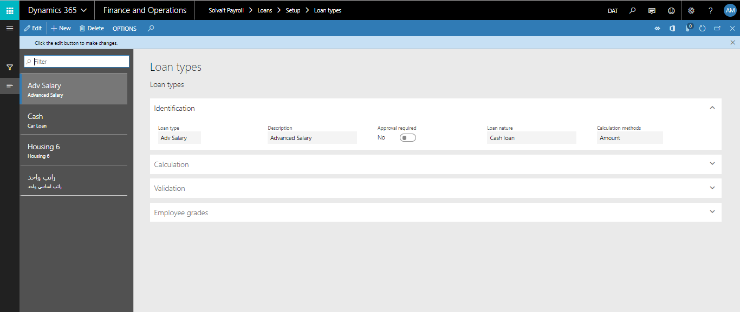

- Screen Details:
Loan Type | Define loan type, such as cars or furniture
Description | Define loan description
Calculation Method | Specify loan calculation ID
Loan payment name | Specify name
Loan nature | Specify loan nature, i.e.,
Approval required | Choose yes if manager’s approval is required for this loan type
Payment sub-cycle | Specify sub-cycle -if any-
Calculation:
Formula Multiplier | Value determined by calculation id
Calculation ID | Select calculation id, such as basic salary or basic + any allowances
Follow formula on loan amount | Option use calculation or use loans by amount
Minimum value | Minimum allowed loan value
Maximum value | Maximum allowed loan value
User can change calculated amount | Amount can be changed on loan request or now
Minimum no of months for settlement | Minimum no of months for settlement count
Maximum no of months for settlement | Maximum no of months for settlement count
Minimum settlement allowable Amount | Minimum settlement allowable Amount
Maximum settlement allowable Amount | Maximum settlement allowable Amount
Minimum percentage | Minimum percentage of loan
Maximum percentage | Maximum percentage of loan
Validation:
Is paid with leave | Deduct from vacation
Eligible from | Allowed duration
Eligible after Months | Allowed after which month from hiring
Loan start date should after loan date (In days) | Loan start date
Allow to be taken while other loans are taken from same type | Allow to be taken while other loans are taken from same type to allow check box
Allow to be taken while other loans are taken | Allow to be taken while other loans are taken to allow check box
Value should not exceed the EOS compensation | Value should not exceed the EOS compensation to apply condition
Employee grades | Add employee grades that can take this type of loan

  - Loan transaction
Worker loans form in the Payroll module represents the Advanced Payment transaction entries form in which the Payroll Administrator uses to issue an advanced payment for a Worker.

Path: Solvait Payroll -> Loans -> Loan Transaction

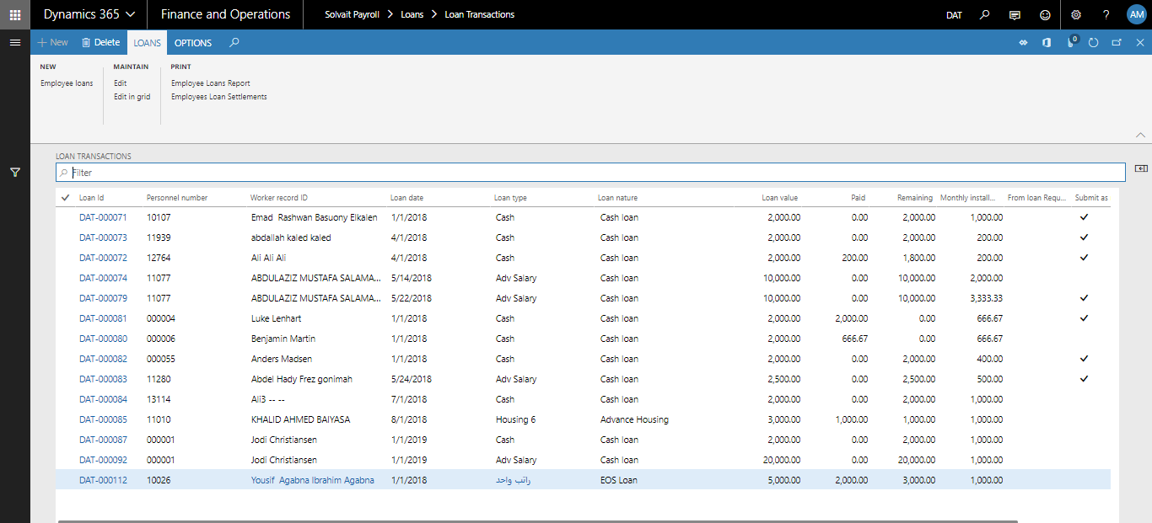

- Screen Details:
Worker ID | Select worker ID
Loan type | Select loan type predefined is setup
Loan ID | Choose loan ID
From loan Request | Will be checked automatically if it came from a loan request in SSS
Loan date | Choose loan transaction date
Deduction start date | Choose loan deduction start date
Loan value | Amount of the loan that should be paid to the Worker with fixed cycle payment in each pay cycle, this amount will be deducted from the Worker
Monthly installment | Either specify number of settlements, and monthly installment will be calculated automatically. Or specify the monthly installment and number of settlements will be calculated automatically
Number of settlement months
Remaining | Auto-calculated field that displays how much amount remained from the total value of the loan and must be deducted from the Worker
Pay loan with salary | If checked, loan will be displayed and paid in pay cycle
Submit as ready | Ready to be submitted to pay cycle
Posted | If posted means paid
Installments: will be calculated and displayed automatically after filling the above information and saving the transaction
Amount | Amount of installment
Date | Date of installment
Paid | Will be checked if loan is paid, may be paid by a previous pay cycle, cash, or by an external voucher
Paid directly | Will be checked if it was paid directly
Cancelation date | Cancellation date if installment was cancelled
Canceled by | Cancelled by who
Canceled | Check if installment was cancelled
Dimension | Dimensions will be filled in automatically

- Create new loan transaction:

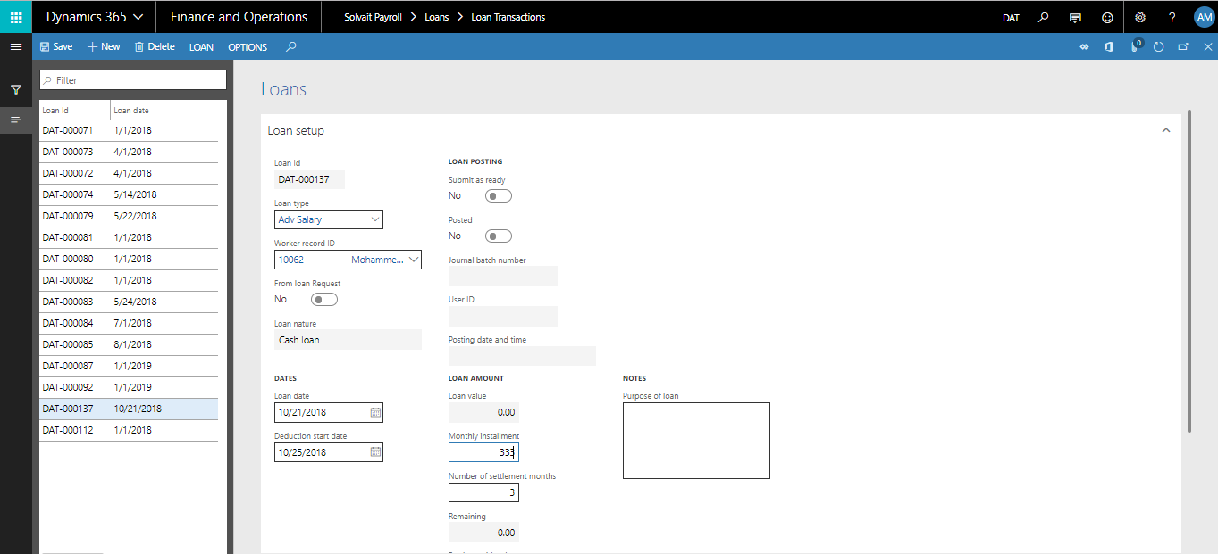

- New loan Transaction:
Steps | Expected result
1. Click on "Solvait Payroll"  2. Click on "Loan Transactions" link.  3. Click on "Employee loan" button  4. Search for the created worker or any existing worker  5. Select Loan type  6. Select Loan date  7. Select deduction start date  8. The loan value should be calculated automatically, or user can enter the loan value (based on the loan setup)  9. Enter either monthly installment or number of settlements  10. Select the pay loan with salary option  11. Click on "Loan" then "Submit as Ready" button  12. Click on "Save" button | The worker should be able to add loan and its amount should be calculated correctly.

Pay Transaction
  - Pay transaction setup
Transaction type can be defined for all irregular payment by incentive and rebate types
The types of cyclic movements can be defined for all irregular payments such as the following types:
• Incentives
• Discount
• Collection leave
• Ticketing Monthly

Bonuses:
• 3 monthly bonuses, for exhibition staff:
o Reward linked to the pledge, reward
o Target reward
o Monthly cash rewards

Business trips
• Internal:
o Food allowance of SR 30 per employee. The company is booking the hotel and flying

• External:
o Food allowance 150 SR per employee.

Path: Solvait Payroll -> Pay Transition -> Setup -> Pay Transitions types

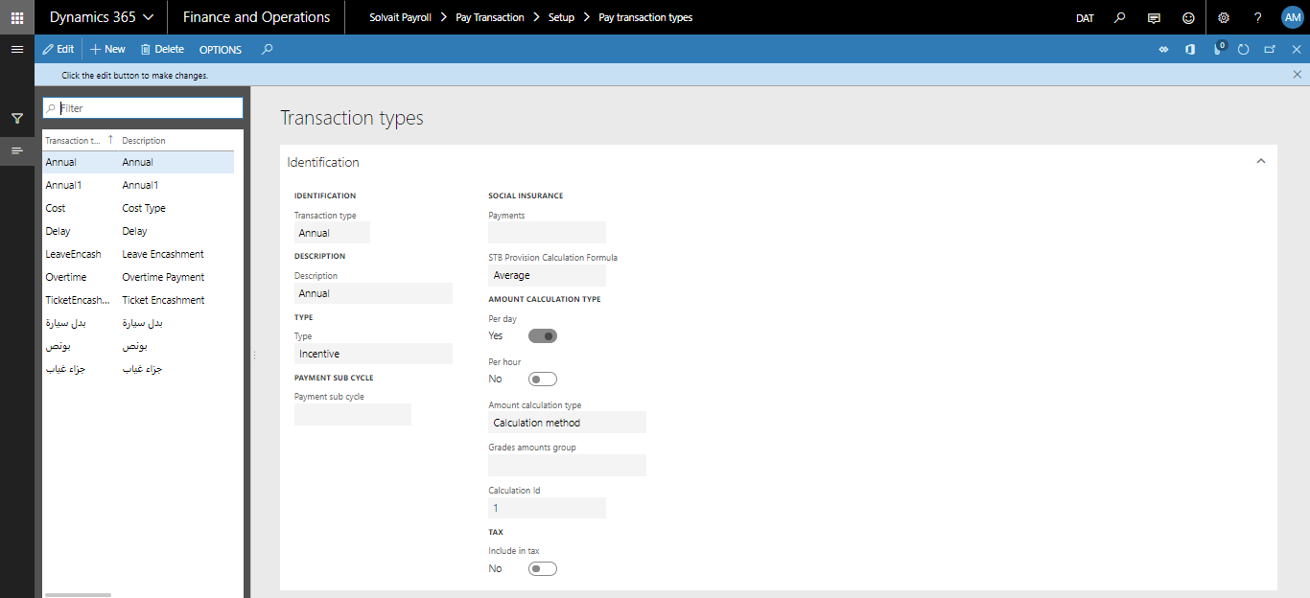

- Screen Details:
Transaction Type | Define transaction ID
Description | Define description for transaction type, such as bonus or penalty
Type | Choose type, such as incentive or rebate
Payment sub cycle | In case It’s paid on sub cycle payment
Payment group | Choose payment group
Social insurance | Social insurance of worker
Per day | Choose per day for calculation per day, such as absence
Per hour | Choose per hour for calculation per day, such as deduction per hour
Amount calculation type | Fixed amount or calculation method
Grade amount group | Follow grades amount or no
Calculation ID | Choose calculation ID for pay transaction
Include in tax | Choose with to include the pay transaction in tax or not
Displayed on SSS | Choose wither to display this type of pay transaction on SSS pay request types
Number of days | Number of days in pay transaction
Transportation facility provided | Yes, if company provides a transportation as per this transaction

  - pay transaction
Pay transactions form is used to enter irregular payments for Workers. An example of that irregular payment would be Bonus.

Once this payment is entered to that form, a payment will be generated (whether it is an increase to salary or decrease from salary) in the pay cycle after payroll is processed.

Pay transaction date specifies when this payment is to be generated.

Path: Solvait Payroll -> Pay Transition -> Setup -> Pay Transitions types

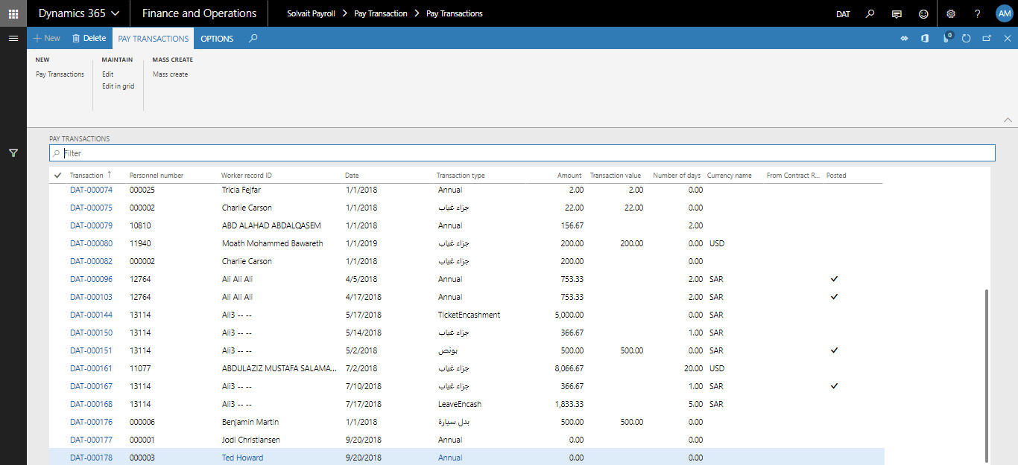

- Screen Details:
General | Worker Id which the pay transaction will be issued to
Transaction type | Type of the transactions. It must be one of the pay transactions types
Date | Choose transaction date
Include in tax | Choose wither to include tax in pay transaction or not
From leave | Yes, if pay transaction is from leave
Amount | If the Pay transactions is calculated as per the number of days, this field must be entered or amount
Number of days | Specify number of days or transaction value so that amount will be calculated automatically
Transaction value | If transaction value is specified, automatically amount will be filled with the same value
Amount | Transaction amount will be calculated automatically after specifying number of days
Posted | Posted is enabled if pay transaction is paid wither in salary on outside salary
Avoid from pay cycle | Avoid pay transaction from being entered and calculated in pay cycle
Social insurance: Payments | Worker payments of social insurance
Dimension | Amount analysis dimension
Notes | Pay transaction note

- Create new pay transaction:

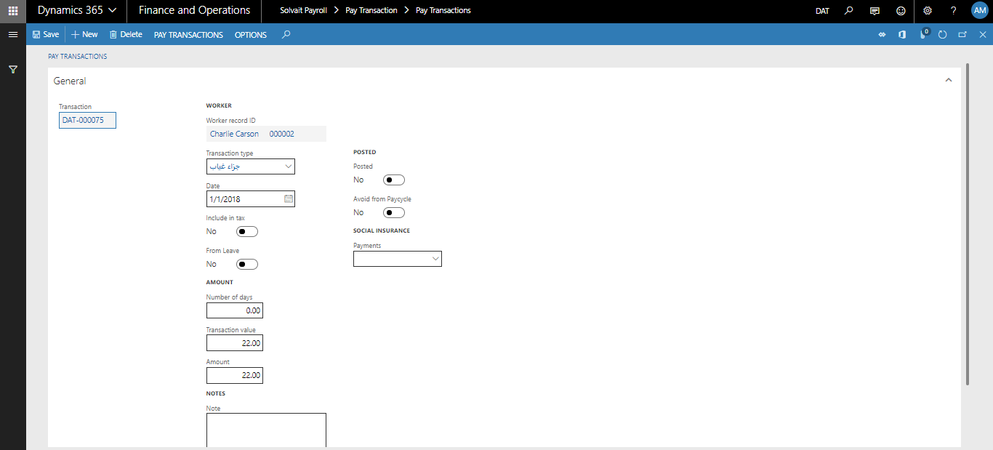

- New Pay Transaction:
Steps | Expected result
1. Click on "Solvait Payroll"  2. Click on "Pay Transactions" link.  3. Click on "Pay Transaction" button  4. Search for the created worker or any existing worker  5. Select the transaction type  6. Select the date  7. Enter the transaction value  8. Click on "Post" option  9. Click on "Save" button | The worker should be able to select the transaction type and its amount should be calculated correctly.

Overtime transaction
  - Overtime setup
Overtime types determine allowed types of overtime for workers, and how the overtime is calculated for each type.

Over Time Allowance is a non-recurring allowance that is paid for employees in Grade 2 only, based on below calculation:

Overtime Hours * 1.5 * Hourly Rate
Hourly Rate = Monthly Basic Salary / 240 Hrs. (48 hours per week).

The Basic Salary changes during the overtime assignment should be considered during the overtime amount calculation.

Path: Solvait Payroll -> Overtime -> Setup -> Overtime -> Overtime types

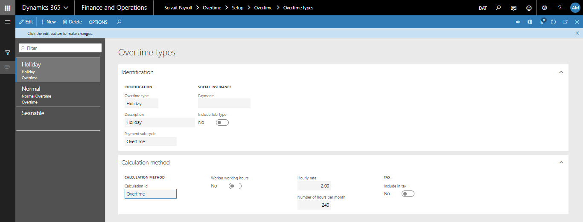

- Screen Details:
Overtime type | Code of OT type
Description | Define description
Payment sub- cycle
Calculation ID | Id of the calculated that the OT value will be based on
Social insurance: payments | Worker payment of social insurance
Is job type | Yes or no
Calculation ID | Choose calculation ID for overtime
Worker working hours | Specify number of working hours
Hourly Rate | OT hourly rate
Calculation period | Specify calculation period
Number of Hours Per month | Number of days in month multiplied by number of normal working hours
Include in tax | Tax

  - overtime Transaction
Overtime transactions form is used to enter Overtime payments for Workers.

Path: Solvait Payroll -> Overtime -> Overtime Transactions

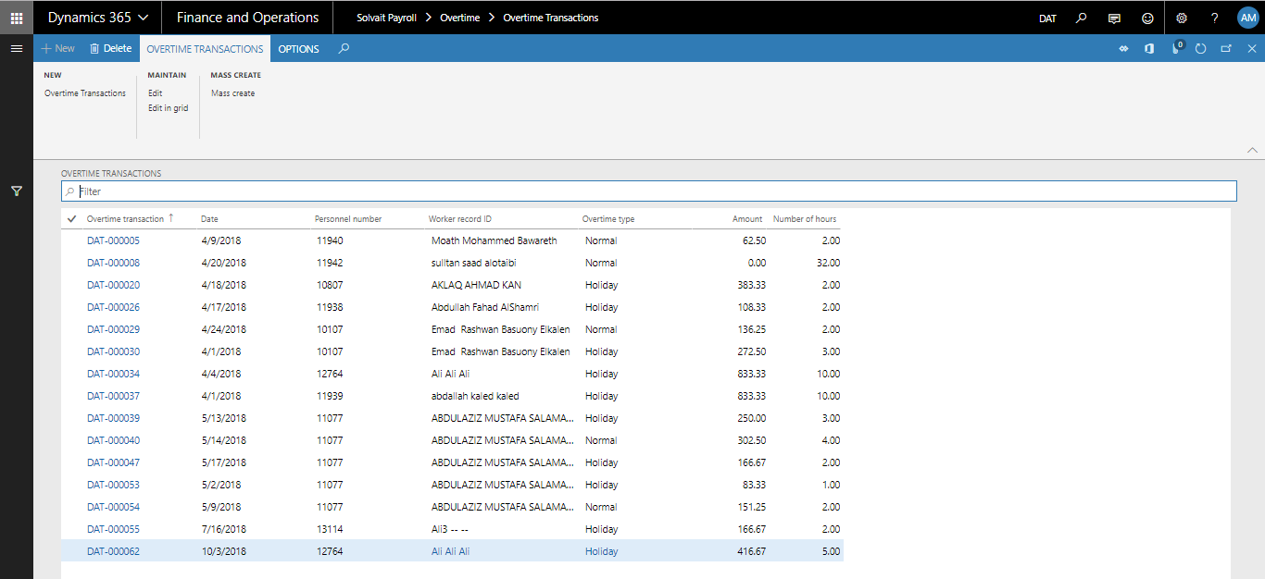

- Screen Details:
General | Select worker id
Date | Choose overtime date
Setup | Define overtime type and number of hours
Include in tax | Choose wither to include overtime in tax or not
Amount | Overtime amount according to overtime value
Dimensions | Amount analysis dimension

- Create new transaction:
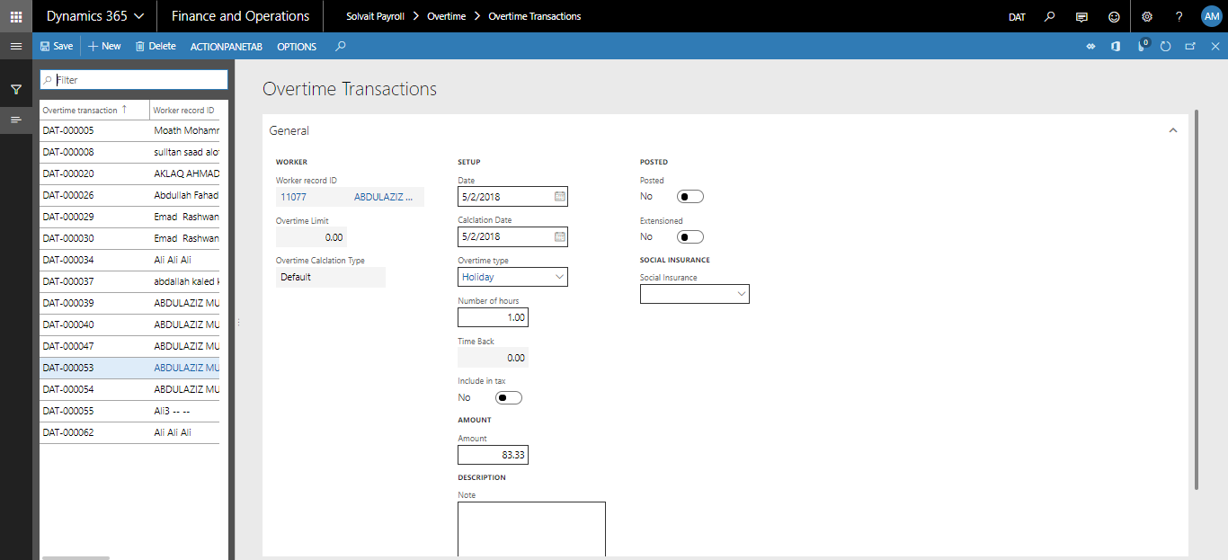

- New Overtime Transaction:
Steps | Expected result
1. Click on "Solvait Payroll"  2. Click on "Overtime Transactions" link.  3. Click on "Overtime Transaction" button  4. Search for the created worker or any existing worker  5. Select date  6. Select the calculation date  7. Select the overtime type  8. Enter number of hours  9. Click on "Post" option  10. Click on "Save" button | The worker should be able to add overtime and its amount should be calculated correctly based on the selected payment id.

End of service transaction
  - Overview
This part of the system addresses the financial values ​​of the end of service of the employees according to the multiple exit reasons, which include the following items
• Termination of worker services
• His resignation
• End of the contract
• Sickness due to

And the reasons for the end of service there will be room to choose the reason for "interruption" and the end of service value is calculated according to the type of movement and the previous period of service spent by the worker

The financial values ​​vary according to the number of years of work. For years less than five years, a half-month equivalent is calculated for each year and the following years are calculated as a bonus month for each year spent by the worker in the organization.

Note: The workflow log only works for end-of-service request and payment and all forms are handled as an attachment to the movements only
  - Setup

End of Service Calculation
Setup EOS according labor office

The EOS Will be as of Saudi Labor Law:

Period | Resignation | Termination
00-02 | 0% | (EOS=50% OF Salary)
02-05 | 33% (EOS=50% OF Salary) | (EOS=50% OF Salary)
05-10 | 66% EOS (EOS=100% OF Salary) | (EOS=100% OF EOS Salary)
10-XX | 100% of EOS Salary | (EOS=100% OF EOS Salary)

Path: Solvait Payroll -> End of service -> Setup -> EOS calculations

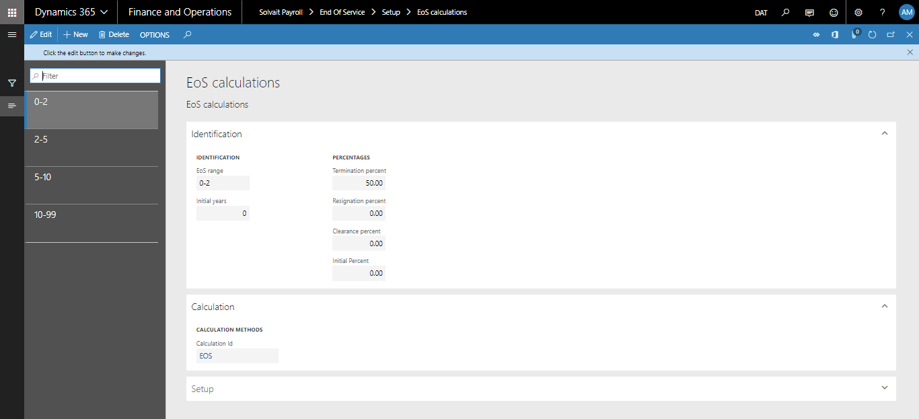

- Screen Details:
EOS Range | EOS Range ID
Initial years
Termination percent | Percentage of amount that will be paid to a terminated Worker
Resignation percent | Percentage of amount that will be paid to a resigned Worker
Clearance Percent | Percentage of amount that will be paid to a Worker in case of clearance
Initial percent
Calculation Id | The default calculation method that will be used to calculate the amount in this range in case the EOS Calculation Id is not specified in the Worker contract
Setup:  Minimum years | Specify minimum years
Maximum years | Specify maximum years
Cancel previous ranges | Checked if cancelled

End of Service Reasons
Reasons of end of service and their description can be defined in this window.

  - End of service transactions
This form is used to enter an EOS transaction for a Worker. EOS could be one of these types:
1. Termination
2. Resignation
3. End of Contract
4. Clearance
5. Termination with cause
For each type and depending on the number of working days for that Worker… the compensation amount will be specified based on the End of Service setup

Path: Solvait Payroll -> End of service -> End of services

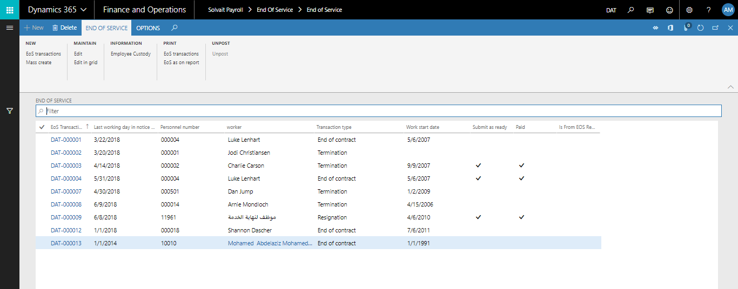

- Screen Details:
EOS Transaction | Auto-generated number for the EOS transaction
Worker | Worker Id which the pay transaction will be issued to
Transaction type | EOS Transaction Type  01- Termination  02- Resignation  03- End of Contract  04- Clearance  05- Termination with cause
Date | Last working date
Reason | Select reason of predefined reasons in setup
Last working day before notice period | Date of last working day before notice period
Last working day in notice period | Date of last working day before notice period
From EoS request | Will be checked if transaction created from EoS request on SSS
Period:  Work start date | Worker work start date
Unpaid leave | Amount of unpaid leave
Absence leave | Amount of absence leave
Resumption days | Number of resumption days
Gross days, months, and years | Will be calculated automatically
Net days, months, and years | Will be calculated automatically
Compensation | For each type and depending on the number of working days for that Worker… the compensation amount will be specified based on the End of Service setup described in 2.8 in this document.
Working days | Auto-calculated field displays the number of working days
Working months | Auto-calculated field displays the number of working months
Working years | Auto-calculated field displays the number of working years
Ticket payment method | From contract
Compensation | Amount of EoS compensation
Unpaid salaries | Auto-calculated field displays the unpaid salaries (if any) for the Worker
Reason of Unpaid Salary | Specify reason of Unpaid Salary
Number of days before notice period | Specify number of days before notice period
Unpaid last working days | Specify unpaid last working days
Notice period number of days | Specify notice period number of days
Unpaid notice period | Specify unpaid notice period
Leave days | Number of leave days
Unpaid tickets | Auto-calculated field displays the unpaid tickets (if any) for the Worker
Unpaid tickets amount | Specify unpaid tickets amount
Unpaid leaves | Auto-calculated field displays the unpaid leaves (if any) for the Worker
Unpaid loans | Auto-calculated field displays the unpaid loans (if any) from the Worker
Housing allowance | Auto-calculated field displays the unpaid Housing allowance (if any) for the Worker
Other allowances: Amount | Amount given to a Worker as an award by the company
Other allowances: Description | Description of the other allowances
Other deductions: Amount | Amount deducted from the Worker
Other deductions: Descriptions | Description of the other deductions
Total compensation | Auto-calculated field to display the total of payment that should the Worker take as a compensation of his duty in the company
Submit as ready | Ready to be submitted to pay cycle
Paid | Checked if paid
Journal patch number | Journal patch number if paid outside salary
Working days calculation:  From and to date | Leaves dates
Number of days | Leaves number of days
Cycle payment types | Cycle payment types specified
Working days transaction types | Such as last working days
Payment description | Such as basic salary
Amount | Amount of leave
Accrual | Accrual amount
EoS compensation calculation:
Leave days calculation | Leave calculation in compensation
Loan calculation | Loan calculation in compensation

- Create new transaction:

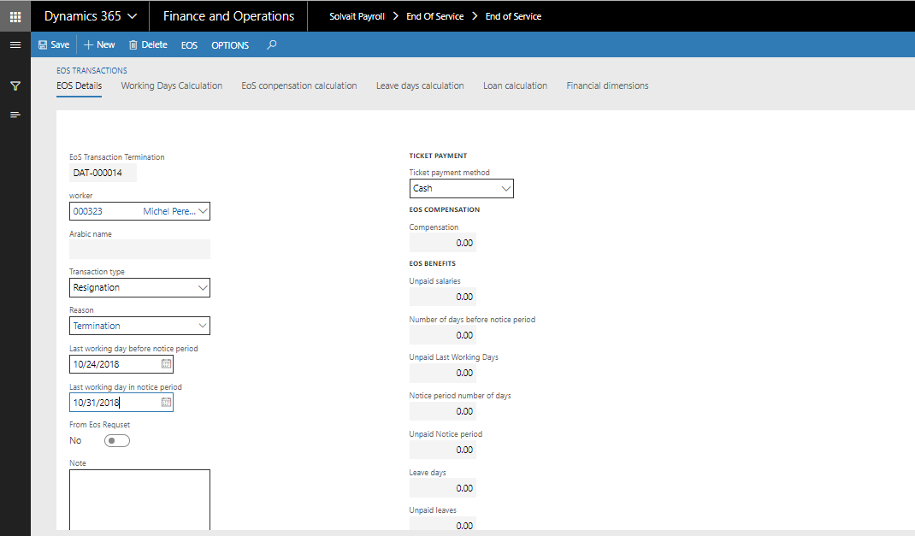

- New EOS Transaction:
Steps | Expected result
1. Click on "Solvait Payroll"  2. Click on "EOS Transactions" link.  3. Click on "EOS Transaction" button  4. Search for the created worker or any existing worker  5. Select transaction type  6. Select reason  7. Select last working day before notice period  8. Select last working day in notice period  9. Click on "Calculate" button  10. Check the calculations:  - Working days calculation  - EOS compensation calculation  - Leave days calculation  - Loan calculation  11. Click on "Save" button | The worker should be able to add EOS and its amount should be calculated correctly.

  - End of Service Clearance

After approving end of service request, a new end of service clearance transaction will be created to be go through workflow as well.

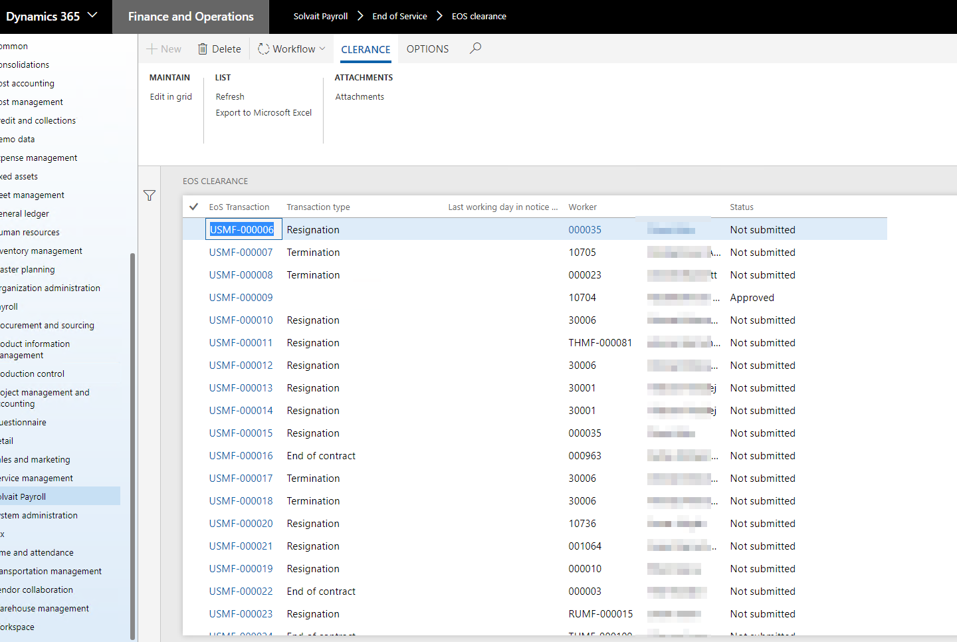

Pay Cycle
  - Overview
The following flow chart will explain how Client HR team will generate the monthly payroll up to posting the pay cycle by finance

  - Pay cycle setup

Calculation methods
Calculation Methods specifies different ways of calculating an amount. Many payments in the Dynamics AX Payroll are referring to the Calculation Methods to calculate an amount for a Worker.
For example, amounts of leaves are calculated based on a calculation method which specifies Basic Salary and Housing Allowance as part of Leave Calculation Method.
In calculation method, Payroll Administrator will specify the components of a calculation method and the percentage of that payment.
Path: Solvait Payroll -> Setup -> Calculations -> calculation methods
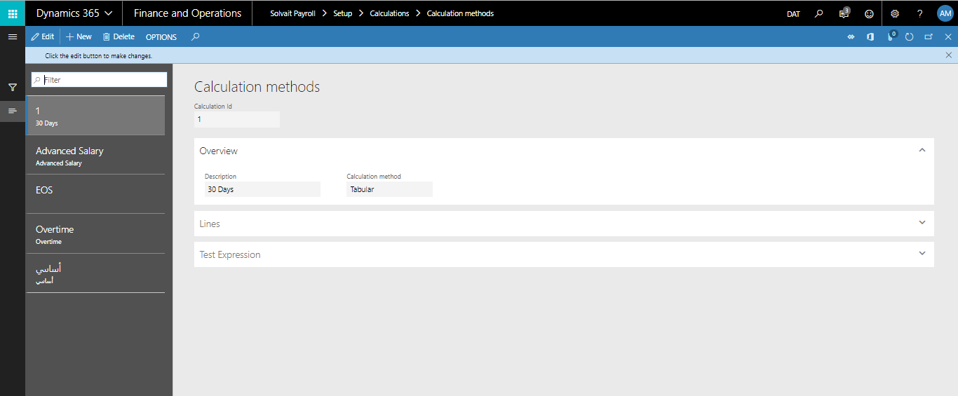

- Screen Details:
Calculation ID | Define calculation id and better to make it alphabetic because all forms lockup to id only and you can take brief from name without login details
Description | Describe the full description for calculation id
Expression | Insert all formula items from operands
Validate | Check formula errors
Pad | Pad calculator
Operands | All company benefits, such as basic and Allowances
Test Expression | This icon for formula testing only
Worker | Select the worker to test the formula
Result | Formula result and formula topics
Evaluated expression | The formula result for example formula is (Basic + Housing) so the result will be worker benefit (3000+750) = (total value)

Allowances and Deductions
User can Define all company allowances and deductions and cost list for example
  - Allowances, such as Housing –Transportation – Food – Telecom – Education
  - Cost, such as Medical insurance – IQAMAT – Fixed government expenses
  - Deduction, such as any fixed deduction deducted monthly from employee

Path: Solvait Payroll -> Contract -> Setup -> Allowances and deductions -> Allowances and deductions.

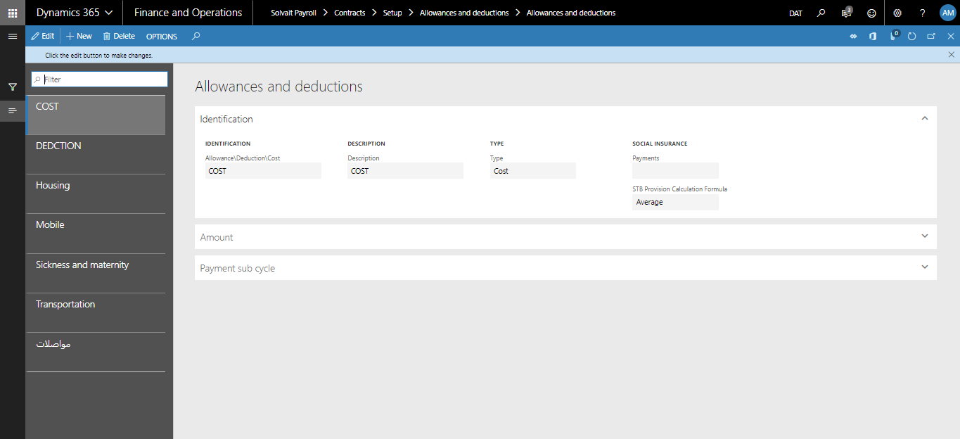

- Screen Details:
Allowances/Deduction/Cost | Define allowances/deduction/cost (ID)
Description | Describe allowances/deduction/cost id description
Type | Select one type from (allowance / Deduction / cost)
Social insurance | (For others regions out of kingdom)
Amount –On salary grade | Select check box to link allowance by company grades
Amount | Fixed Amount
Amount per day | If worker absent this allowance will affected or no
Currency | Select allowance currency
Payment sub cycle –calculated with salary | Select check box If allowance calculated with salary
Payment sub cycle | Select sub cycle id if company will pay allowance on separate sub cycle

Pay groups
User can record all company pay group list for example user can define groups by the following topics
          - Payment method
          - By nationality (foreign /citizen)
          - Workers by projects

Path: Solvait Payroll -> Setup -> Pay group -> Pay group

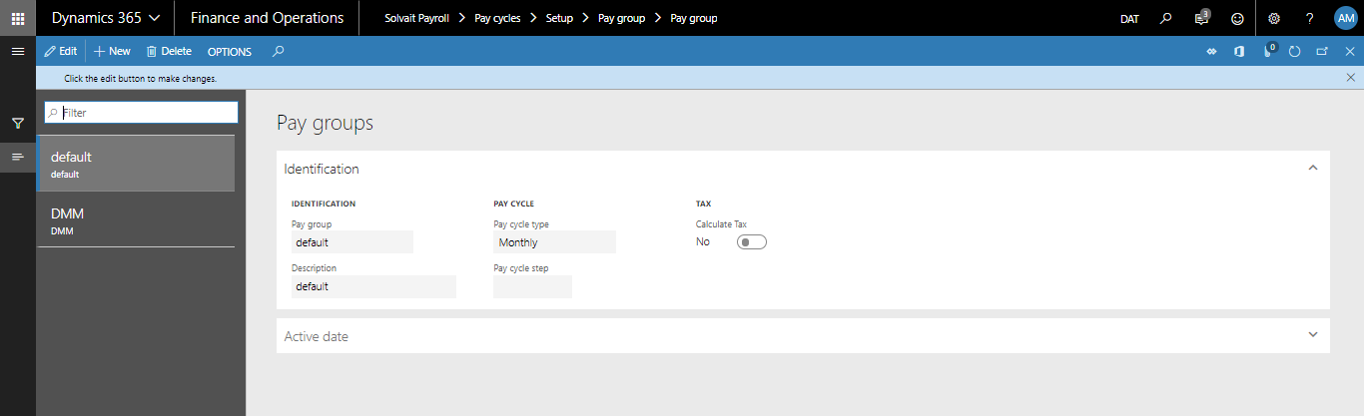

- Screen Details:
Pay group | Define pay group id and better to make it alphabetic because all forms lockup to id only and you can take brief from name without login details
Description | Define pay group id by full details, such as Bank or Cash group or all employee group
Pay cycle type | Monthly or daily or weekly
Calculate tax | For tax calculation and it’s not used on Saudi
Active date | Cycle date
Pay calendar | Calendar cut off

Payment sub cycle
Company can generate sub pay cycle for irregular payment, such as bonus or commissions or over time

Path: Solvait Payroll -> Setup -> Pay group -> Payment sub cycles

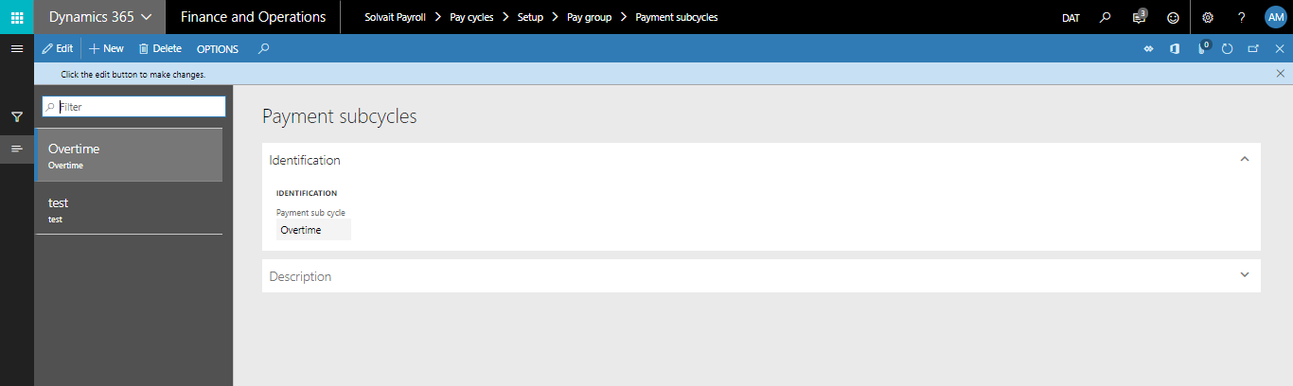

- Screen Details:
Payment sub cycle | Define payment sub cycle id and better to make it alphabetic because all forms lockup to id only and you can take brief from name without login details
Description | Define payment sub cycle id by full details, such as bonus sub cycle

Cutoff days
User can define company monthly cut-off

    - Cut-off Date is well known to HR & Payroll employees. It describes when to start calculating transactions in the month and when to stop/end.

Path: Solvait Payroll -> Setup -> Pay group -> Cut-off dates

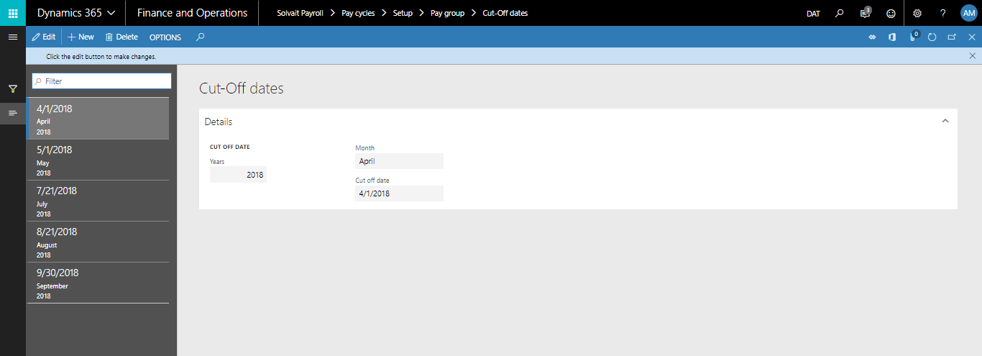

- Screen Details:
Cutoff date | Record company monthly cut off form example (25-01-2013)
Month | Select cycle month
Year | Current year or previous year for history data

Posting profile
Mapping of all payment’s types with the ledger accounts in the Chart of Accounts.

For more details about the automatic posting is described in the last section of this document: Posting to Ledger.

Path: Solvait Payroll -> Setup -> Posting profile

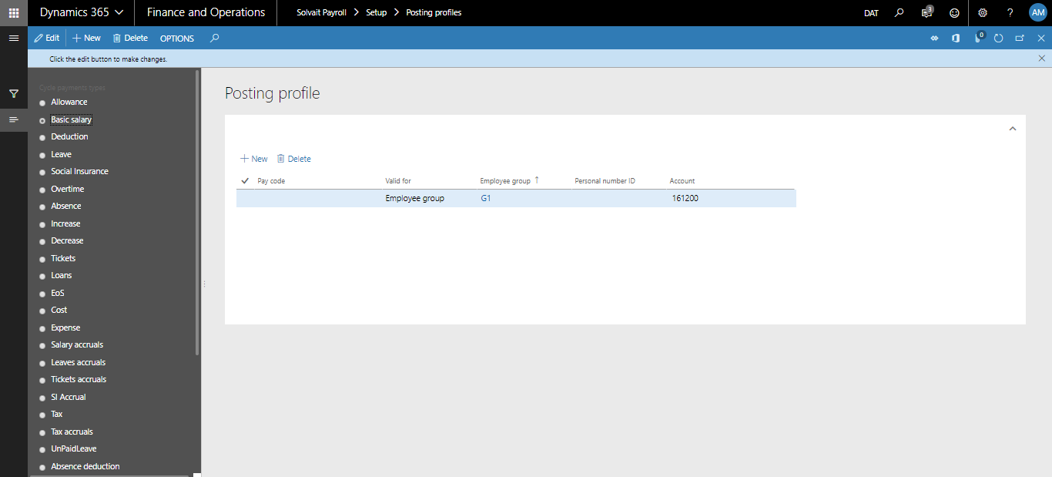

- Screen Details:
Payment type | Type of payment that will be posted to Ledger.
Pay code | If that payment type is divided into sub types. Such as in case of Allowances, pay code would be types of those allowances, such as the Housing Allowance.
Valid for | Whether this ledger account is specified for All Workers, a Worker, or a particular Pay Group
Pay group | Pay group
Worker | Worker name
Ledger Account | Will be used when that payment is posted to the ledger

  - Pay Cycle processing

Generate Payment
This form generates the payment for the selected Pay group. What this form does is that it creates a new Pay Cycle and then loops through the active Workers contracts tagged with the selected pay group. By looping through Workers, payments are collected from the different payroll setup forms and payroll transactions forms that are eligible for the selected Workers within the generated Pay Cycle.

Path: Solvait Payroll -> Pay Cycles-> Pay Cycles-> Pay Cycles-> Generate Payments

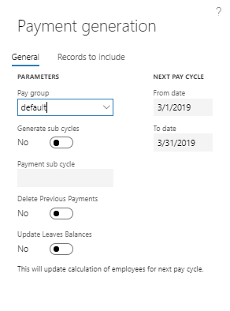

- Screen Details:
Pay group | Pay Cycle will be generated specifically for the selected pay group
Generate sub cycles | If checked then a sub-cycle must be selected in order to generate its payment and not to generate the main/salaries pay cycle
From date | Auto-calculated field that specifies the starting date of the pay cycle
To date | Auto-calculated field that specifies the ending date of the pay cycle
Generate button | When clicked, the form will start generating the payments as described above

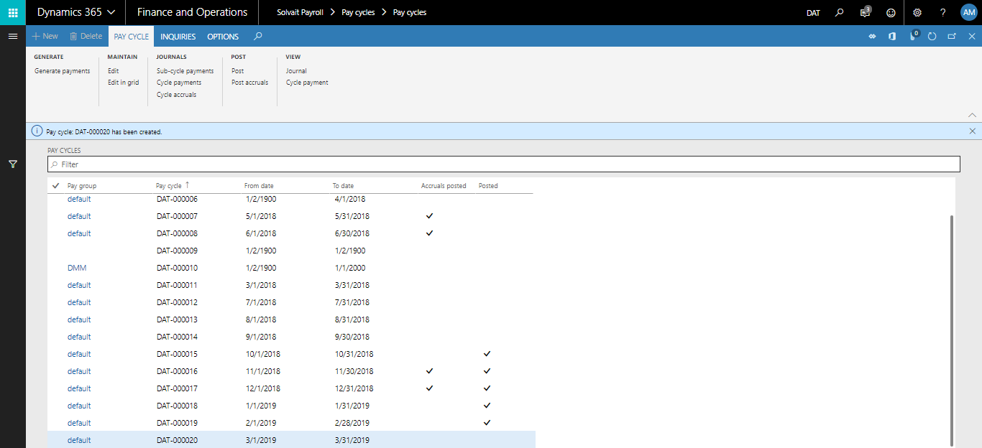

- Generate Pay Cycle
Steps | Expected result
1. Click on "Solvait Payroll"  2. Click on "Pay Cycles" link.  3. Click on "Generate Payments" button  4. Select "Pay Group"  5. You can filter for specific worker from the worker query  6. Click on "Ok" button  7. The pay cycle will be generated  8. Click on "Cycle Payments" button | Pay cycle should be created with all earnings and deductions for all employees

Pay Cycle
This form contains the auto-generated pay cycles by the Generate Payment. Also, it contains a summary about the data generated, such as number of Workers and total number of payments.

Path: Solvait Payroll -> Pay Cycles-> Pay Cycles (second link)

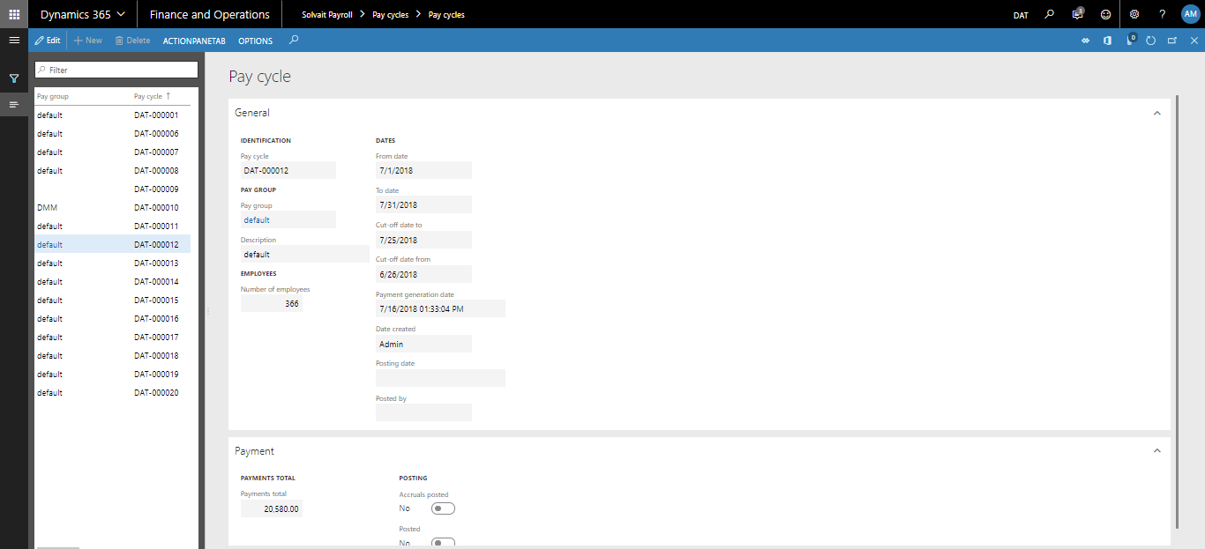

- Screen Details:
Pay cycle | Auto-generated pay cycle number (unique number)
Pay group | Pay group of the pay cycle
Description | Description of the pay group
Number of Workers | Number of Workers processed by the current Pay Cycle
From date | Starting date of the Pay cycle
To date | Ending date of the Pay cycle
Payment generation date | Logging data that shows the date and time of the pay cycle generation
Posting date | Logging data that shows the date and time of the pay cycle posting to ledger
Amount | Total amount of pay cycle
Accruals posted | Whether the accruals have been posted for this Pay cycle or not

Cycle payment
This form contains the payments details of the generated Pay Cycle.

Path: Solvait Payroll -> Pay Cycles-> Pay Cycles-> Journals-> Cycle Payments

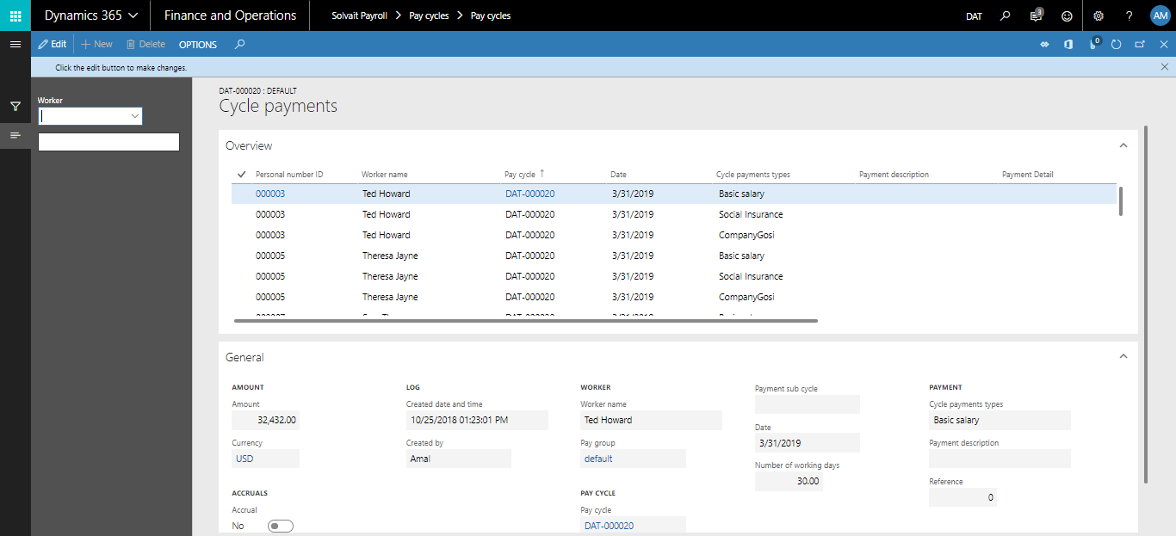

- Screen Details:
Workers | Worker Id
Worker Name | Worker Name
Pay Cycle | Pay Cycle Id
Date | Transaction date
Cycle Payment Types | Values:  - Basic Salary  - Allowance  - Housing  - Transportation  - Mobile  - Food  - Other allowances  - Deduction  - Overtime  - Absence  - Increase  - Decrease  - GOSI
Payment details | Contains sub types of payments types, such as Housing allowance and Leave transaction
Amount | Payment Amount
Currency | Currency of payment
Accruals | If this amount is an accrual payment
Posted | If this payment is posted to ledger or not

Accruals
This form contains the accruals payment for each month.

Path: Solvait Payroll -> Pay Cycles-> Pay Cycles-> Journals-> Cycle Accruals

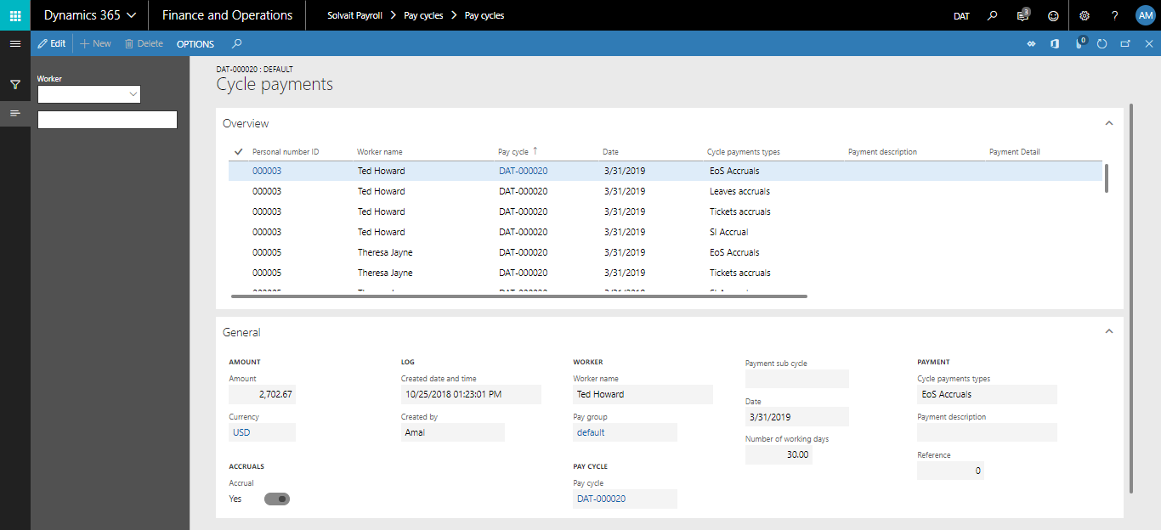

- Screen Details:
Cycle Payment Types | Values:  - Leave Accruals  - GOSI Accruals  - EOS Accruals  - Ticket Accruals

Post to ledger
After ensuring that the payroll processing results is correct, the last step to close that period is to post payments to ledger. Before this stage, any payroll transaction on “an open period” could be changed or deleted. Pay cycle even could be re-generated if it is not posted to ledger.

Posting to ledger can be made in different ways. The usual scenario is when the Payroll Administrator prepares his payments through Payment Generation form, then after ensuring that data is correct, he simply clicks Post to Ledger button on the Pay Cycles form. This will move the payments into one Payroll Journal with multi-lines of transactions. Each line would represent one payment.

Another scenario would be through Settlement Voucher form. Settlement Voucher allows you to post one or one payments only to the ledger without the need to post other payments. For example, if the Payroll Administrator needs to pay a Worker his Housing Allowance or an Advanced Payment… then he would do that with the Settlement Voucher form.

Ledger accounts used internally in the Payroll Journal to post the posted Payroll payments are configured in the Payroll Posting Profile described earlier.
The following section will describe in greater details the forms used to complete this step, which are:
1. Pay cycle – Posting to Ledger
2. Settlement Voucher
3. Payroll Journal

Payroll Journal that is generated automatically by the system is expected to be, such as the following:

Payment Type | Debit | Credit | Account
Basic Salary | 10,000 |  | Depts. Expenses Accounts-Basic
Housing | 2500 |  | Depts. Expenses Accounts-Housing
Mobile | 500 |  | Depts. Expenses Accounts-Mobile
Transportation | 1,000 |  | Expenses Accounts-Transportation
Loan Deduction |  | 1000 | Employee Loans
Absent punishment |  | 300 | Other revenue
GOSI deduction |  | 1125 | GOSI deduction
Total |  | 11,575 | Salary Accruals

This diagram shows the process flow of the Posting to Ledger step by finance team:

Client will post salary cycle by details with the dimensions as listed in the employee master file.

Path: Solvait Payroll -> Pay Cycles -> Pay Cycles
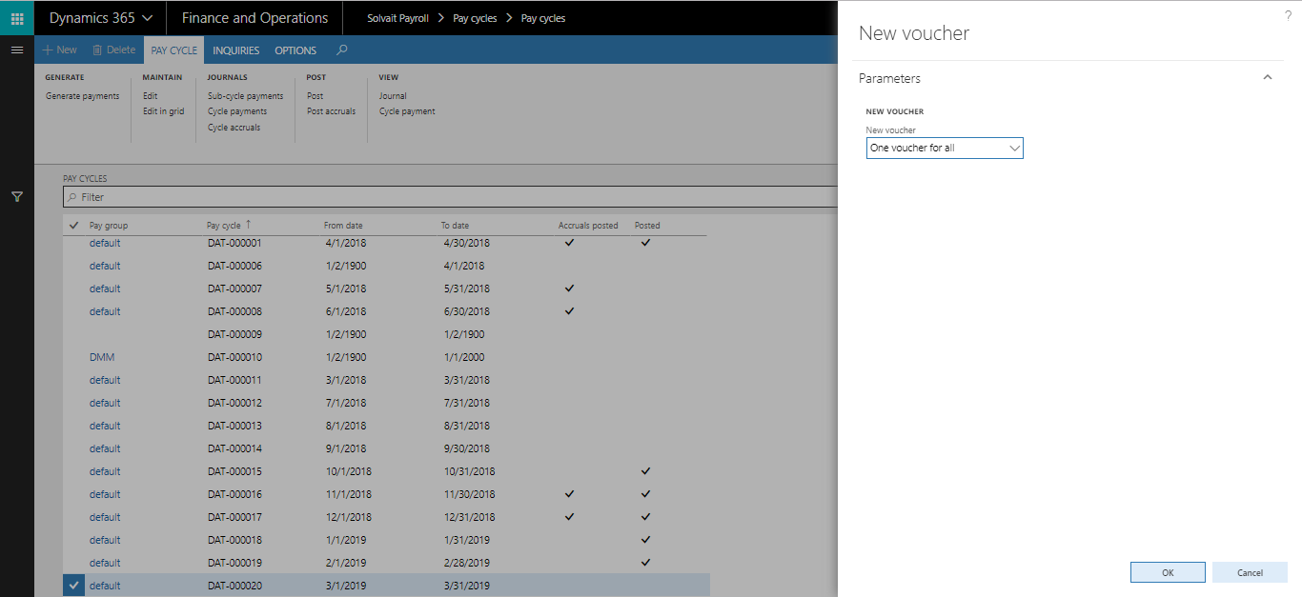

- Post Pay Cycle:
Steps | Expected result
1. Click on "Solvait Payroll"  2. Click on "Pay Cycles" link.  3. Click on any generated pay cycle  4. Click on "Post" button | The Pay Cycle should be posted to Journal and the Post checkbox should be checked

Pay Accruals
After finishing pay cycle posting to general ledger company can pay salary accruals for each worker according to their payment method cash or bank
Path: Solvait Payroll -> Pay Cycles -> Pay Accrual
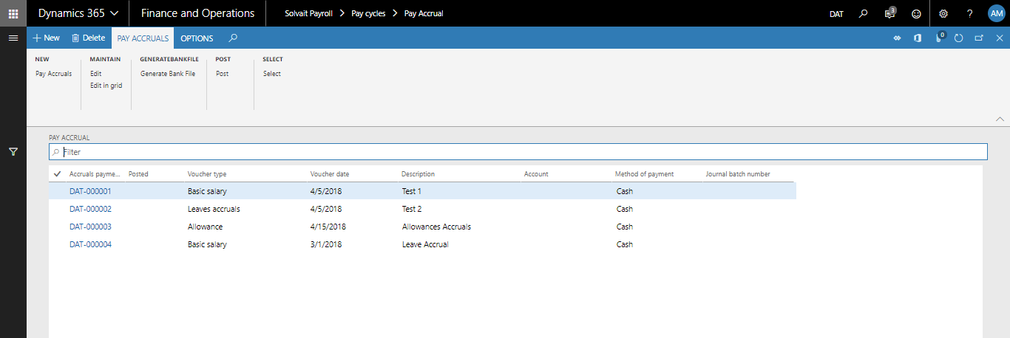

- Screen Details:
Payment | Select voucher type for example salary accruals and then select the method of payment cash/bank then system will filter according to method of payment from new form cycle details you select one worker or all worker on same method of payment
Payment Lines | Will include cycle details, such as basic salary allowances and deduction from salary GOSI and loans and other deductions, such as absent punishment

Payroll Journal

Path: Solvait Payroll -> Journals -> Payroll Journals

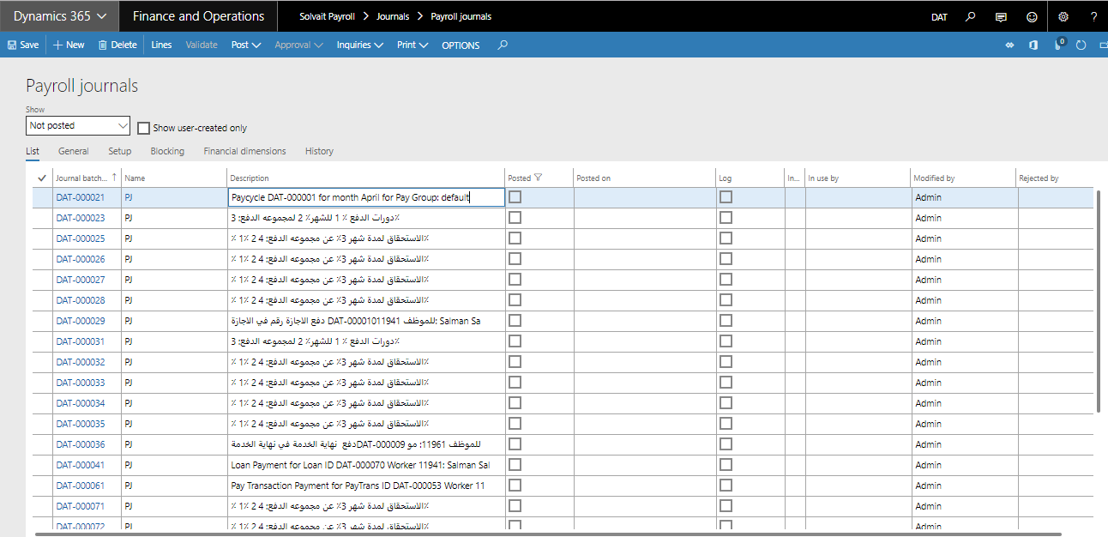

Payroll Journal - Loan

Path: Solvait Payroll -> Journals -> Payroll Journals

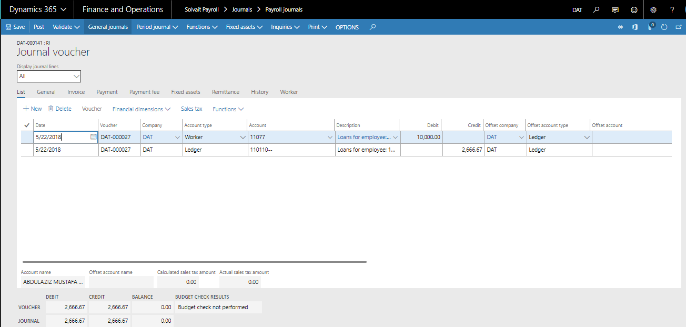

  - Pay cycle inquires

Pay slip
The following pay slip explain the worker pay slip details according to his cycle payment

Path: Solvait payroll -> Pay Cycles -> Pay Cycles Report -> Pay slip

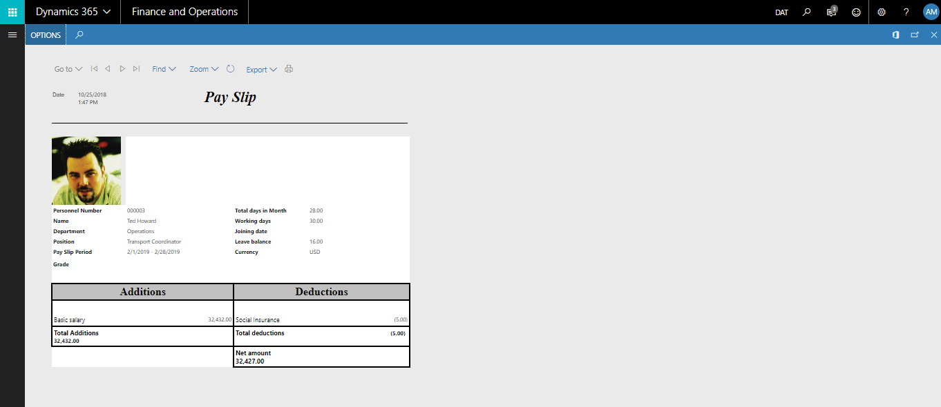

- Screen Details:
Basic Information | Worker name and position and department and working days and joining date and leave balance
Addition | Basic + allowances + overtime + others
Deduction | Loans +GOSI – punishment

- Generate Pay Slip Report:
Steps | Expected result
1. Click on "Solvait Payroll"  2. Click on "Pay Cycles Reports" link  3. Click on "Pay Slip" link.  4. Enter Pay cycle number  5. You can filter for specific worker  6. Click on "Ok" button | If you filter for specific worker, the pay slip will be generated only for the selected user. Otherwise, the pay slip will be generated for all workers in the selected pay cycle

Detailed payroll Report
The following report explain all additions and deduction for all worker on one sheet and we can filter according to any type, such as department or position or nationality or employee group or dimension

Path: Solvait payroll -> Pay Cycles -> Pay Cycles Report -> Detailed Payroll report

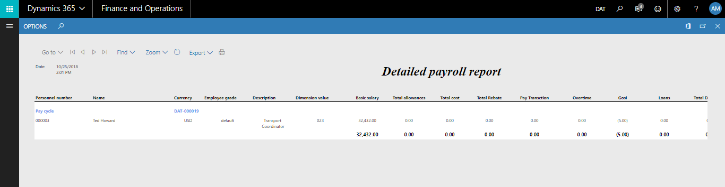

- Screen Details:
Basic Information | Worker name and position and department and working days and joining date and leave balance
Benefits | Basic + allowances + overtime + others
Deduction | Loans +GOSI – punishment
GAP | NCA layout and style of the report

- Generate Detailed Payroll report:
Steps | Expected result
1. Click on "Solvait Payroll"  2. Click on "Pay Cycles Reports" link  3. Click on "Detailed Payroll report" link.  4. Enter Pay cycle number  5. You can filter for specific worker  6. Click on "Ok" button | If you filter for specific worker, the report will be generated only for the selected user. Otherwise, the report will be generated for all workers in the selected pay cycle

Salary Bank
The following report explain all additions and deduction for all worker on one sheet and we can filter according to any type, such as department or position or nationality or employee group or dimension

Path: Solvait payroll -> Pay Cycles -> Pay Cycles Report -> Detailed Payroll report

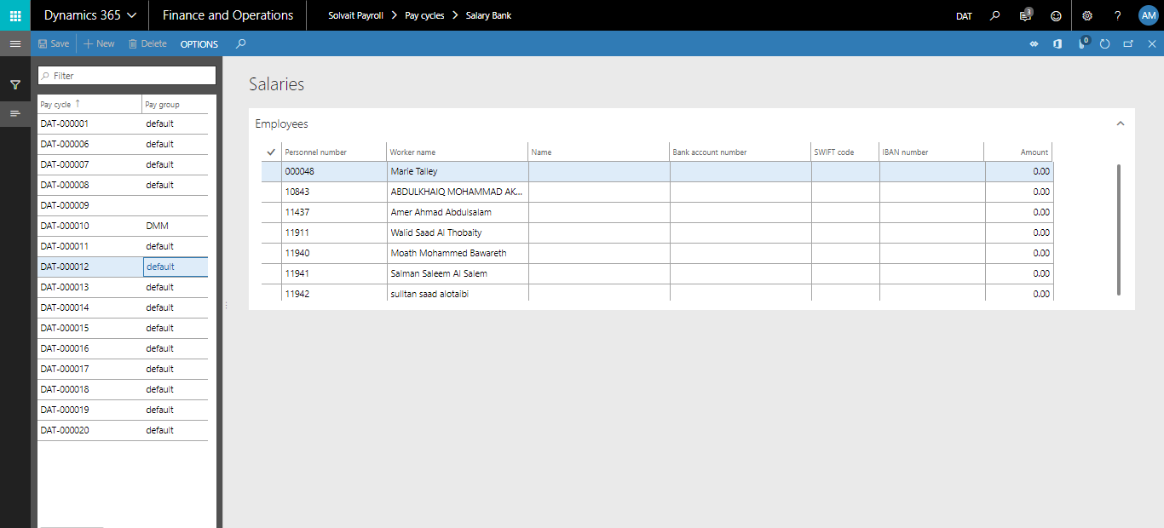

- Screen Details:
Pay cycle | Pay cycle code
Identification | Personal number and worker name
Bank details | Bank account number and bank group
Amount | Total monthly salary
GAP | NCA layout and style of the report. Not a layout, rather sequence of columns and values of those columns. In fact, this is a screen, not a report.

- Generate Salary Bank report:
Steps | Expected result
1. Click on "Solvait Payroll"  2. Click on "Pay Cycles" link.  3. Click on "Salary Bank" link.  4. Select the generated Pay Cycle | The detailed payment transactions (bank account, IBAN, amount etc.) for the workers will display based on the selected pay cycle

Attendance Management
  - Attendance Parameters
    - Defaults

Path: Solvait Payroll -> Setup -> Parameters -> Attendance parameters -> Defaults

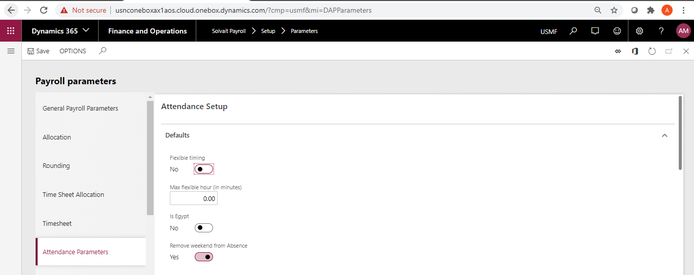

- Deduct all flexible:
  - This will enforce the system to deduct all minutes with flexible hours in case the worker came late to the worker even after the flexible hours.
- Flexible timing:
  - This option will allow to have flexible hours for the whole company.
  - The flexible timing will be calculated based on the “Max flexible hour”
    - If the worker came during the flexible hours, then no deduction will be applied for the worker

  - Attendance and Absence
    - Employee Calendar
      - Calendar

Path: Solvait Payroll -> Time and attendance -> Setup -> Attendance and absence -> Employees calendar -> Calendars

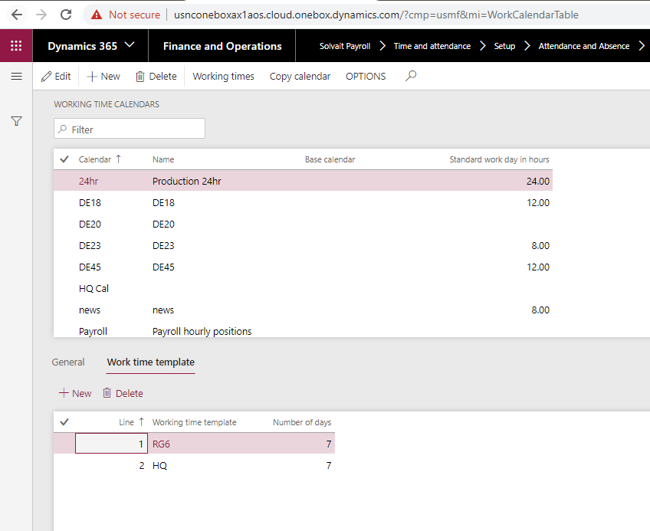

- This screen defines the calendar in the company
- The calendar must be assigned to the worker in order to display records for the worker in the attendance form.

      - Working Time Template

Path: Solvait Payroll -> Time and attendance -> Setup -> Attendance and absence -> Employees calendar -> Working time template

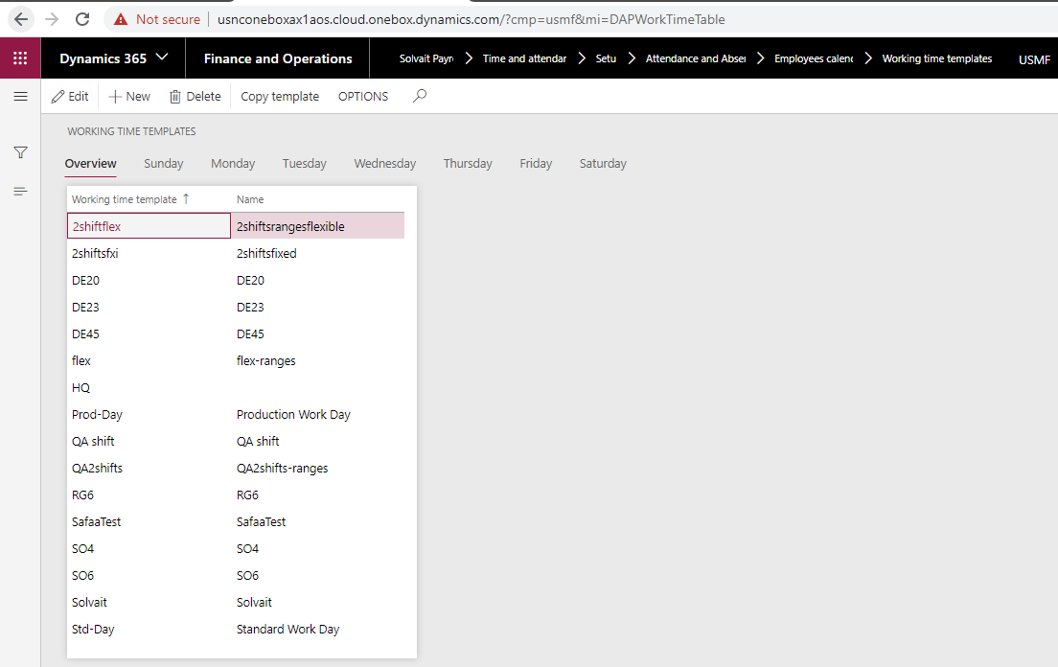

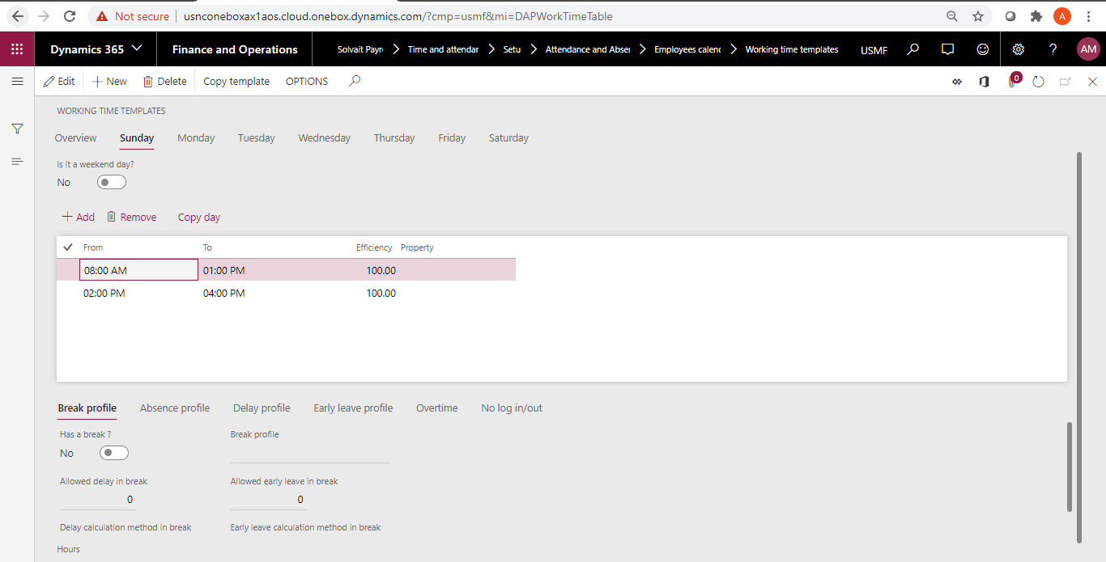

- This screen defines the working time for the shift day by day
- The attendance profile should be added day by day as each company has its own setup for each day
- If the profile was not filled in any day, then the attendance calculation will not be calculated for that day
- The attendance calculations will be based on the shift hours for each day
- The Overtime profile should be filled on weekend to allow the system calculated the attendance calculations on weekends and holiday if it came during the weekend
- When you have one shift per day, just enter the start time and end time of the working day
- When you have two shifts per day:
  - Enter two shifts indicating the start and end time for each shift
  - The break profile can be defined in the break section if the company have penalties for the break
  - You cannot define the break profile in case the company have no penalties for the break
- The system will display an information message to the worker to identify on which days the profile wasn’t defined for.

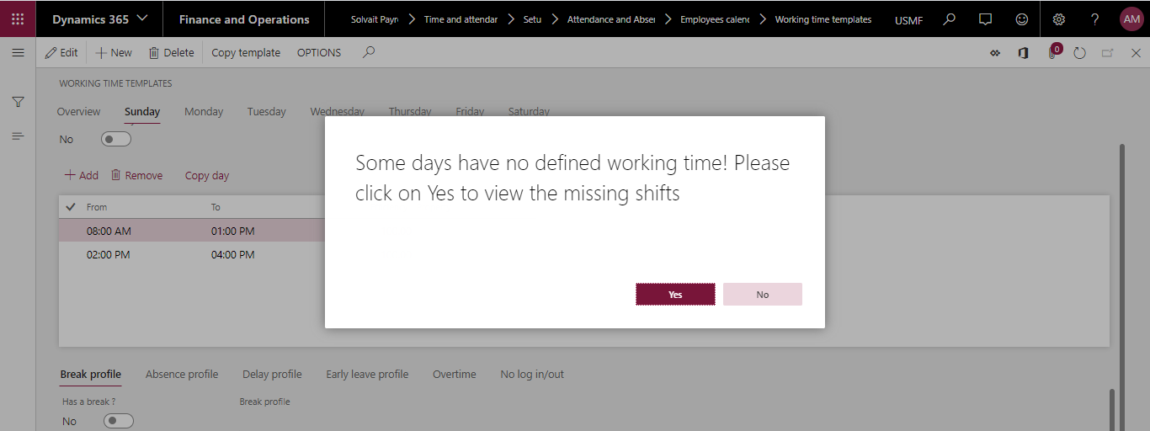

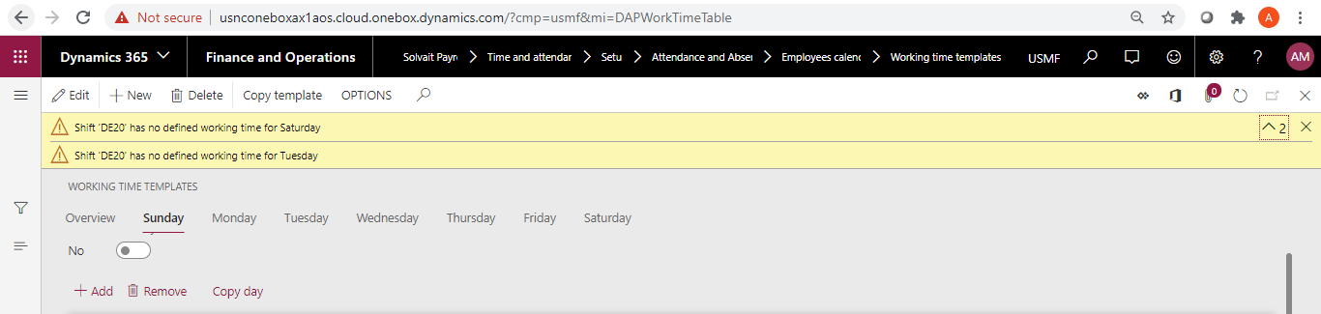

      - Attendance plan

Path: Solvait Payroll -> Time and attendance -> Setup -> Attendance and absence -> Employees calendar -> Attendance plan

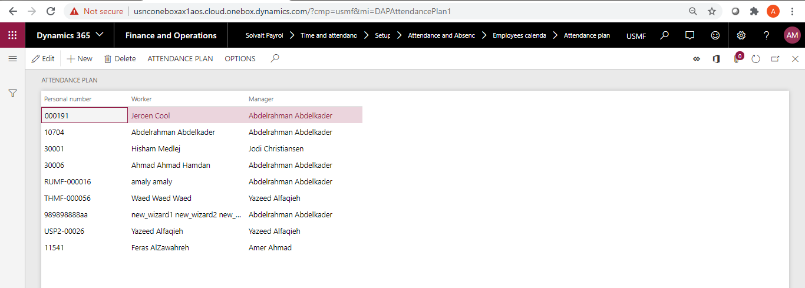

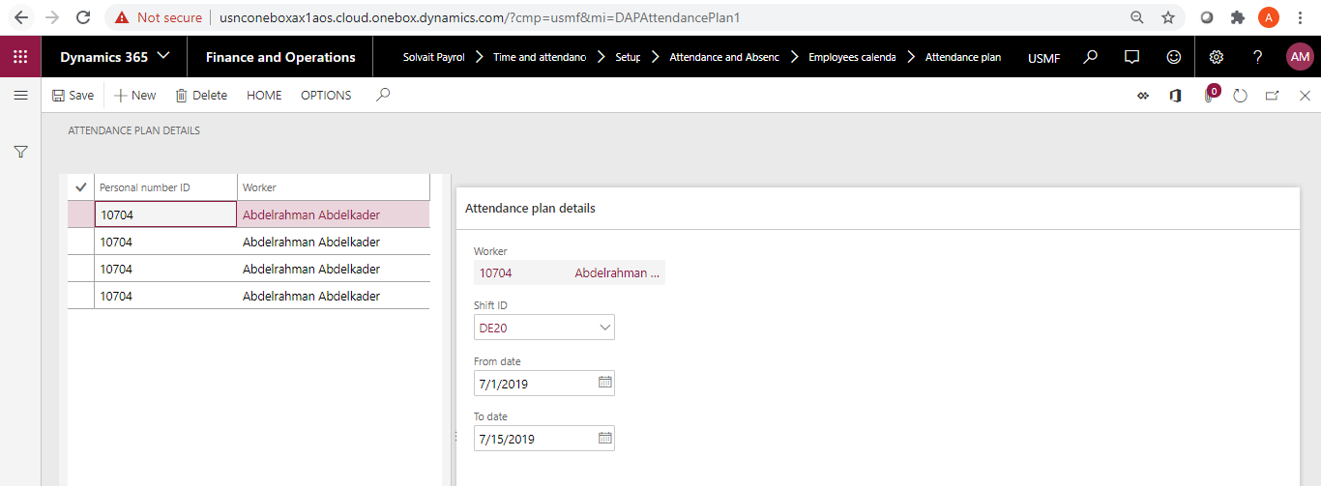

- This screen defines assigned shifts for the worker during his working time at the company
- You can assign several shifts for the worker in the same month
- You can’t overlap the shifts for the worker
- If the “Applicable to attendance planner” is checked for the worker in his profile, then the attendance will read the assigned shifts from the attendance planner.

    - Absence profile

Path: Solvait Payroll -> Time and attendance -> Setup -> Attendance and absence -> Absence profile

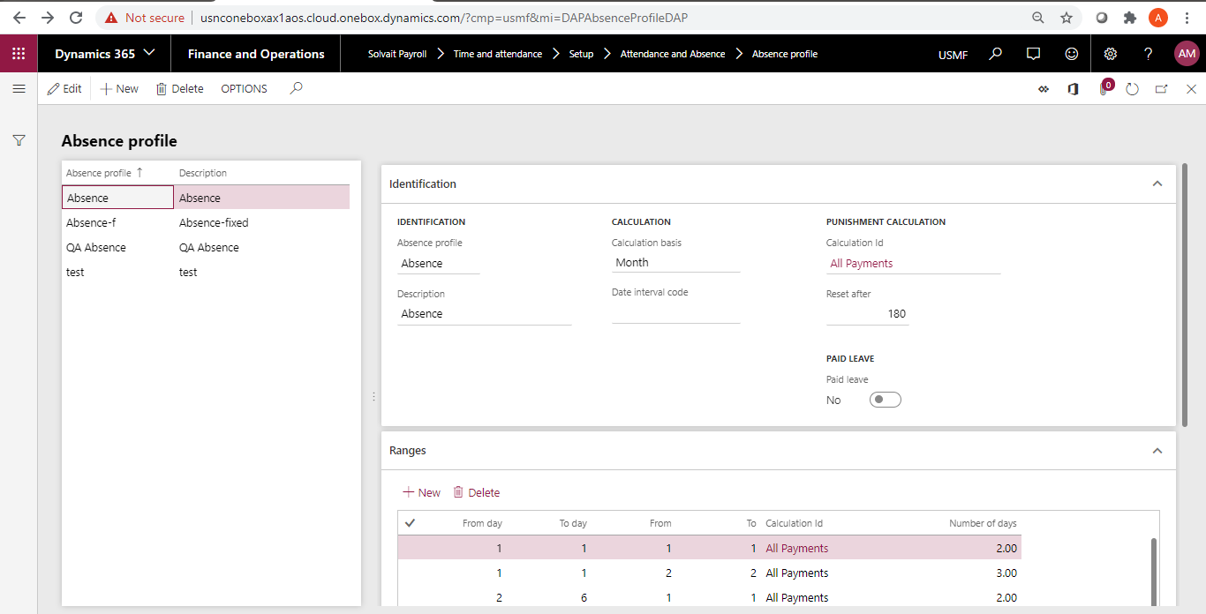

- This screen is used to define the absence profile
- There are two types of calculations:
  - Fixed
    - The calculation will be as the following:
      - Calculation ID/30
  - Ranges
    - Ranges is used for Absence punishment
    - If the case exits in one of the ranges, then the calculation will be as the following:
      - (Calculation ID/30) * number of days

    - Lateness profile

Path: Solvait Payroll -> Time and attendance -> Setup -> Attendance and absence -> Lateness profile
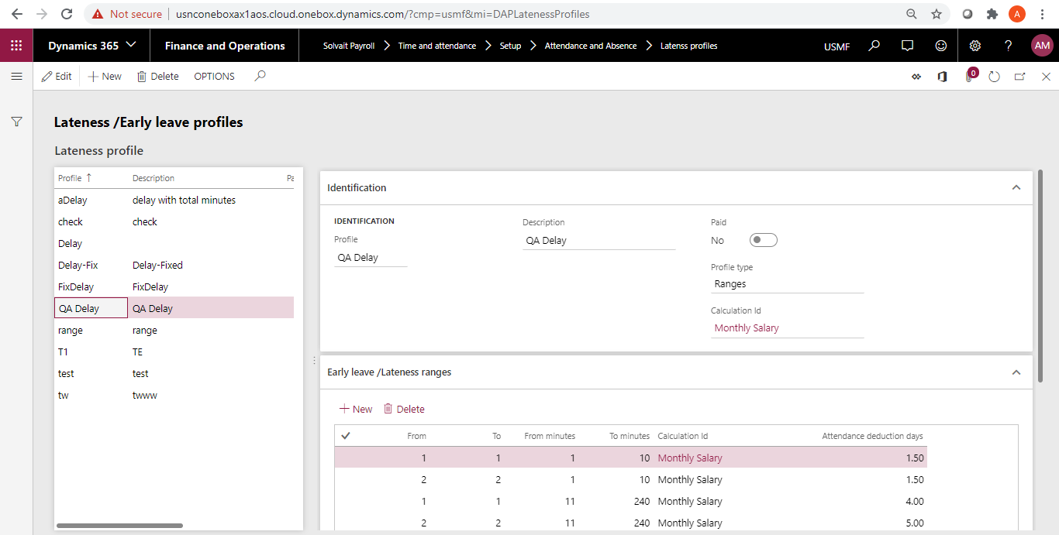
- This screen is used to define the lateness/delay profile
- There are two types of calculations:
  - Fixed
    - The calculation will be as the following:
      - (Calculation ID/30/shift hours/60) * delay minutes
  - Ranges
    - Ranges is used for delay punishments
    - The delay amount is deducted one time for all records in the range
    - If the records are outside the range, no penalties will be applied to the worker
    - If the case exits in one of the ranges, then the calculation will be as the following:
      - (Calculation ID/30) * attendance deduction days
    - Ex.
      - A worker has delay 3 times
      - Delay was more than 16 minutes and less than 30 minutes
      - Deduction rules will be on the second range (total package/30) * .50

    - Early leave profile

Path: Solvait Payroll -> Time and attendance -> Setup -> Attendance and absence -> Lateness profile
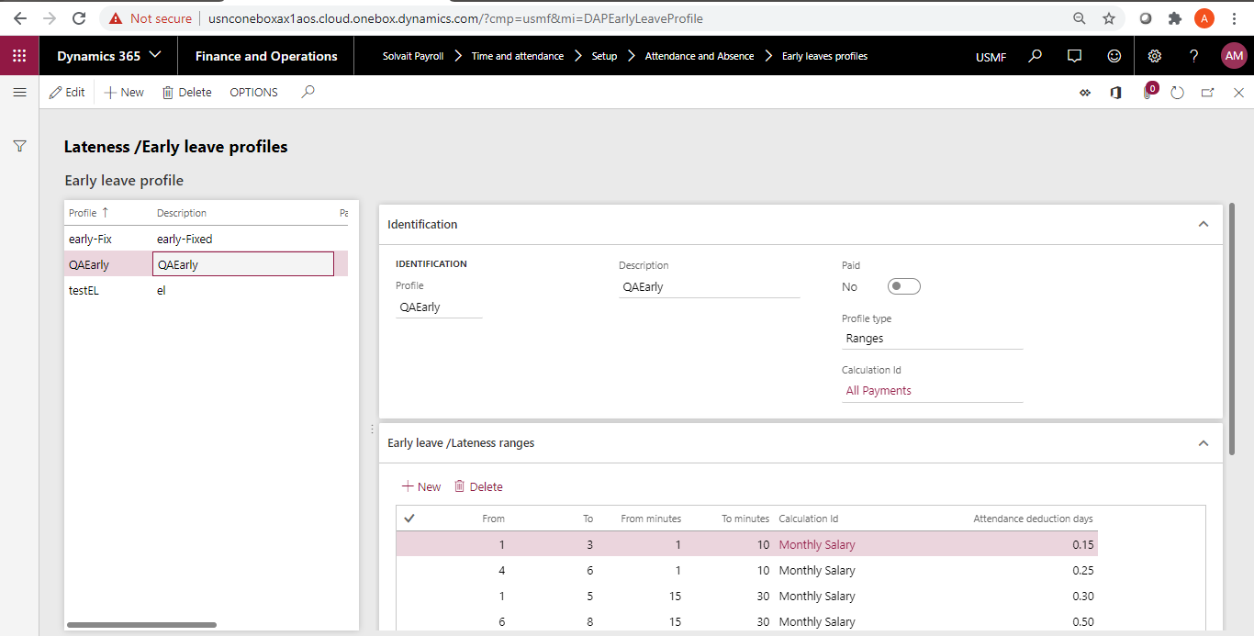
- This screen is used to define the early leave profile
- There are two types of calculations:
  - Fixed
    - The calculation will be as the following:
      - (Calculation ID/30/shift hours/60) * early leave minutes
  - Ranges
    - Ranges is used for early leave punishments
    - The early leave amount is deducted one time for all records in the range
    - If the records are outside the range, no penalties will be applied to the worker
    - If the case exits in one of the ranges, then the calculation will be as the following:
      - (Calculation ID/30) * attendance deduction days
    - Ex.
      - A worker has early leave 3 times
      - Early leave was more than 1 minute and less than 10 minutes
      - Deduction rules will be on the first range (total package/30) * .50

    - Break profile

Path: Solvait Payroll -> Time and attendance -> Setup -> Attendance and absence -> Break profile

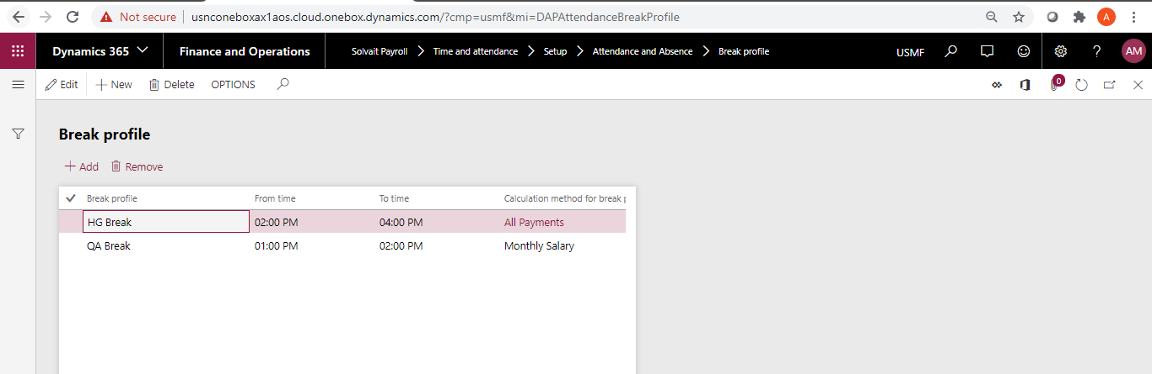

- This screen is used to define the break profile
- It applies a penalty in case the worker left early to the break or came late to the break time with the same calculations of the Delay and Early leave

    - No login/out profile

Path: Solvait Payroll -> Time and attendance -> Setup -> Attendance and absence -> No login/out profile

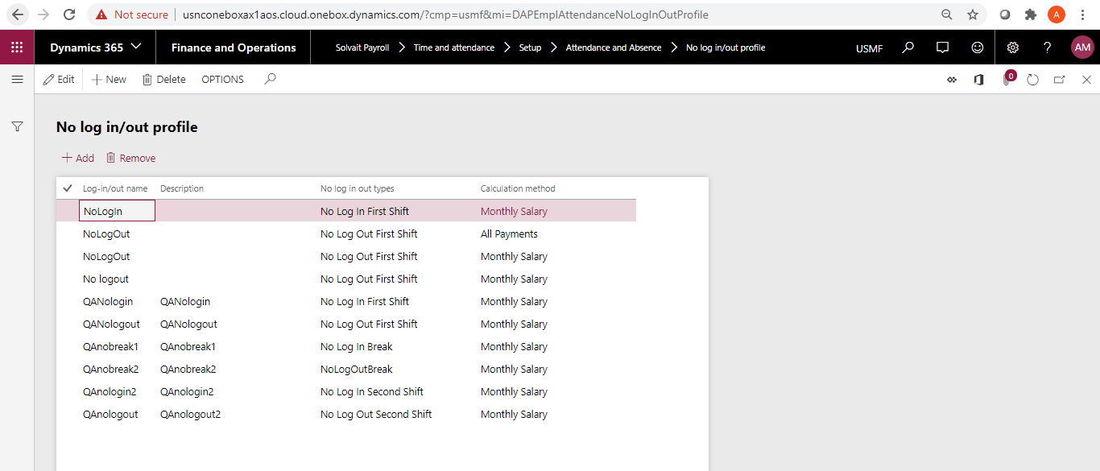

- This screen is used to define the no login/out profile
- It applies a penalty in case the worker has missing finger print for any shift

  - Worker
    - Attendance setup

Path: Solvait Payroll -> Workers -> Workers -> Personal -> Attendance setup

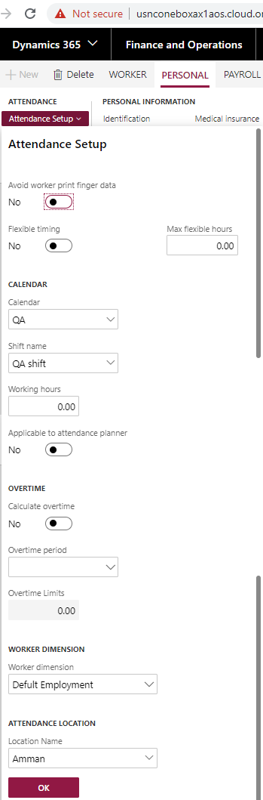

- Applicable to attendance planner:
  - If this checkbox was checked, then the attendance will read the assigned shifts for the worker from the attendance planner form.
- Flexible timing:
  - If this checkbox was checked, then the attendance will calculate the flexible hour for the worker based on “Max flexible hours” value
- Calendar:
  - Each worker should be assigned to calendar in order to display in the attendance screen
  - Each worker should be assigned on a shift to allow the attendance calculate the attendance deduction based on the assigned shift.
- Overtime period:
  - This is related to the overtime validation
  - This validation will be applied for the worker itself.
    - Month:
      - The overtime hours limits will be per month.
      - The hours validation will be based on the “Overtime limits” value
    - Week:
      - The overtime hours limits will be per week
      - The hours validation will be based on the “Overtime limits” value

  - Generate Attendance

Path: Solvait Payroll -> Time and attendance -> Attendance -> Generate attendance

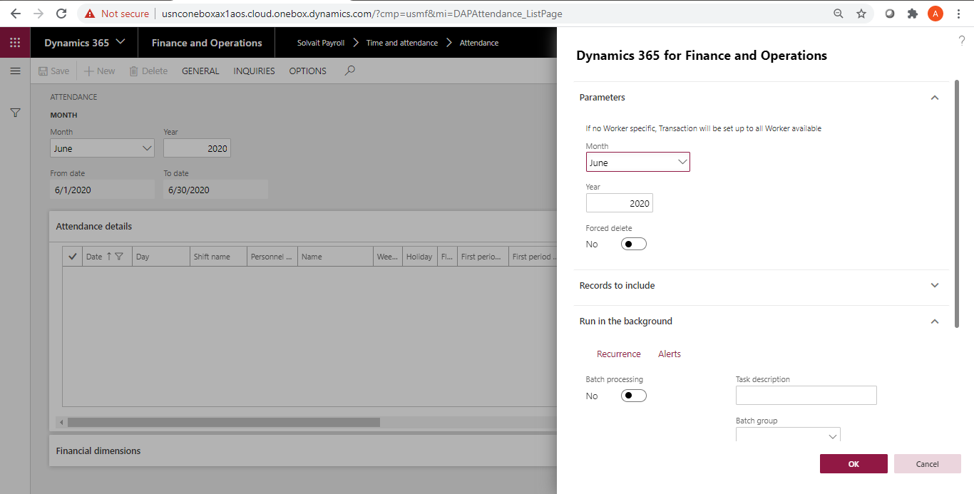

- You have two ways to generate attendance for any month:
  - Manual generation by clicking on the “Generate attendance” button
  - By scheduling the process through the batch.
- The worker should have to have a Calendar and shift in order to display in the attendance.
- The worker’s contract should be active to display in the attendance screen.

  - Import attendance from machine

Path: Solvait Payroll -> Time and attendance -> Attendance -> Import attendance from machine

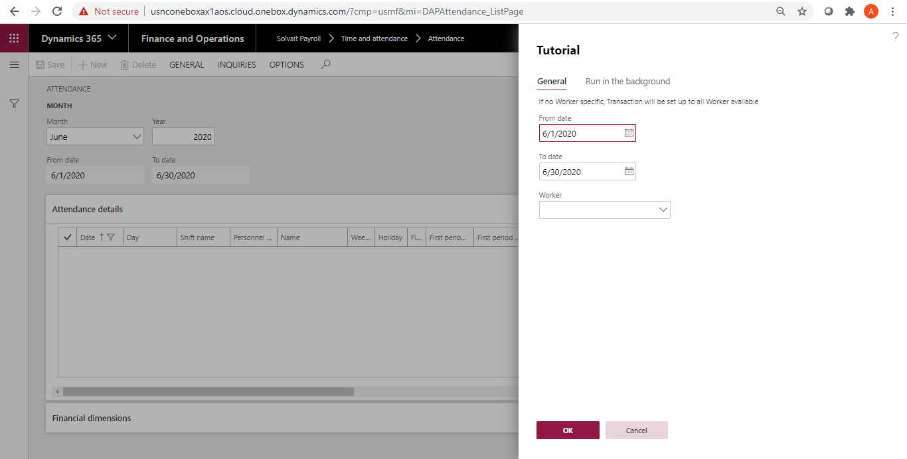

- The attendance system should be connected to the fingerprint DB to be able to import the fingerprint to the attendance form.
- The connection setup should be filled in the Timesheet -> Attendance machine

  - Import attendance (By excel)

Path: Solvait Payroll -> Time and attendance -> Attendance -> Import attendance (By excel)

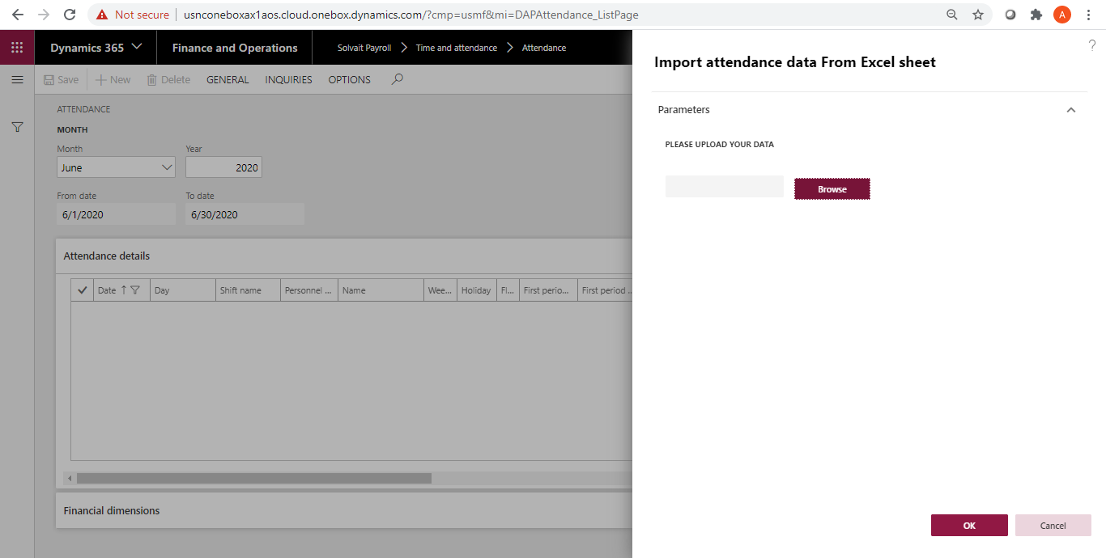

- Can import fingerprint from an excel sheet and update the attendance lines with them.

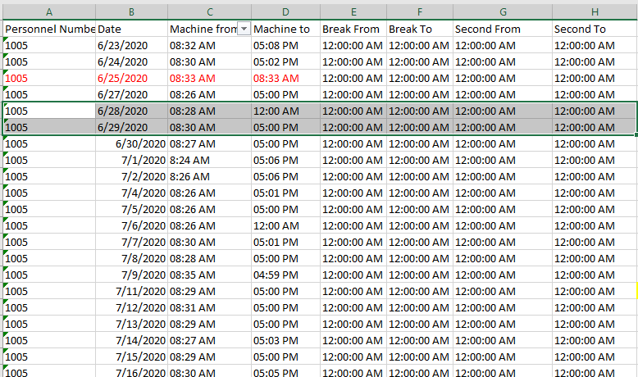

  - Timesheet

Path: Solvait Payroll -> Time and attendance -> Attendance -> Timesheet

- Can update fingerprints for any worker on any day from the timesheet screen and update the attendance lines with them

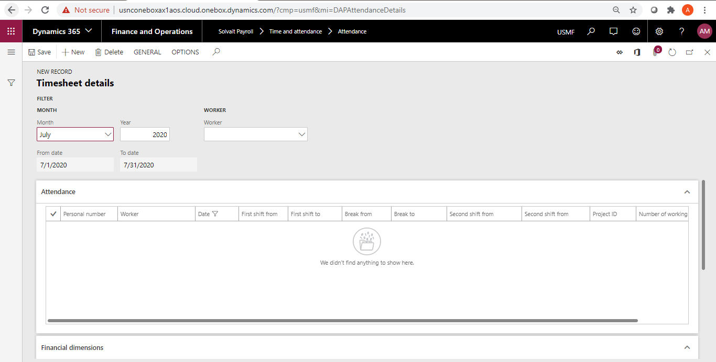

  - Calculate

Path: Solvait Payroll -> Time and attendance -> Attendance -> Calculate

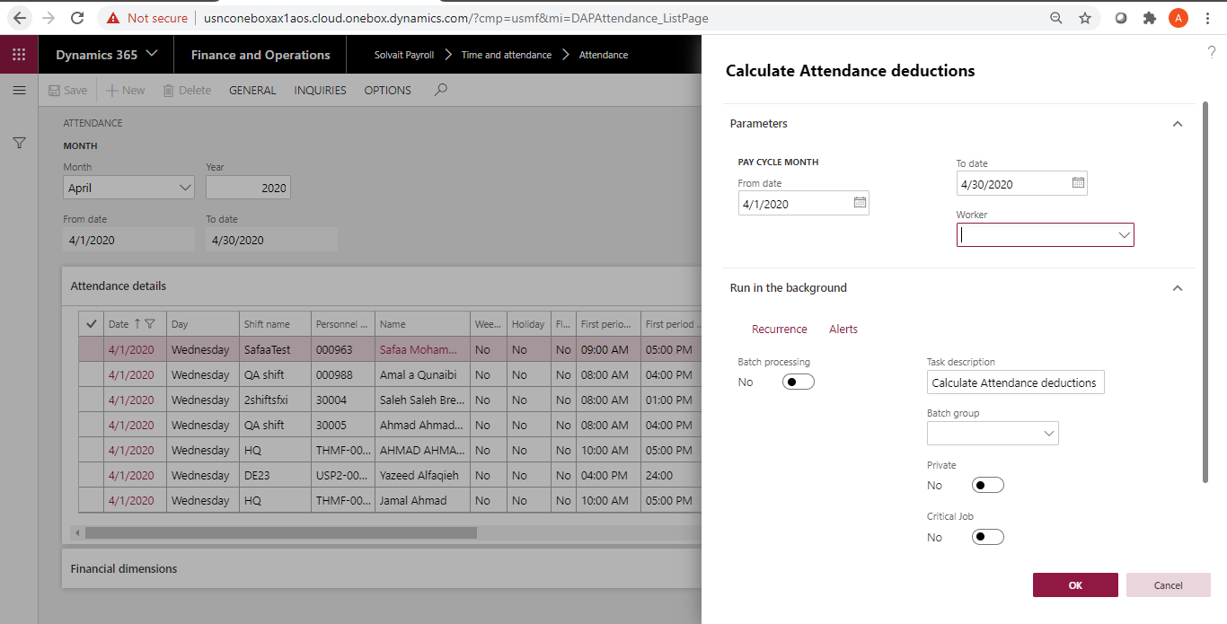

- You should click on “Calculate” button to calculate the attendance calculations
- The attendance calculations will be shown in the attendance main screen and view attendance cases screen.

  - Attendance main screen
Path: Solvait Payroll -> Time and attendance -> Attendance

- In this screen, you will find the following:
  - First shift details
  - Break details
  - Second shift details
  - Working hours
  - Weekend and holidays days
  - Leaves, BTs, courses, and excuses days
  - Financial dimension
  - Attendance details

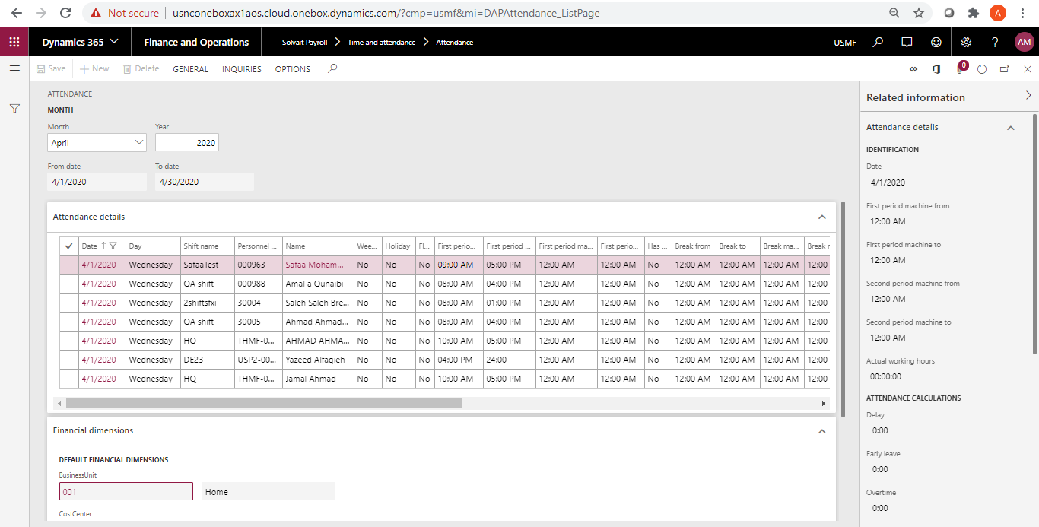

  - View Attendance
Path: Solvait Payroll -> Time and attendance -> Attendance -> View attendance cases

- The form will display all the attendance details and calculations for all workers

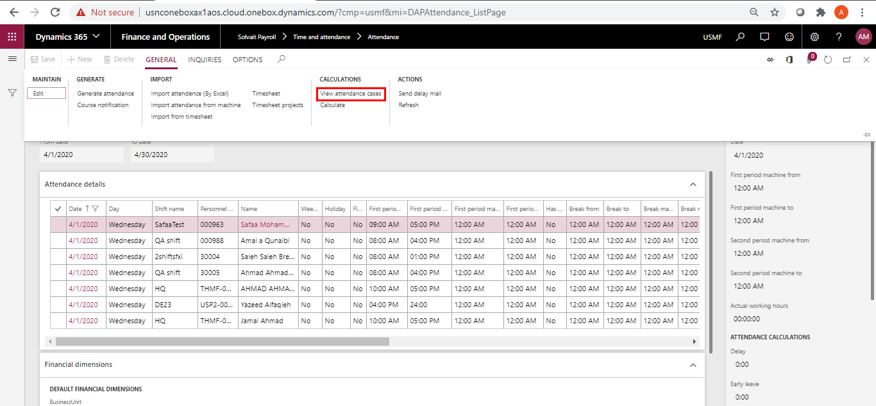

- View attendance cases contains 3 tabs:

    - Employee attendance details
Path: Solvait Payroll -> Time and attendance -> Common -> Time and attendance -> Attendance -> View attendance cases -> Employee attendance details

- This tab displays the attendance calculation for each attendance type:
  - Absence
  - Delay
  - Early leave
  - Break
  - No login/logout
  - Overtime
  - Leaves
  - Excuses
  - Business trip
  - Courses

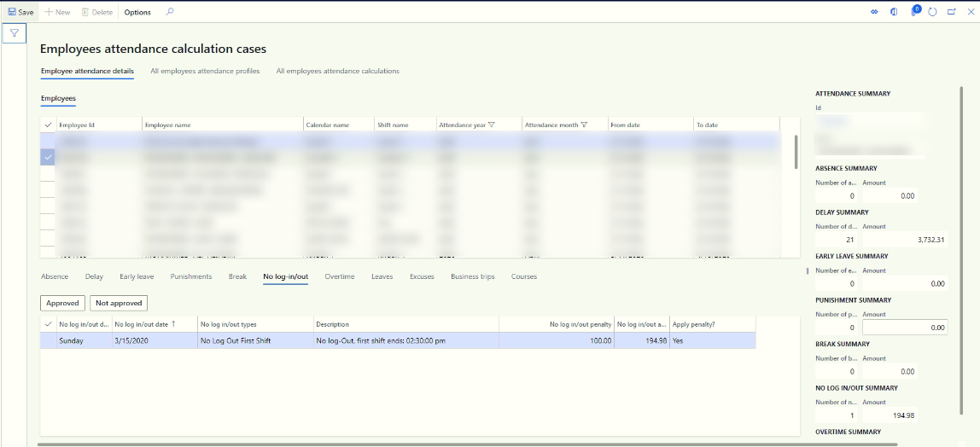

      - Absence
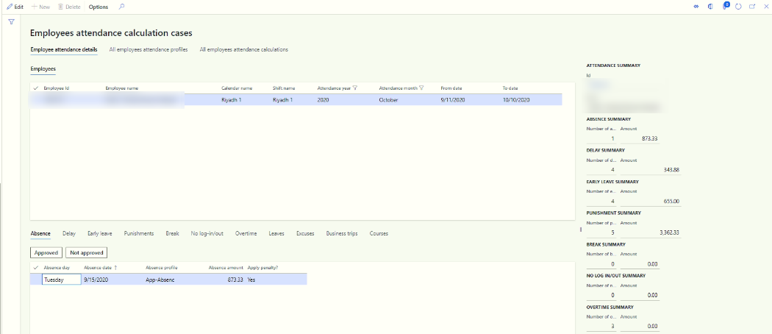
- The absence calculations will be calculated based on the absence profile that was added in the assigned shift for the worker.
  - If no ranges were added, then the calculations will be calculated for each day based on the provided calculation ID. For an example it will deduct 100% from the basic salary.

  - If ranges were added, then the calculations will be calculated based on the date ranges; for an example Absence for Day 1 and Day 2 will deduct 25% of basic salary

- The manager can approve or reject the absence transaction

      - Delays
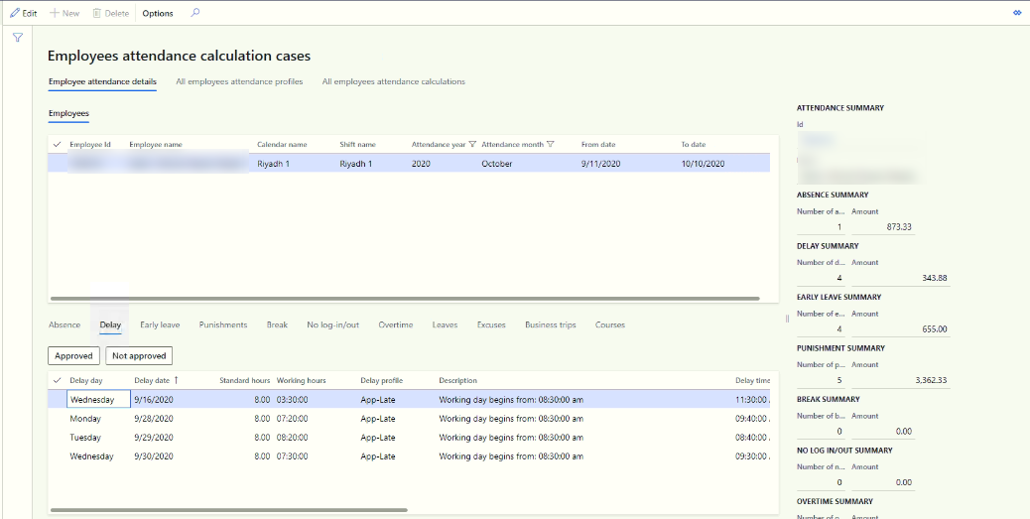

- The delay calculations will be calculated based on the lateness profile that was added in the assigned shift for the worker.
  - Fixed
    - The calculation will be as the following:
      - (Calculation ID/30/shift hours/60) * delay minutes
  - Ranges
    - The delay amount is deducted one time for all records in the range
    - If the records are outside the range, no penalties will be applied to the worker
    - If the case exits in one of the ranges, then the calculation will be as the following:
      - (Calculation ID/30) * attendance deduction days
  - Flexible
    - If there were flexible hours, then the delay will be calculated if the worker didn’t compensate the required hours.
    - If the flexible hour option was selected, then the system will not consider “Allowed delay minutes” option
  - Shifts
    - If there is only one shift, then the delay will be calculated for the first shift.
    - If there are two shifts, then the delay will be calculated for each shift; shift 1 and shift2.
    - If there is break, then the delay will be calculated if the worker came late from break
  - Deduction
    - The deduction will be as per the “Allowed delay minutes method” option:
      - If “Deduct all minutes” was selected, then all delay minutes will be deducted
      - If “Deduct minutes after allowed period”, then the delay minutes will be deduction after “Allowed delay minutes” value.

- The manager can approve or reject any delay penalty

      - Early leave
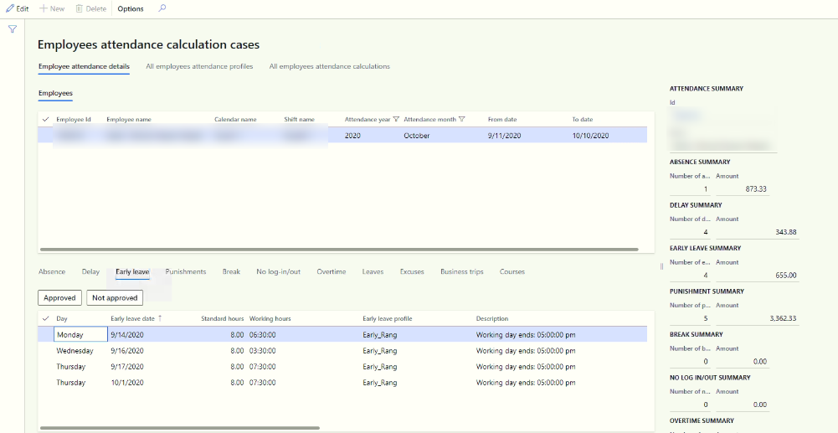
- The early leave calculations will be calculated based on the early leave profile that was added in the assigned shift for the worker.
  - Fixed
    - The calculation will be as the following:
      - (Calculation ID/30/shift hours/60) * early leave minutes
  - Ranges
    - The early leave amount is deducted one time for all records in the range
    - If the records are outside the range, no penalties will be applied to the worker
    - If the case exits in one of the ranges, then the calculation will be as the following:
      - (Calculation ID/30) * attendance deduction days
  - Flexible
    - If there were flexible hours, then the early leave will be calculated if the worker didn’t compensate the required hours.
    - If the flexible hour option was selected, then the system will not consider “Allowed delay minutes” option
  - Shifts
    - If there is only one shift, then the early leave will be calculated for the first shift.
    - If there are two shifts, then the early leave will be calculated for each shift; shift 1 and shift2.
    - If there is break, then the early leave will be calculated if the worker left early to the break
  - Deduction
    - The deduction will be as per the “Allowed delay minutes method” option:
      - If “Deduct all minutes” was selected, then all early leave minutes will be deducted
      - If “Deduct minutes after allowed period”, then the early leave minutes will be deduction after “Allowed delay minutes” value.

- The manager can approve or reject any early leave penalty

      - Break
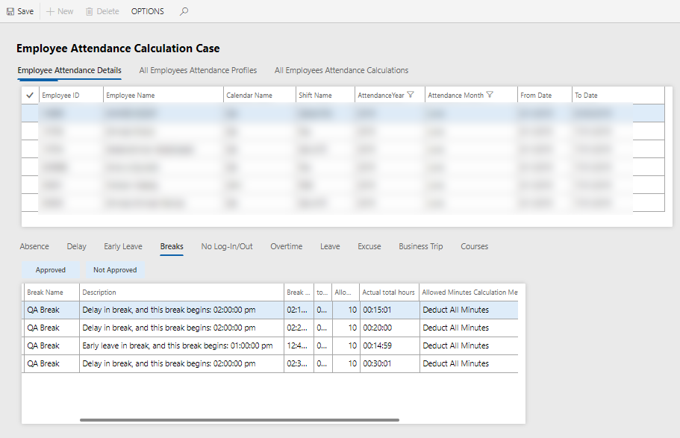
- The break calculations will be calculated based on the break profile that was added in the assigned shift for the worker with the same calculations of the Delay and Early leave

- The manager can approve or reject any break penalty

      - No log in/out
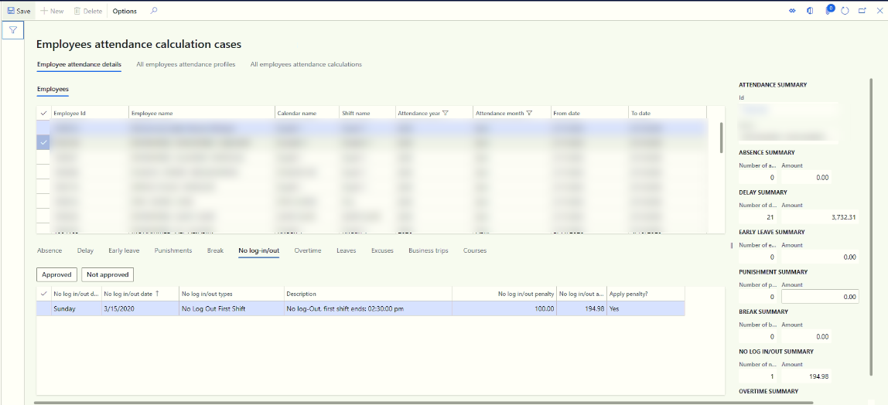
- The no login/logout calculations will be calculated based on the profile that was added in the assigned shift for the worker

- The manager can approve or reject any no login/logout penalty

      - Overtime
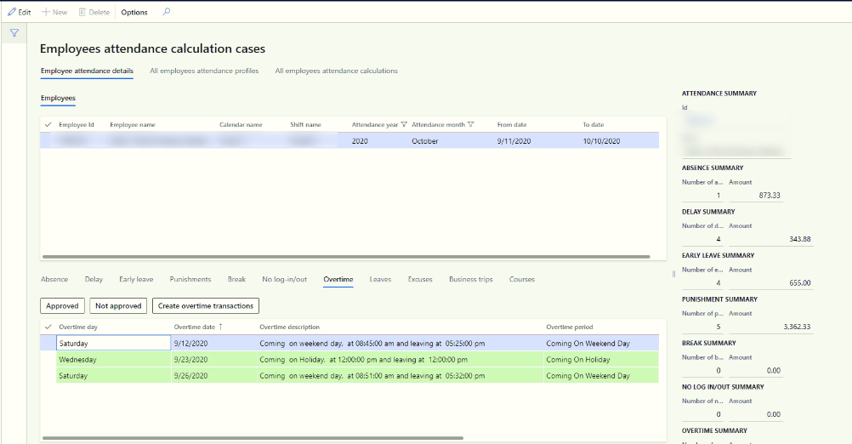
- The overtime calculations will be calculated as per the overtime setup
- Overtime for normal working day, weekend, and holiday will be calculated
- Flexible:
  - If there are flexible hours, then the overtime will be calculated when the worker compensates his working hours
  - If there are no flexible hours, then the overtime will be calculated when the worker finishes his working hours/end of his shift

- The manager can approve or reject any no login/logout penalty.
- The manager should click on “Create overtime” to create overtime transaction
  - One line for each overtime type will be created for all same overtime type (grouping by overtime type)

      - Leave

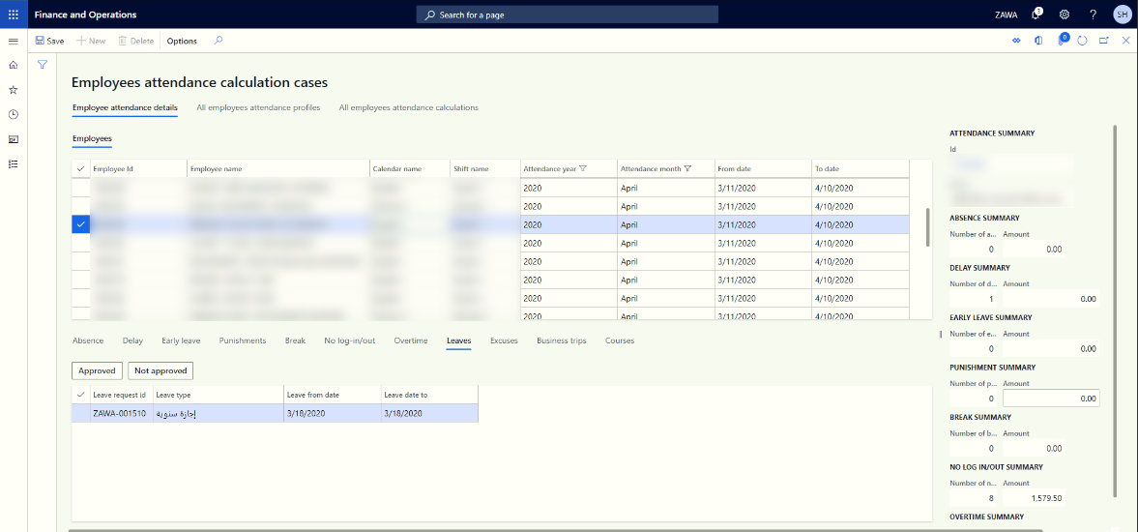
- The leave transaction will display under the leave tab
- When the worker has a leave, the system will not consider the worker Absence

      - Excuses

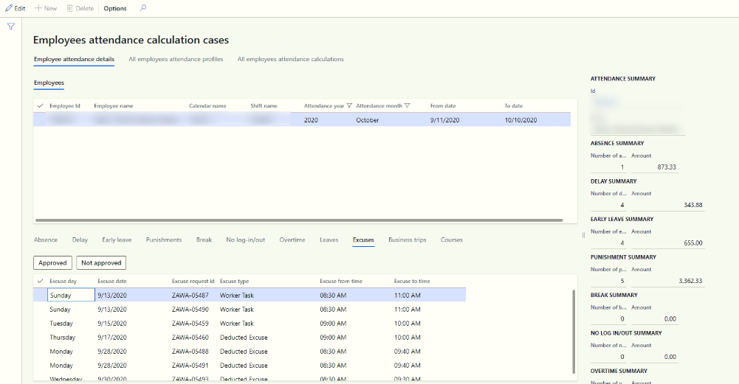
- The excuse requests will display under the Excuse tab
- When the worker has an Excuse on the day, the system will not consider the worker Delay or early leave

      - Business trip

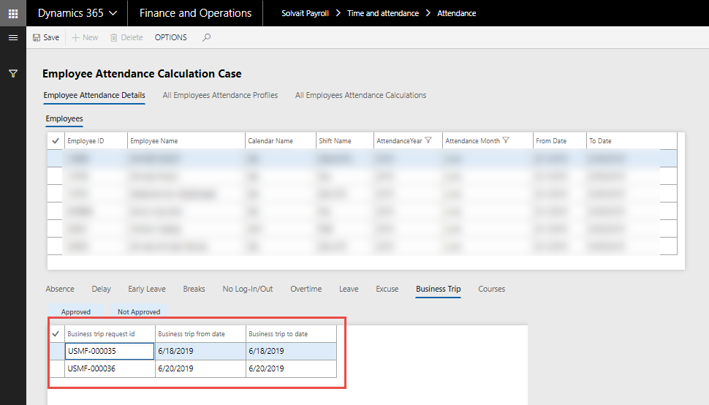

- The Business trip transaction will display under the Business trip tab
- When the worker has a BT, the system will not consider the worker Absence

      - Courses

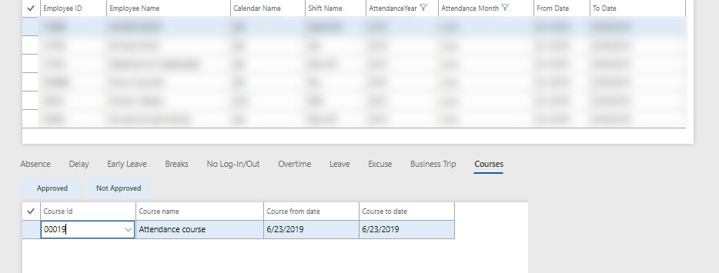
- The Course details will display under the course tab
- When the worker has a course, the system will not consider the worker Absence

    - All employee’s attendance details
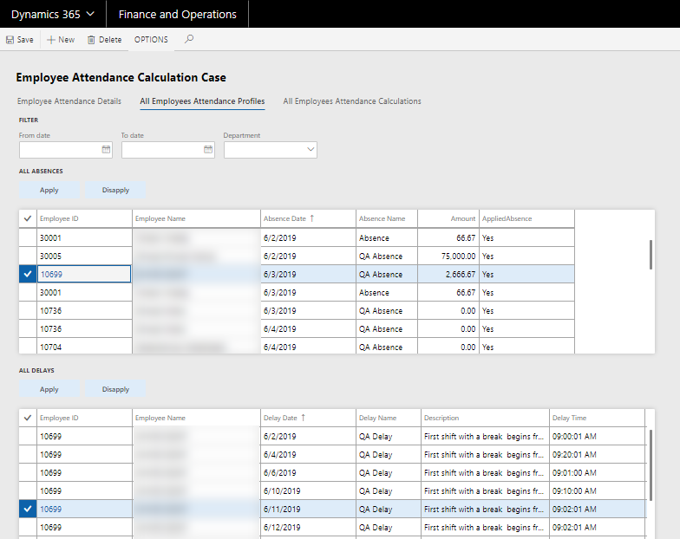
- This screen displays all attendance lines for each attendance case. Ex. Absence, Delay etc.…
- You can filter the attendance lines as per the dates or department.
- You can Apply penalty to disapply penalty for any attendance line.

    - All employee’s attendance calculations

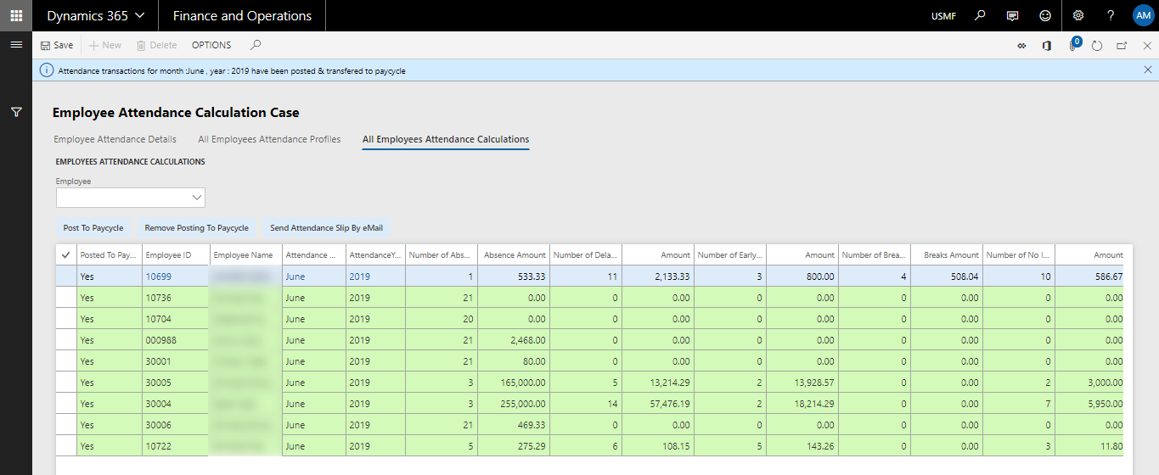

- This screen displays all the attendance deductions and the total deductions for each employee
- You can filter any employee for view the deduction details.
- You can post the transactions to pay cycle for selected workers or all workers.
- You can send the attendance slip that contains the attendance deductions for selected workers or all workers.
- Once the attendance lines are posted, you can’t perform any action (ex. Generate attendance or import fingerprint) for the posted month

  - Clear attendance lines

Clear attendance lines can be used to deleted generated attendance lines between specific dates. Choose from and to dates then click OK.

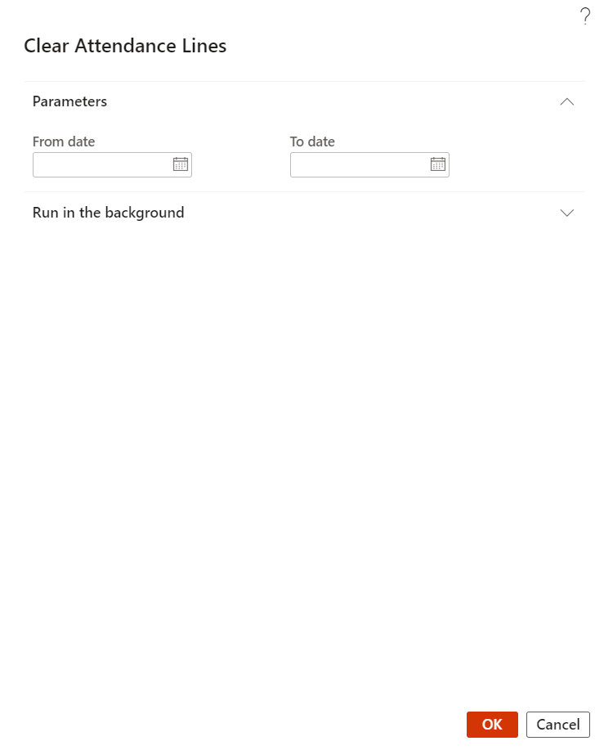

Appraisal

Assign Goals

Path: Solvait payroll -> Appraisal -> Setup -> Appraisal -> Assign goals

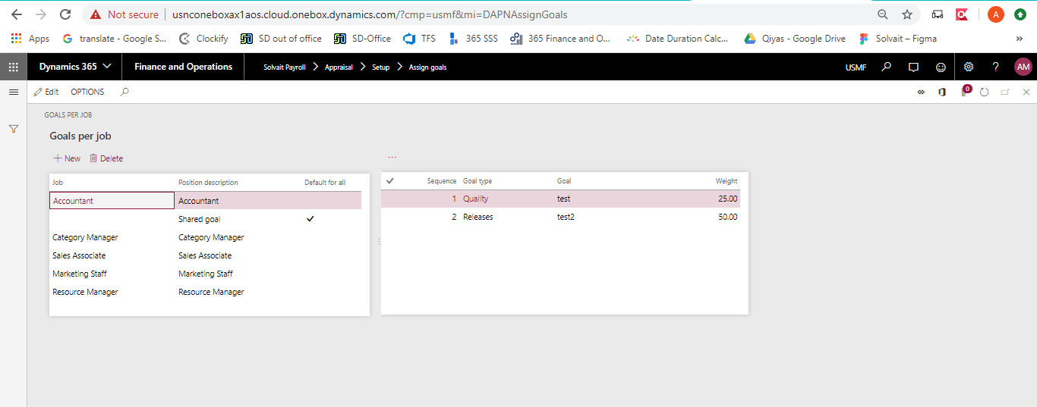

- assign goals for each job
- Can add a shared goal for all jobs
  - The manager can add a default goals by checking “Default for all” checkbox
- A warning message will display if the total goals exceeded 100%
  - Total weights include the shared goals

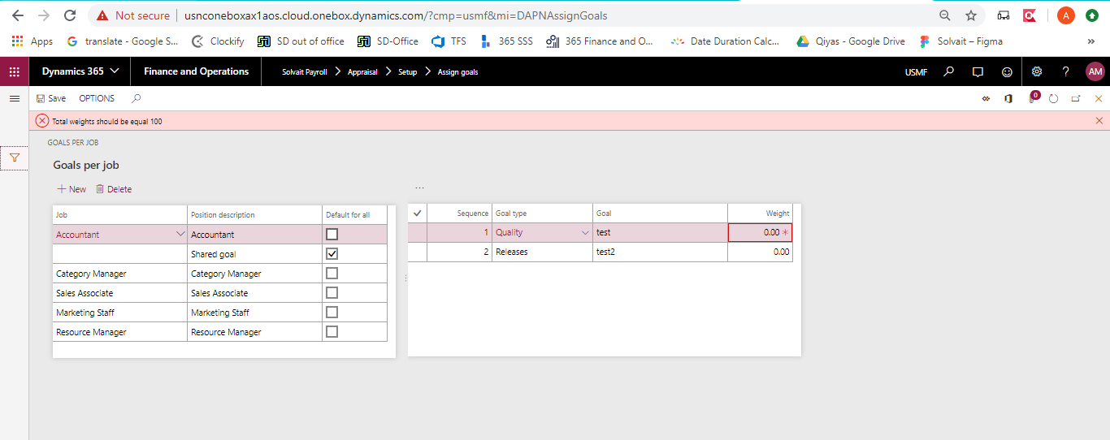

- A message will display if the total goals were less than 100%

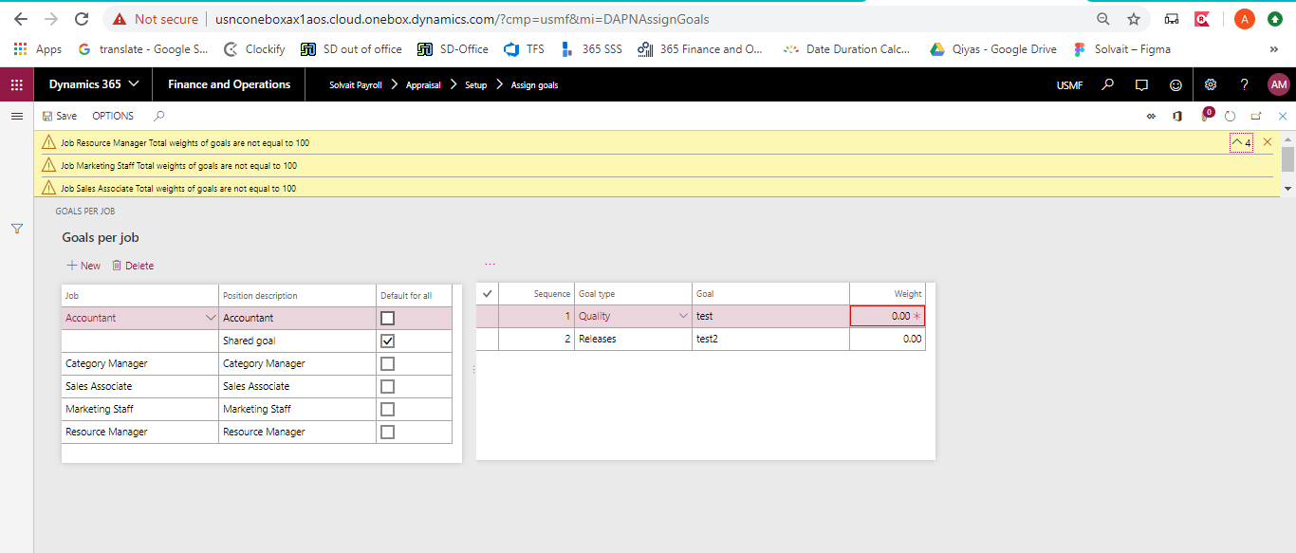

  - Assign competencies

Path: Solvait payroll -> Appraisal -> Setup -> Appraisal -> Competencies

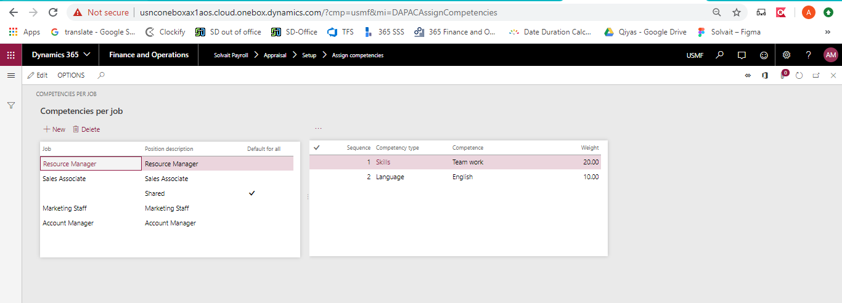

- Assign competencies for each job
- Can add a shared competency for all jobs
  - The manager can add a default competency by checking “Default for all” checkbox
- A warning message will display if the total competencies exceeded 100%
  - Total weights include the shared competencies

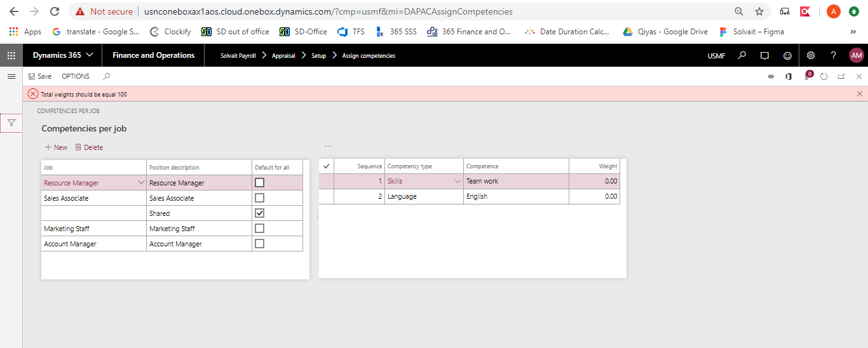

- A message will display if the total goals were less than 100%

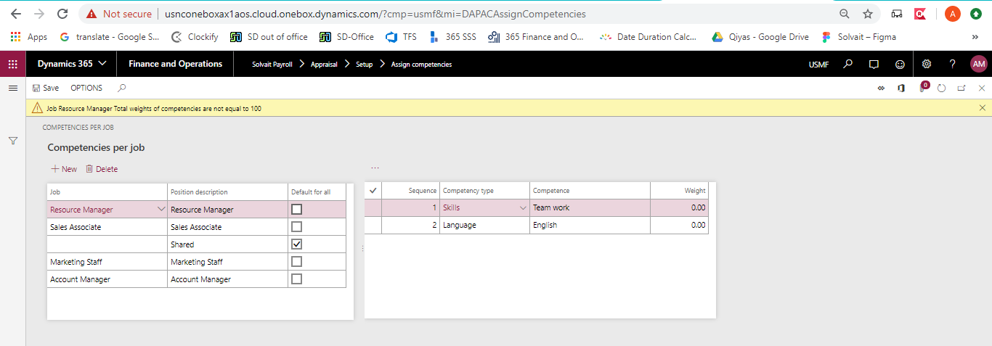

  - Master Appraisal page

Path: Solvait payroll -> Appraisal -> Master appraisal page

    - Create an Appraisal

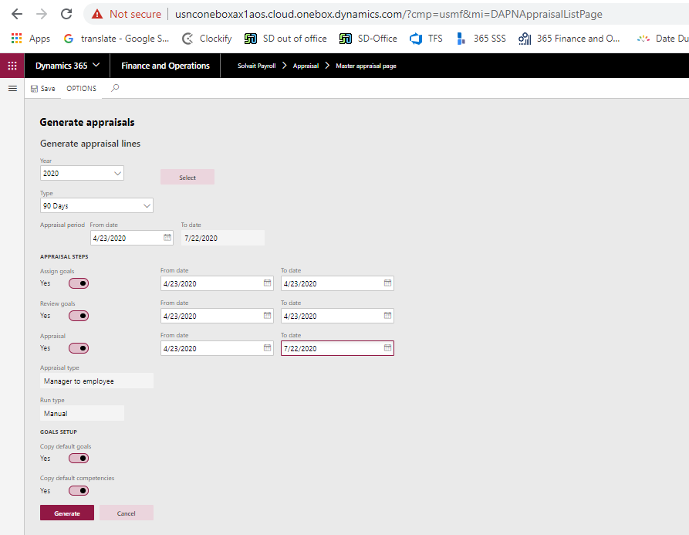

- Only the HR manager has the authority to create the appraisals.
- There are different types for appraisal:
  - 90 days
  - 180 days
  - Annual
  - Promotion
  - Probation period

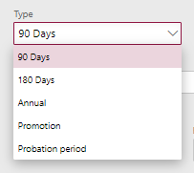

- Appraisal period will be filled as per the selected appraisal type.
- Appraisal type:
  - There are different steps for appraisal, the HR manager can select any step:
    - Assign goals
    - Review goals
    - Appraisal
- Appraisal type:
  - There is only one appraisal type which is Manager to employee.
- Run type:
  - The run type for the appraisal is Manual process
- Goals/Competencies setup:
  - There are 2 options for goals and competencies:
    - Copy default goals/competencies (by checking the related checkboxes)
    - Don’t copy any goal or competencies (by removing the checkboxes)
- Select:
  - The appraisal can be generated for selected users or for all users
    - Workers should be in the same legal entity
    - Workers should have active contracts

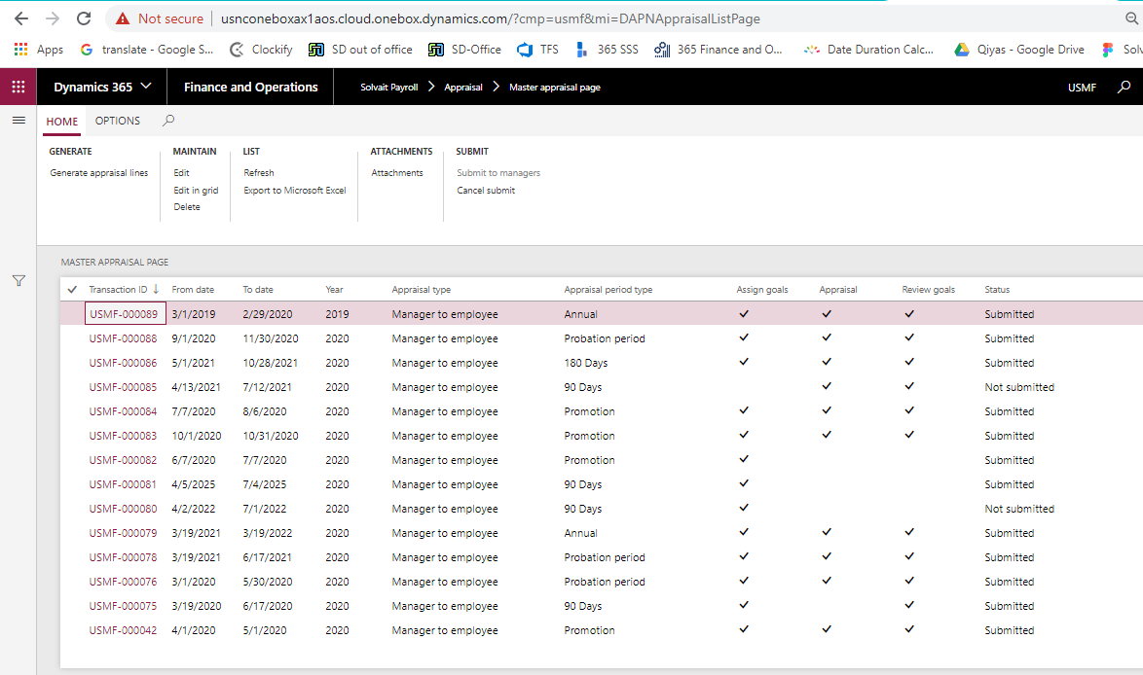

- The appraisal will be generated after clicking on “Generate” button.
- The status of the generated appraisal will be “Not submitted”

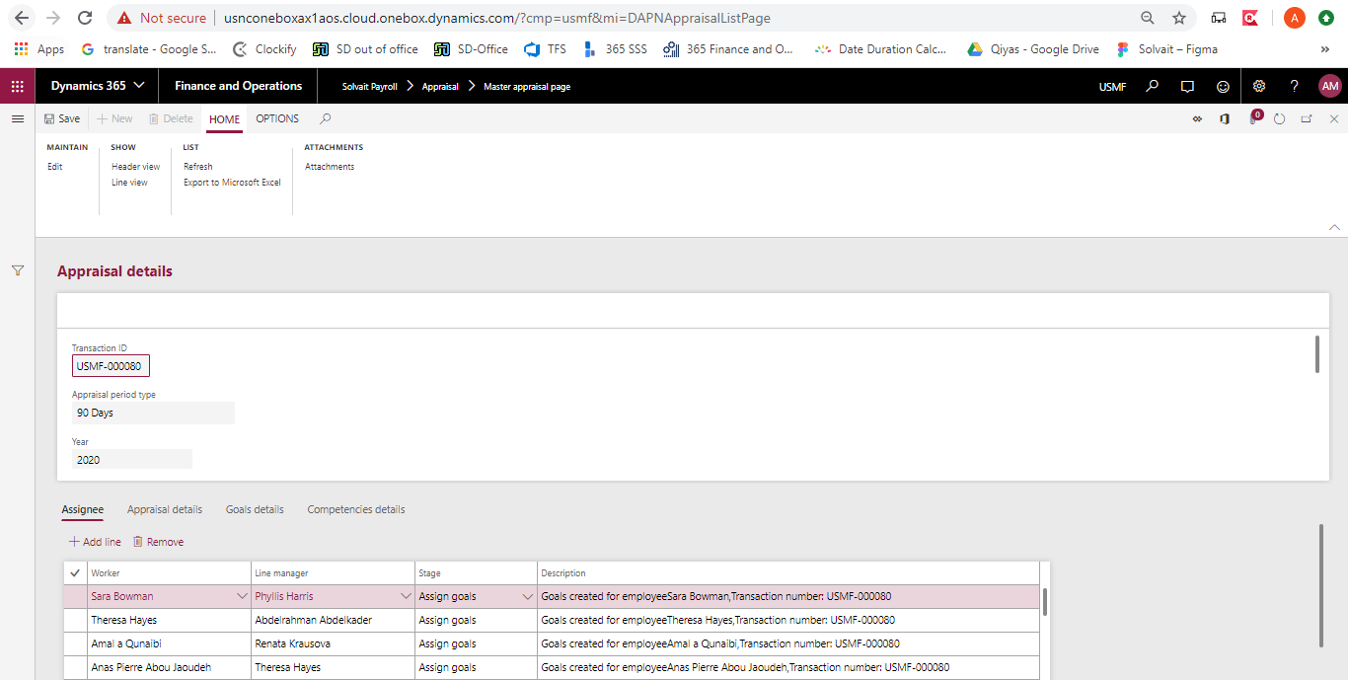

- The following data will display in the appraisal line details:
  - Assignee
  - Appraisal details
  - Goals details
  - Competencies details
- The HR manager should submit the appraisal lines to the line managers.

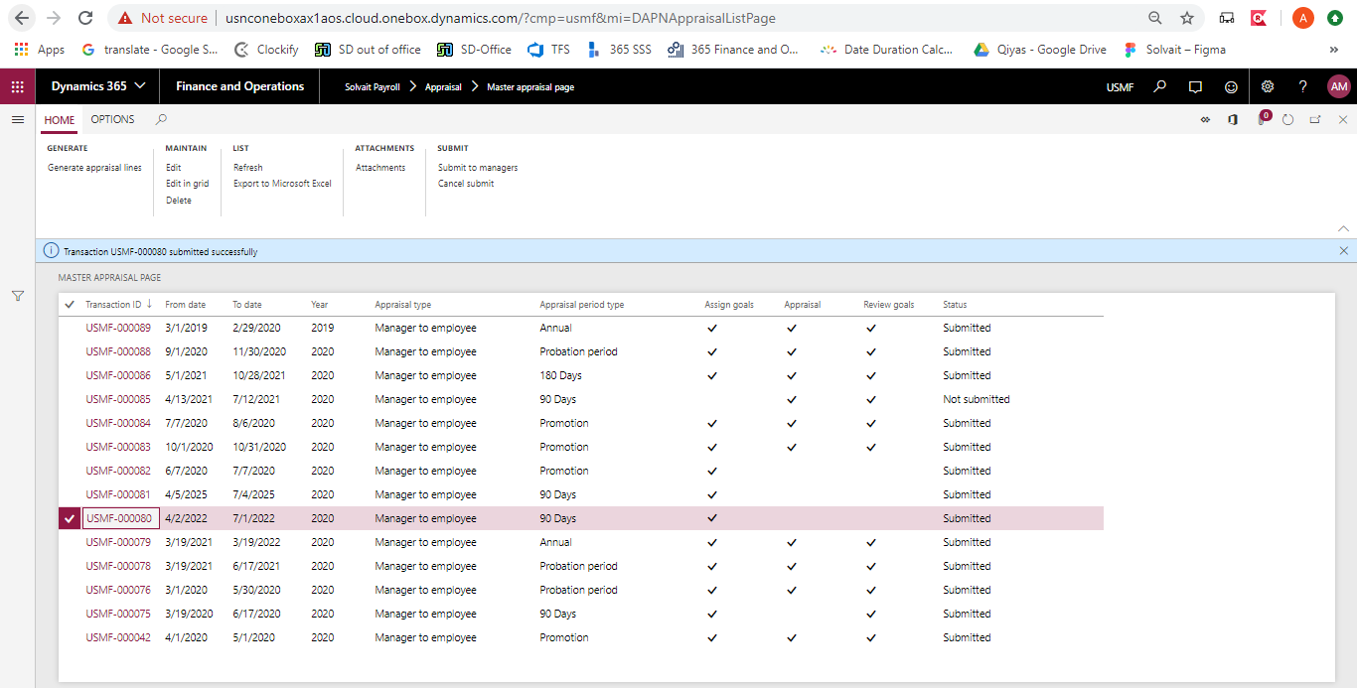

  - HR appraisal list

Path: Solvait payroll -> Appraisal -> HR appraisal list

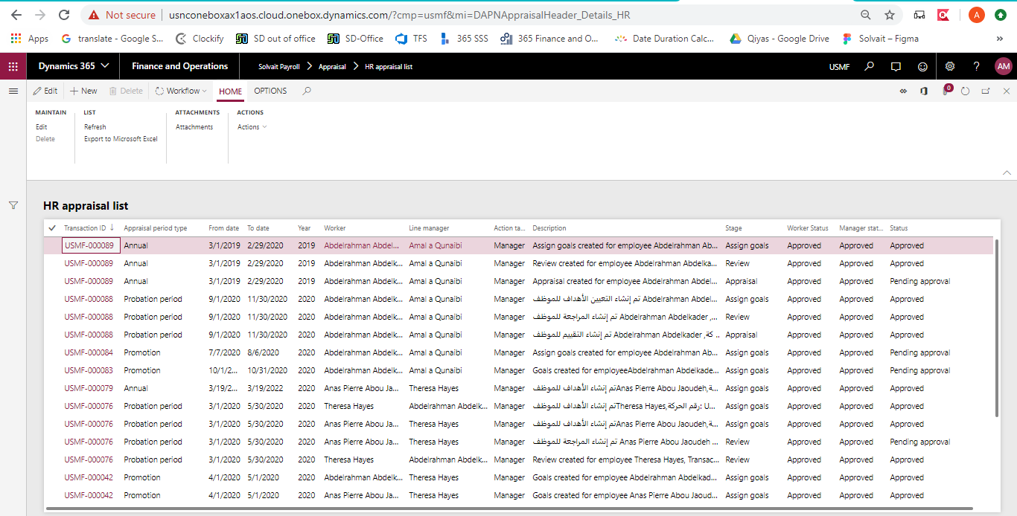

- Any escalated requests will display under “HR appraisal list” page
  - The HR manager can resubmit the escalated request.
- The requests with “Pending approval” status will display under “HR appraisal list” page to allow the HR manager to perform the final approval on the request.
  - When the request is Approved, means that the request is ready to be moved to the next stage.

  - All appraisal requests

Path: Solvait payroll -> Appraisal -> All appraisal requests

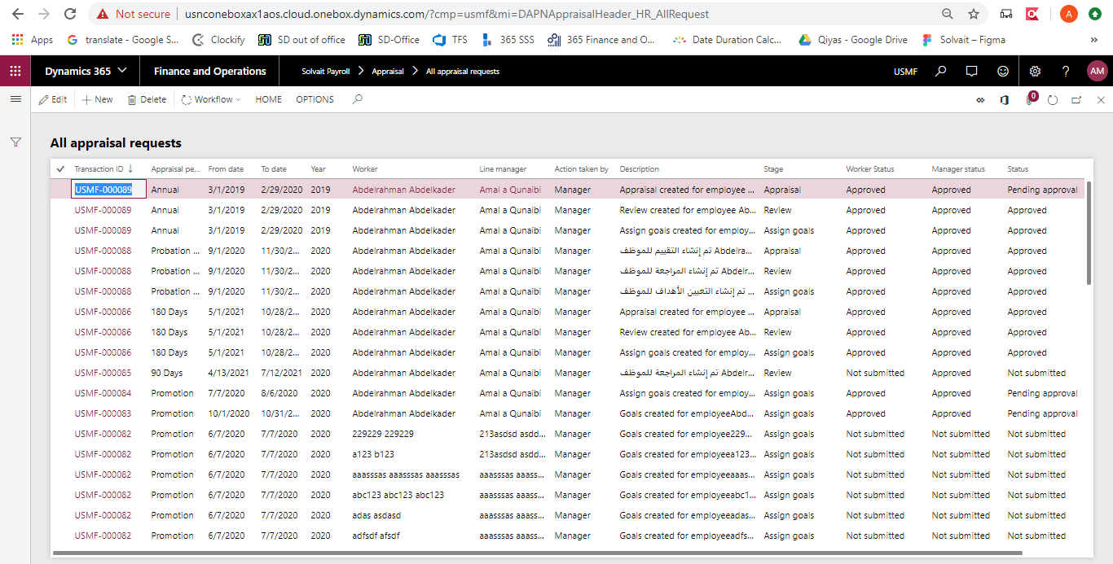

- This screen will display only for HR manager.
- The HR can view the status of all appraisals

  - Appraisal assigned to me

Path: Solvait payroll -> Appraisal -> Appraisal assigned to me

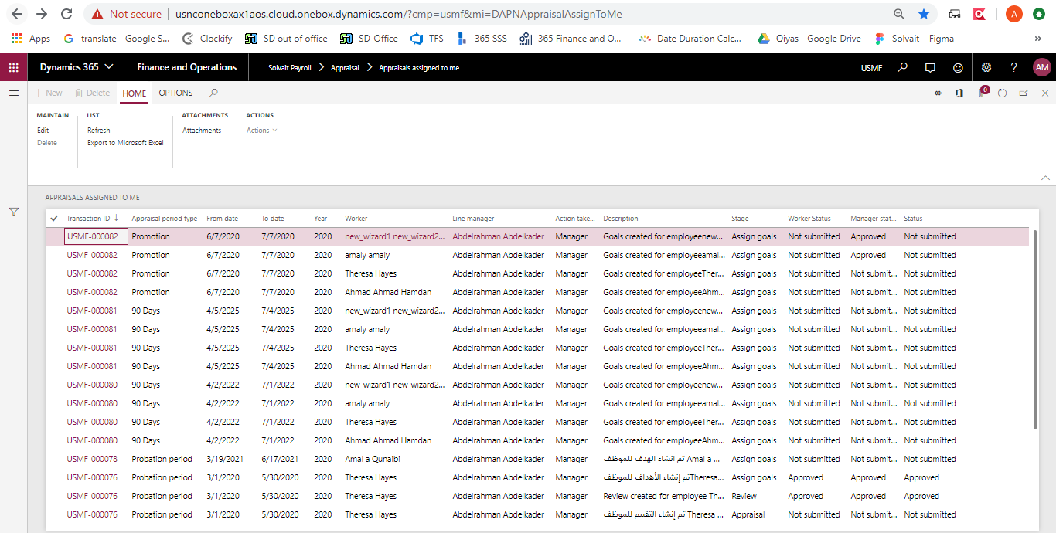

- This screen will display only for Line managers.
- The manager can view the details of the worker appraisal
- The following actions can be done by the manager on the appraisal:
  - Assign goal stage:
    - In the “Assign goal” stage, the manager can edit the start date and end date of each goal and competency, update the weight, add note, and add training needs.
    - Can add the KPIs for each goals and competencies
  - Review stage:
    - In the “Review” stage, the manager can add the initial percent for goals and competencies
    - Can add/update the KPIs for each goals and competencies
  - Appraisal stage:
    - In the “Appraisal” stage, the manager can add the final percent for goals and competencies
    - Can add/update the KPIs for each goals and competencies

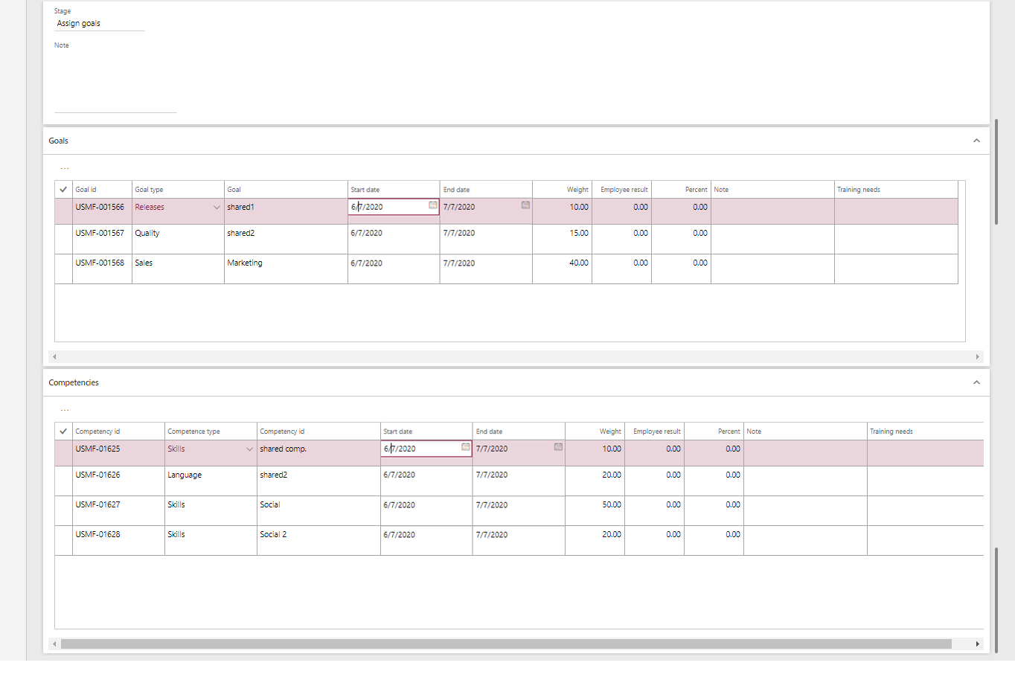

- The manager can add additional goals and competencies through the “Goal/Competence template”
  - Only the shared and the manager’s lines will display in the screen
  - The manager can add selected or all lines to the worker

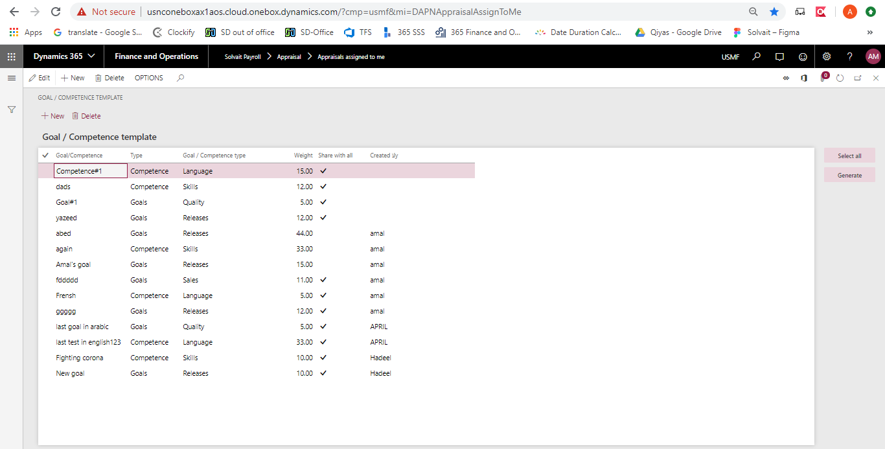

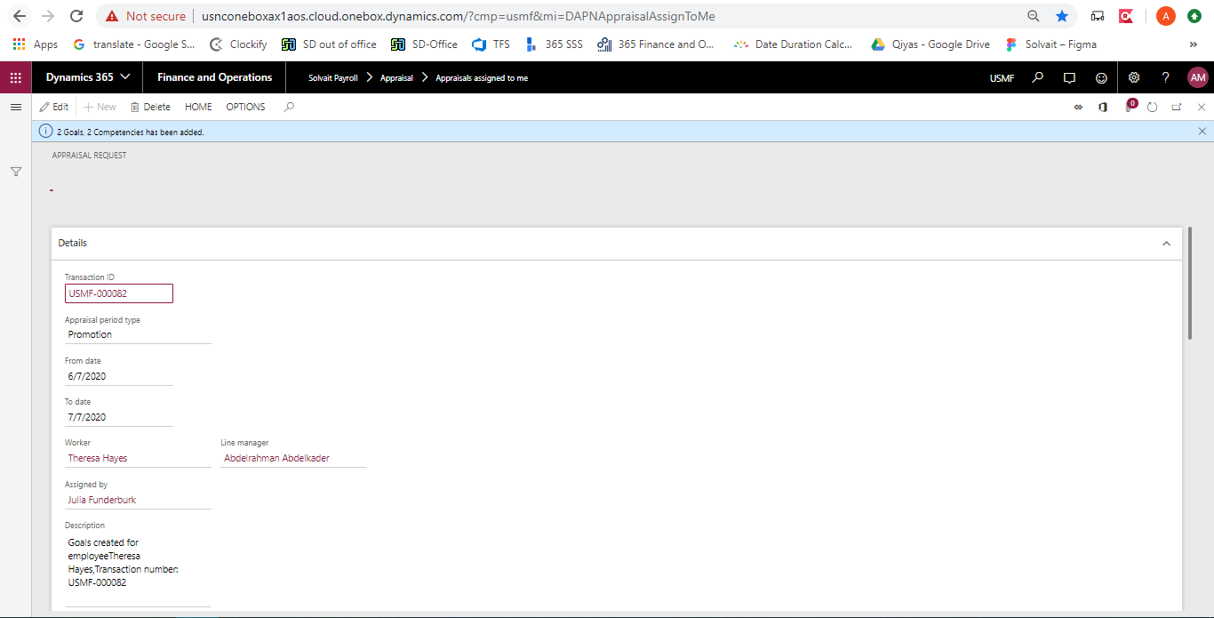

  - My appraisal

Path: Solvait payroll -> Appraisal -> My appraisal

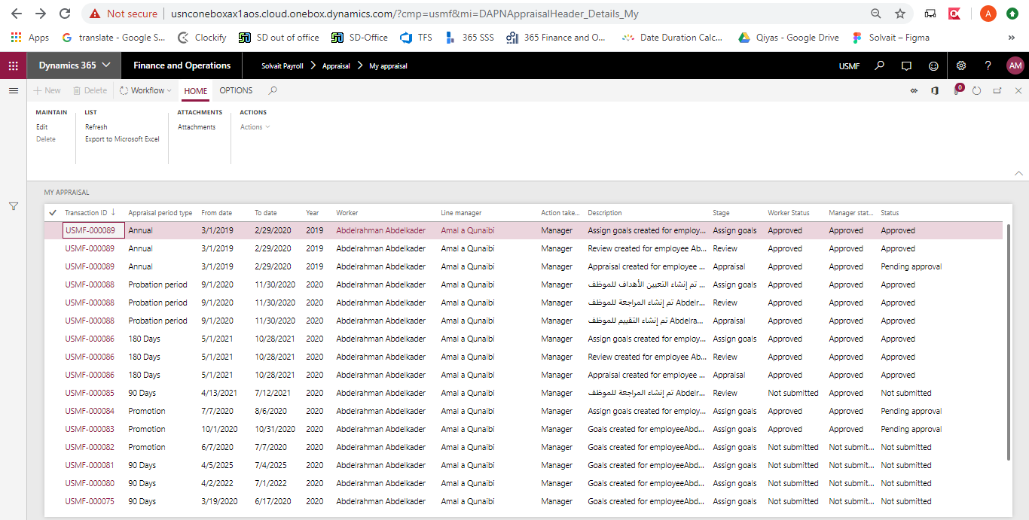

- This screen will display only for Worker.
- The Worker can view the details of the appraisal
- The following actions can be done by the worker on the appraisal:
  - Assign goal stage:
    - In the “Assign goal” stage, the worker cannot perform any action. Can only view the appraisal details.
  - Review stage:
    - In the “Review” stage, the worker can add initial value for the employee results.
  - Appraisal stage:
    - In the “Appraisal” stage, the worker can add final value for the employee results.

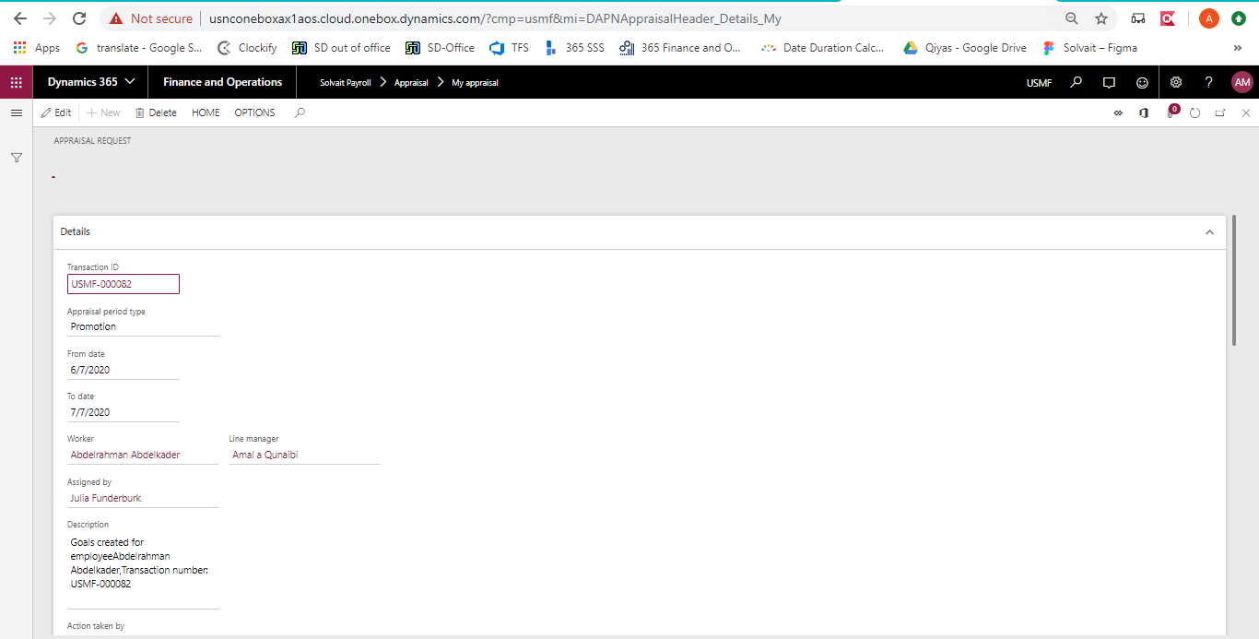

  - Appraisals Pending stages

Path: Solvait payroll -> Appraisal -> Appraisals pending stages

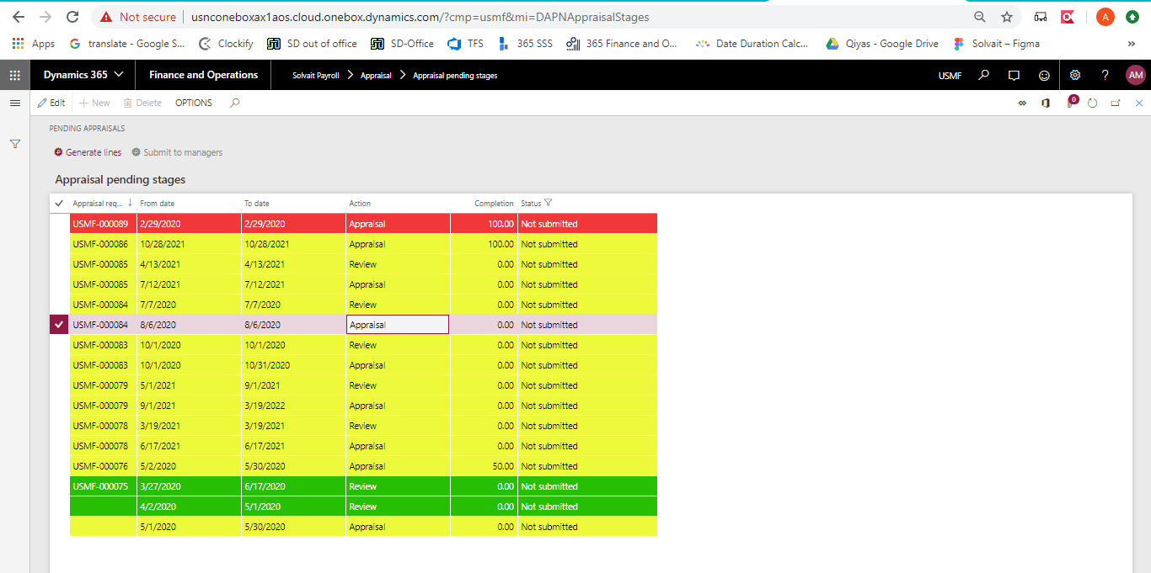

- This screen will display the pending stages of the appraisal period.
- Lines will be color as the following:
  - Red: means the appraisal line that were supposed to be generated are not generated on time
  - Yellow: means the appraisal line are in pending stage
  - Green: means the appraisal line in ready stage and appraisal should be generated in this period.
- Generate lines:
  - The HR manager can click on “Generate line” to generate appraisal lines for the next stage
    - The completion percentage will be calculated as per the approved appraisal requests
  - The HR manager cannot submit lines to manager until the completion is 100%
  - After clicking on “Submit to manager” button, the line will disappear from the screen,

  - Reports

Appraisal Report

Path: Solvait payroll -> Reports -> Appraisal Reports -> Appraisal report

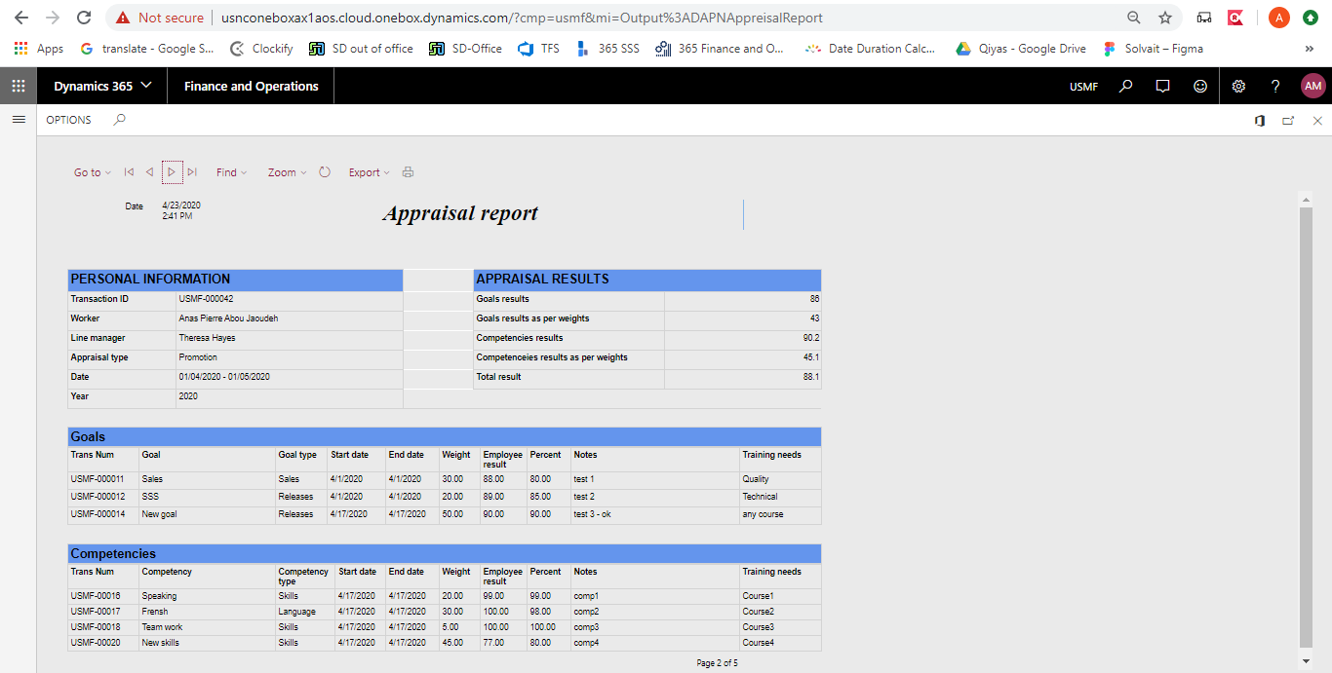

- This report will display the appraisal result for each worker
- Each worker will display on a separate page.
- The calculations are being calculated as the following:
  - Goal results = Total of (Percent * weight)
  - Goal results as per weight = Goal result * objective percentage
  - Competencies results = Total of (Percent * weight)
  - Competencies results as per weight = Competencies result * competencies percentage
  - Total results = Goal results as per weight + Competencies results as per weight

  - Employee Self-Services

Appraisal Assigned to Me

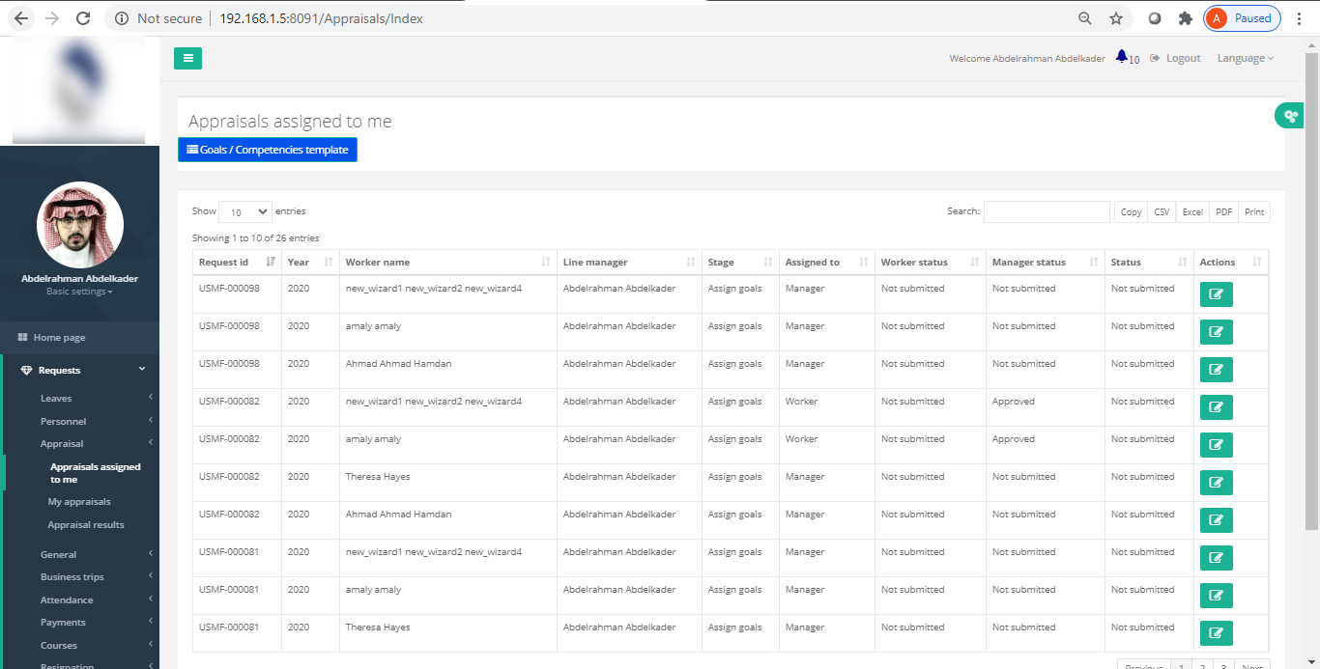

- This screen will display only for Line managers.
- The manager can view the details of the worker appraisal
- The following actions can be done by the manager on the appraisal:
  - Assign goal stage:
    - In the “Assign goal” stage, the manager can edit the start date and end date of each goal and competency, update the weight, add note, and add training needs.
    - Can add the KPIs for each goals and competencies
  - Review stage:
    - In the “Review” stage, the manager can add the initial percent for goals and competencies
    - Can add/update the KPIs for each goals and competencies
  - Appraisal stage:
    - In the “Appraisal” stage, the manager can add the final percent for goals and competencies
    - Can add/update the KPIs for each goals and competencies

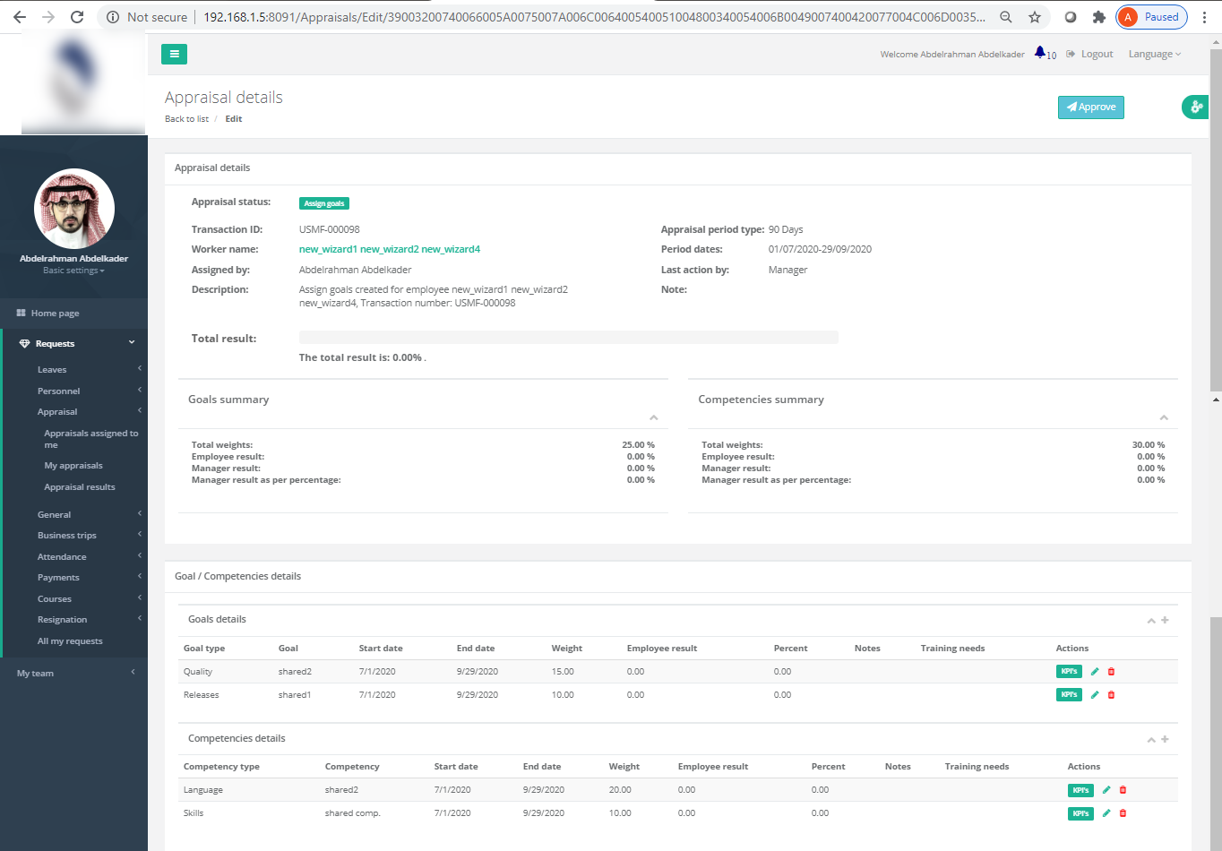

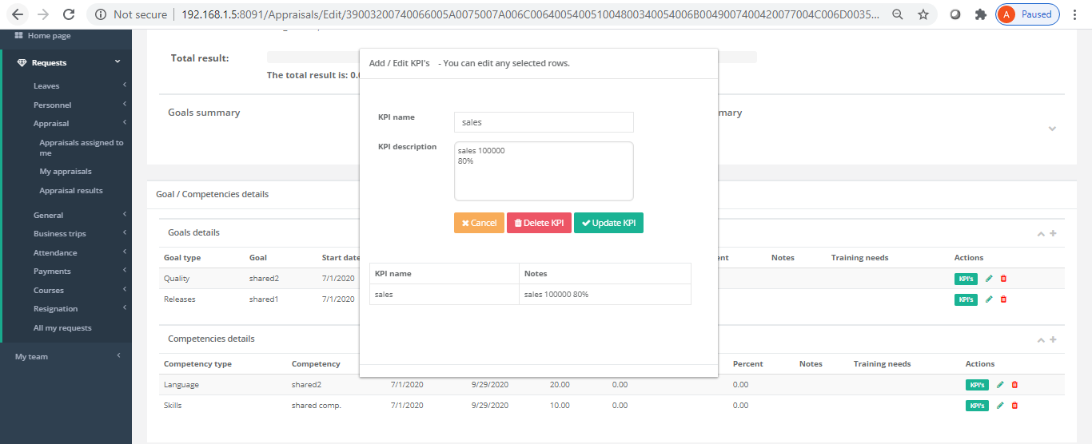

- The manager can add additional goals and competencies through the “Goal/Competence template”
  - Only the shared and the manager’s lines will display in the screen
  - The manager can add selected or all lines to the worker

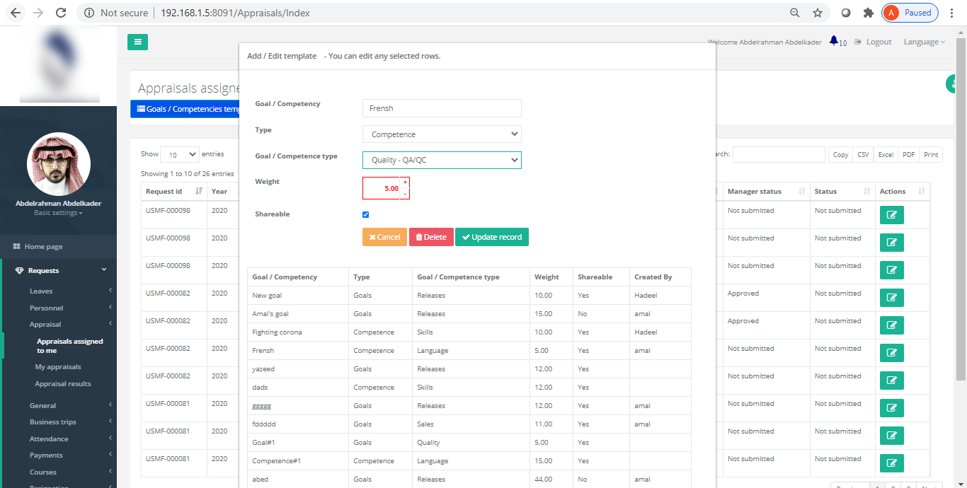

My appraisal

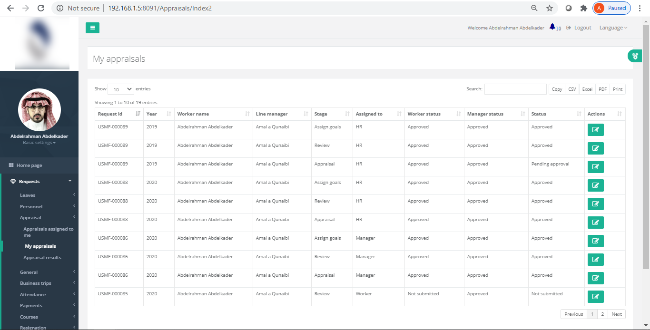

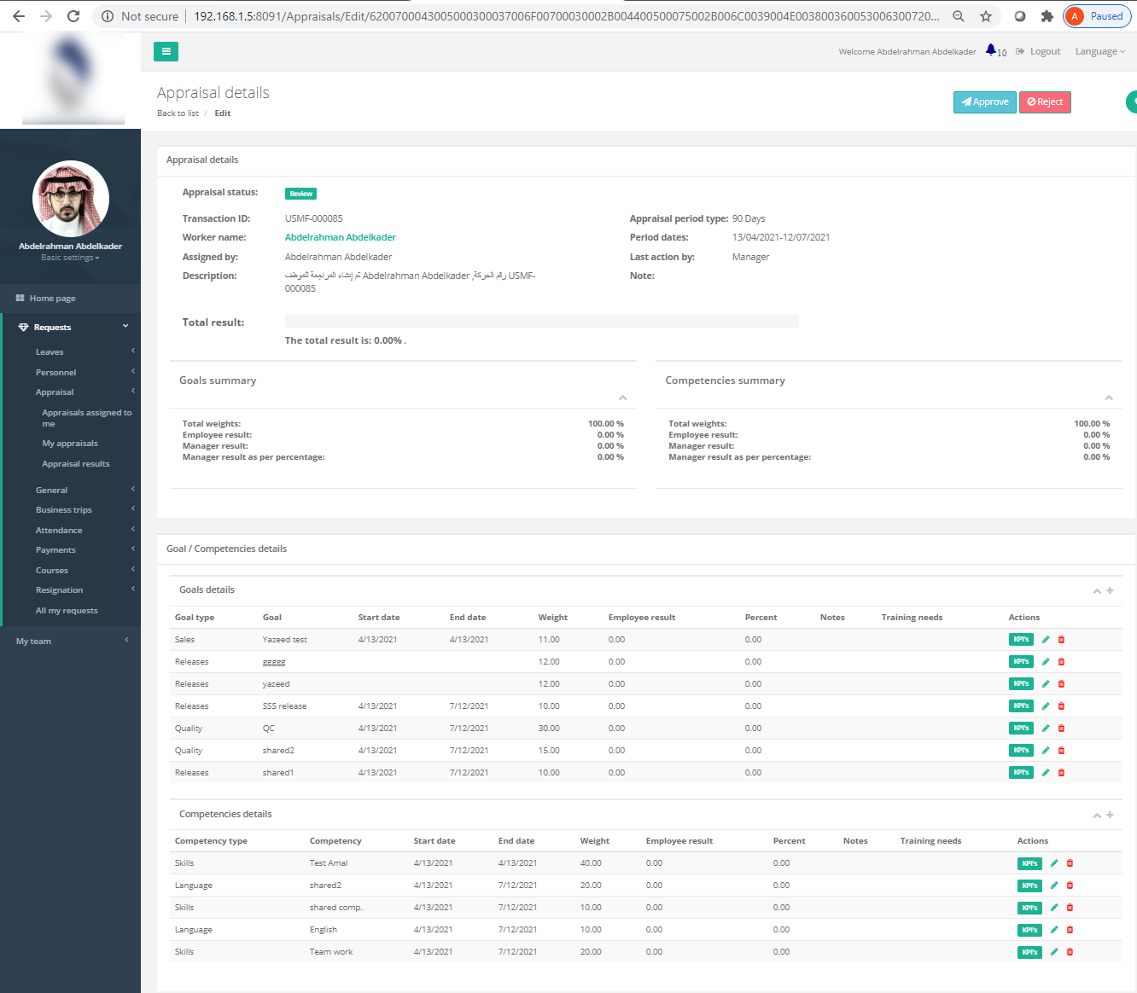

- This screen will display only for Worker.
- The Worker can view the details of the appraisal
- The following actions can be done by the worker on the appraisal:
  - Assign goal stage:
    - In the “Assign goal” stage, the worker cannot perform any action. Can only view the appraisal details.
  - Review stage:
    - In the “Review” stage, the worker can add initial value for the employee results.
  - Appraisal stage:
    - In the “Appraisal” stage, the worker can add final value for the employee results.
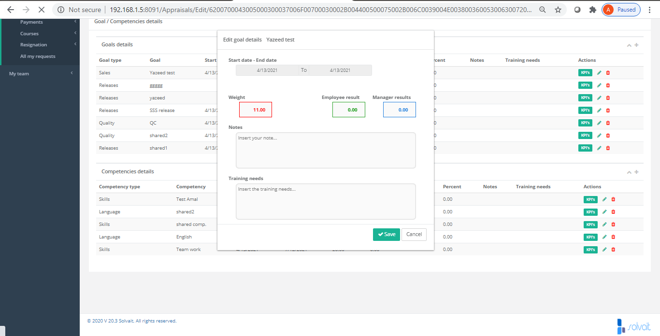

Appraisal results

- This report will display the appraisal result the worker
- The calculations are being calculated as the following:
  - Goal results = Total of (Percent * weight)
  - Goal results as per weight = Goal result * objective percentage
  - Competencies results = Total of (Percent * weight)
  - Competencies results as per weight = Competencies result * competencies percentage
  - Total results = Goal results as per weight + Competencies results as per weight

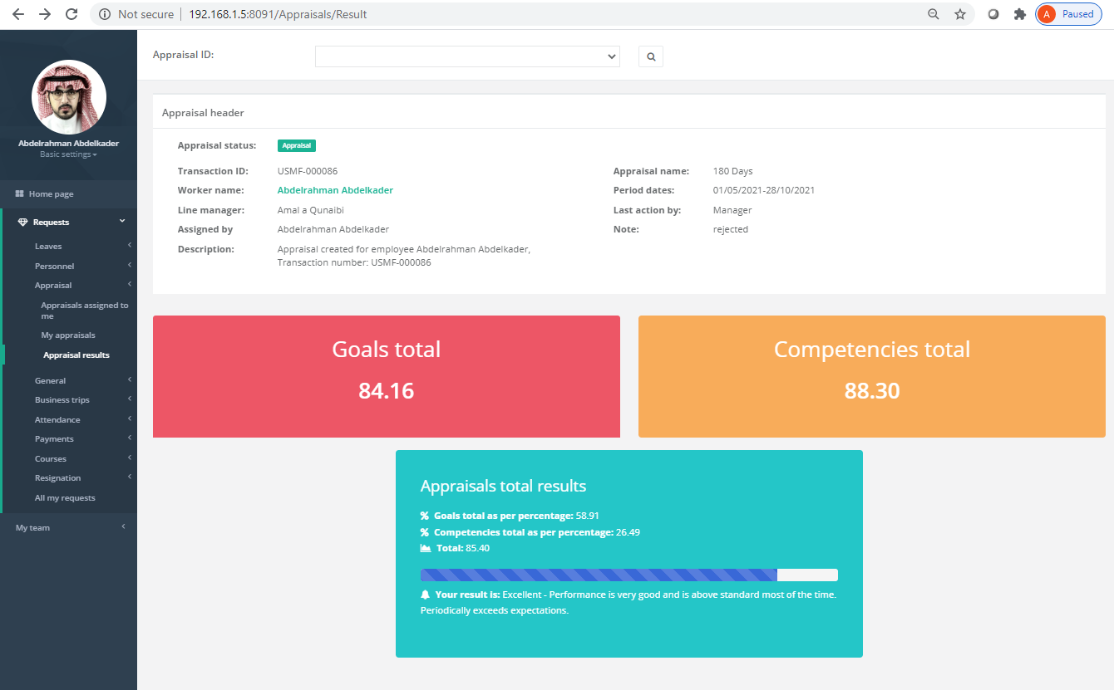

Payroll Workflow
To access payroll workflow, go to:
Solvait Payroll -> Setup -> Payroll Workflow
In order to configure workflow, follow the following steps:
- First, make sure AX users and SSS users are configured, as shown in the users’ section.
- Open AX from Internet Explorer (IE), then go to:
Solvait Payroll -> Setup -> Payroll Workflow
- To create a new workflow, click on “New” then choose the suitable workflow.
- Fill in Microsoft sign in credentials.
- Create approval step, drag, and drop an approval step, link it with the start and end steps.
- Click on approval step, click on basic settings, then click on the step again and click on basic settings, fill in the required details, then go to assignment.
- Choose assignment type, if hierarchy is chosen, click on hierarchy selection. Hierarchy means the workflow will go through the steps in organization structure that is configured in Human Resources module.
- Inside hierarchy selection choose “managerial hierarchy” for the first option, and “personnel number” for the second option. Click on add condition and choose worker -> Employee line manager -> choose value
E.g., If value chosen is <= 4 means number of hierarchy approval levels will be less than or equals four levels. Then click on close.
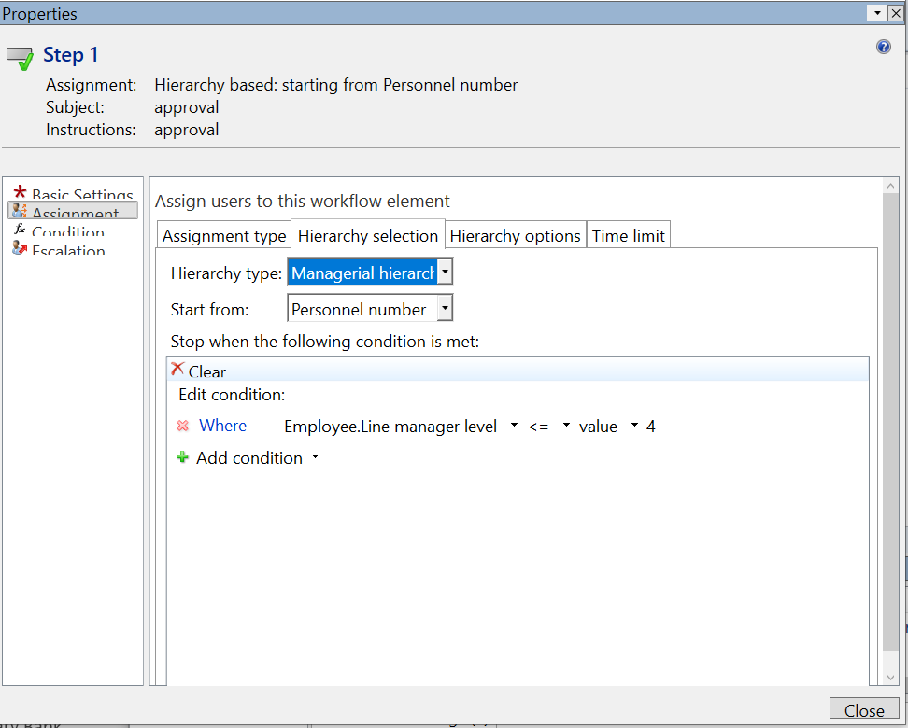
- To go to a previous level, click on level-up.
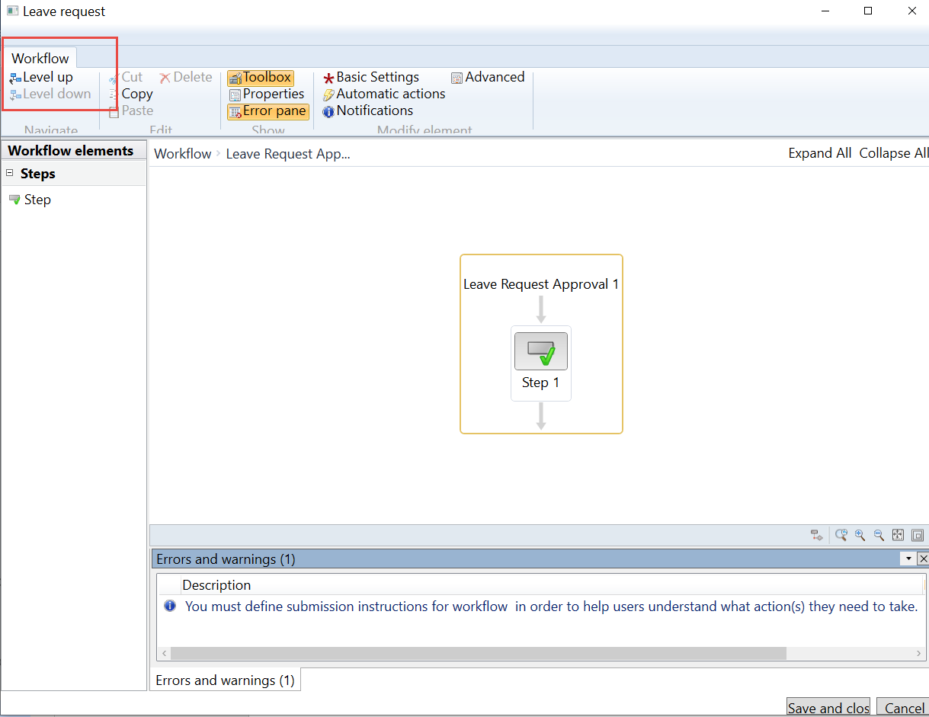

- If assignment type chosen is user, click on user and choose AX user you want to assign, click on arrow to be added to selected users. This means approval workflow will go to a specific user.
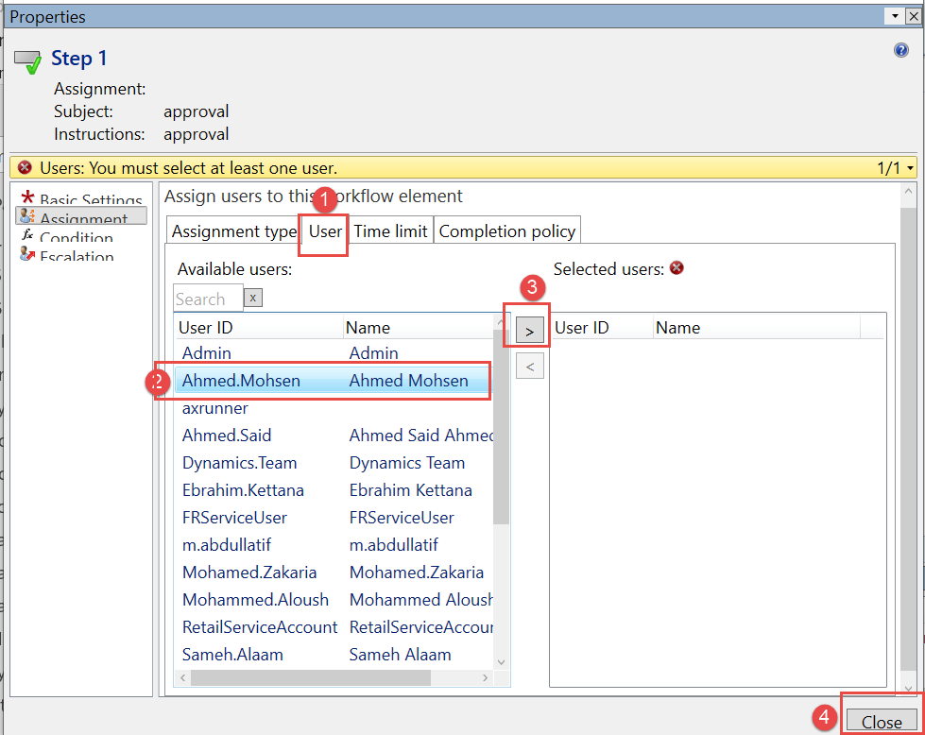
- Conditions can be added to workflow, put the suitable approval steps on both sides of conditions. Add a condition and select the suitable fields for this condition.
- Finally, click on save and close, fill in notes in save workflow window, click OK, then click on activate the new version.
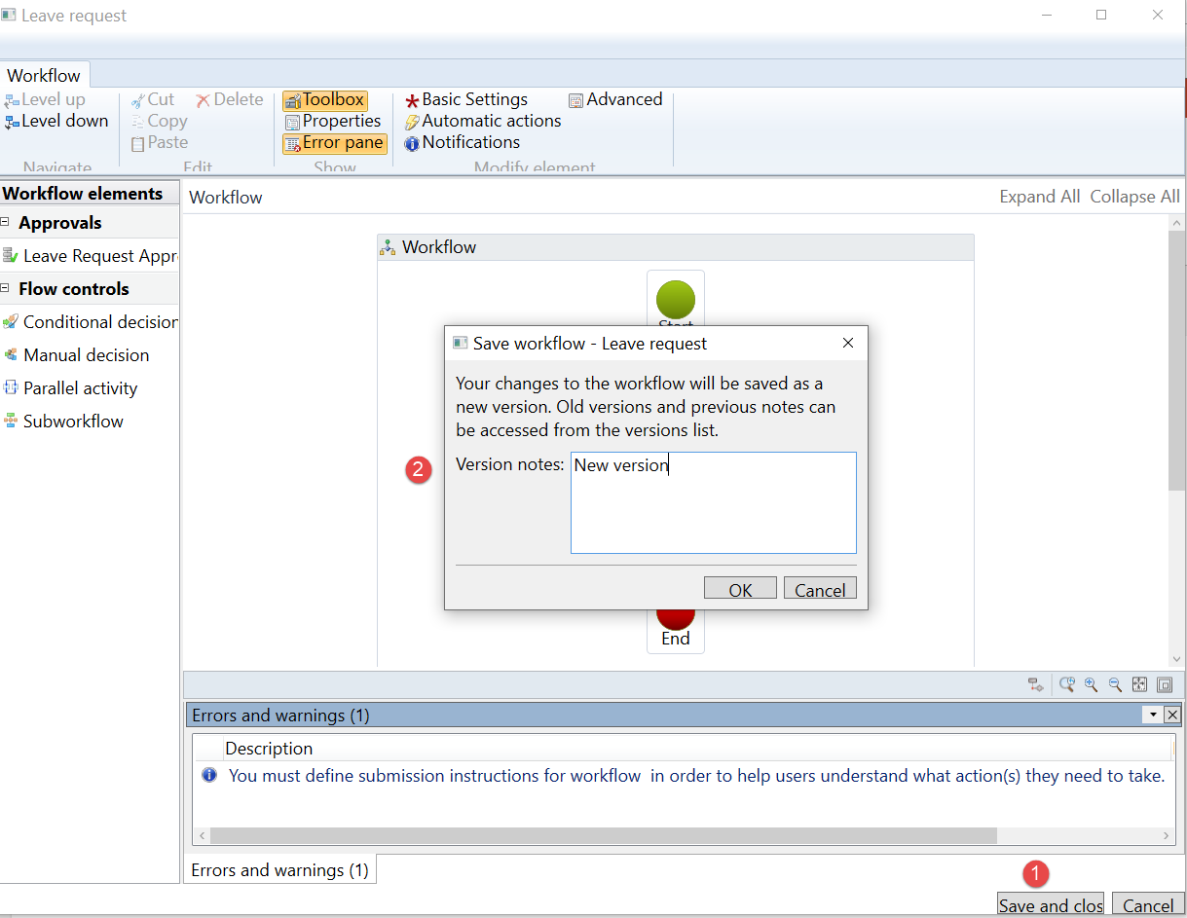
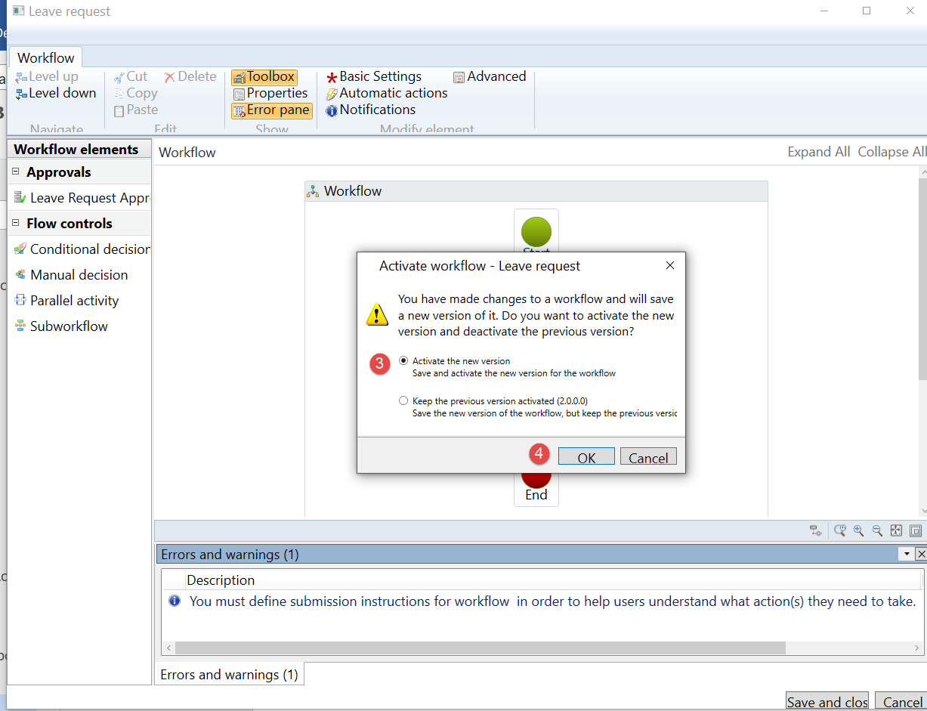

System Administration
System Administration module contains system setup for users and security roles. Users setup and configuration will be discussed in the following section

Users
SSS users do not to be linked to AX users unless it is a user for manager in the position hierarchy, since a manager needs a certain security role to make actions on request, such as reject and approve. Configuring AX users and adding security roles will be explained in this section.
In order to configure SSS users, go to:
Solvait payroll -> Setup -> General -> Solvait Users
Add a new row and fill in the required data including:
User | Username to be entered through SSS
Worker | Select the worker associated with the user
Permission type | 1, 2, 3, or 4
Active | Select active to activate it, and unselect it to deactivate the user
Company | Choose worker legal entity
Password | AX user password -if any-
User ID | AX user ID -if any-
Solvait password | Type SSS user password,

Next, to configure AX users, go to:
System Administration module -> Users -> Users
To add a new user, click on New and fill in the required data, such as: user name, user ID, email, company, and select the associated worker with this user in Person field.
Next, give the user suitable security roles. System admin is the highest role given to certain users in the system such as HR employees that need full access to the system.
For managers to be able to take actions on the requests they receive, SSS role must be added: DAPSSSRequest. This role contains all SSS requests security roles.
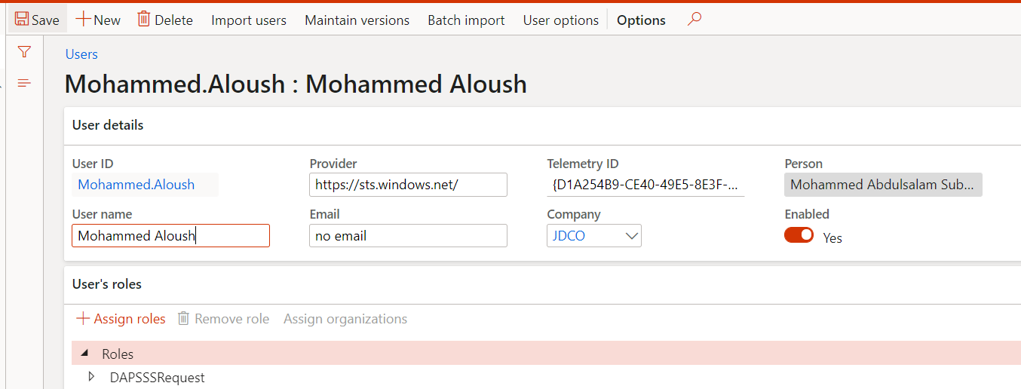
The second way to add a new AX user is by import users, click on import users to import users from Active Directory (AD), then select the user you want to import, then fill in the required data for him/ her.

